Space and Time

John Linus O'Sullivan *

Abstract: How did the universe come into existence? This very question cannot be asked because everything came from energy without time. If the energy was not always there as time, then nothing would exist to ask. With this in mind, timeless energy and cause of action is explained outside the realm of time and matter where the speed of light is constant relative to matter but is standing relative to time. Magnetic field waves are shown as gravity force in the electric field and are curved from mass in space-time.

1. Introduction

The electromagnetic field is comprised of open-ended standing wavelets in the opposite direction relative to mass. Open-ended wavelets are curved quadrant waves having electric and magnetic fields and the magnetic field provides the gravitational forces on the electric field. Gravity forces are very weak compared to the other forces of nature because gravity forces are at the nodes in the magnetic field while the other forces are at the antinodes in the electric field. Gravity forces at the nodes in the magnetic field effect mass in the electric field at the constant speed of light. Photon waves at the antinodes in the magnetic field pack a punch as particles with energy equal to frequency of the photons based on Planck's constant, E = hv.

2. Report and Figures

From Figure 1A below, energy is formed into half wavelengths at ultra high frequency standing waves. The black-red (dark) electric waves become transverse waves in the expansion process forming perpendicular to the brown-green (light) magnetic waves. As the half waves multiply from energy displacement at the antinodes, the expansion of the transverse wavelets becomes three dimensional as space in a sphere resulting in an endless unit without a boundary. The half waves are open-ended where the antinodes are at the ends and nodes in the middle such that each half wave keeps multiplying indefinitely to complete whole wavelengths in the electro-magnetic field. Each half wavelet shell in a spiral is equivalent to two smaller half wavelets within completing whole wavelengths where light speed is constant relative to mass, C = f λ.

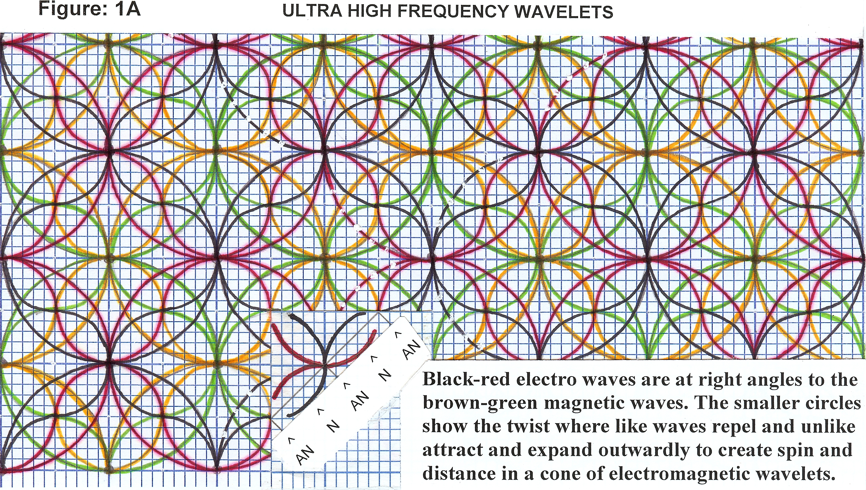
_________________________________
* b. 1938. Tralee, Ireland.
Independent Research, Connecticut, USA
E-mail: jlosullivan@msn.com © 2012
From illustration Figure 1B below, moving two steps in any direction from mass (center) and squaring, there are four complete green (light) circles in the square. On three steps from center and squaring, there are nine complete brown (light) circles in the outer square and so on in the square of the distance from mass in the magnetic field. Light and gravity waves propagate in the magnetic field at the square of the distance to mass (center). The black-red electric waves and brown-green magnetic waves oscillate perpendicular to each other as circular and sinusoidal waves with electric charges propagating in the direction Z and magnetic current propagating in the direction G. This is likened to placing the palm of the right hand edgeways on the table with the thumb sticking up; then place the left palm facing down between the fingers of the right hand with the thumb extended out. The thumb on the right hand is the E vector oscillation for the electric field and thumb on left hand is the B vector oscillation for the magnetic field with propagation of electric energy in the direction of fingers on the right hand and propagation of magnetic energy in the direction of fingers on the left hand. Magnetic current is circular shown as brown and green circles around mass (center) where a change in one field will have a change in the other. On the next increase in electric wave amplitude moving in direction Z, the magnetic wave amplitude will be center at the nodes relative to direction Z. The circular motion of open ended point-particles in direction Z as mass in conjunction with the circular motion of open ended photons in direction G as light and gravity provides Pythagorean Theorem and square distance. Holding the illustration up diagonally at eye level show how the electric wave antinodes are in a straight line when the magnetic waves are at the nodes. The mass experience is from all four corners of the field in direction Z going into infinity without space and time.

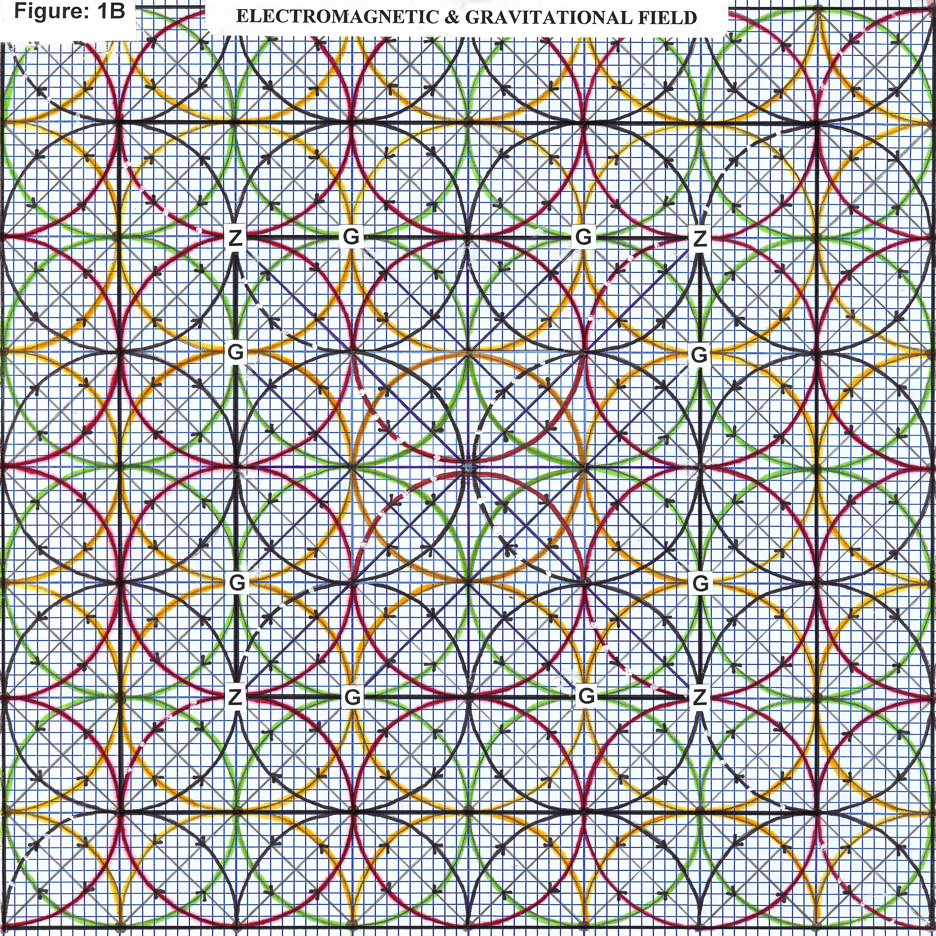
Electric and magnetic wavelets expand into larger wavelets from the antinodes (displacement) energy of standing waves at twice the amplitude of the smaller wavelet giving distance to the field. The waves need to be visualized as a spectrum of different size wavelengths increasing in size moving outwardly, not one size wave-length as shown. The multi source pattern of the wavelets is energy left in the field as the electromagnetic spectrum after mass and gravity are condensed into finite energy. Gravity forces come from the brown-green magnetic waves inside the black-red electric waves Figure 1B (center) and an inward attraction force at the nodes that conserve energy. Gravity magnetic forces are at the nodes when the mass electric forces are firing at the antinodes and visa versa. In Figure 1B, the black electric and brown magnetic are outward/inward circular waves respectively while the red electric and green magnetic are expanding/contracting sine waves respectively. Quarks deep in the cone apex include the black electric circular waves, the black electric sine waves and green magnetic sine waves as the proton while the brown magnetic circular waves, the brown magnetic sine waves and red electric sine waves are the neutron. Gluons are the amplitude of the wavelets like the e coupling constant but are much stronger in the cone apex holding protons and neutrons together. Beta decay come from the interaction of the black-red sine waves between the neutrons and protons. Electrons at the base of the quantum cone are the red-brown coupling waves and positrons are the black-green coupling waves. Electron(s) as a mass particle continue outwardly to interact with photon waves at the base of the quantum cone which is amplitude of the e coupling constant. The e coupling constant, about 137.03597 is the amplitude for a real electron to emit or absorb a real photon [1]. Each photon is a complete wavelength within a half wave particle shell and is expanding outwardly into infinity. Pi is the result of open ended standing waves where the circles never close in the mass composition. Finite energy is equal to MC².

3. Conclusion

Left Side Right Side
Extended Equation: E = C = ∞ = ZG² Where ZG² is total wave energy.

Open-ended standing waves are on both sides of the equation where the speed of light is infinite on the left side and a constant relative to mass on the right side. Total wave energy is energy of the electric field propagating in direction Z multiplied times energy squared of the magnetic field propagating in direction G. The wave propagation moving in direction Z is similar to classical electromagnetic wave propagation and account for the inverse square distance of light and gravity relative to mass. Vectors E and B in direction Z are three spatial dimensions in space with light and gravity from the magnetic field as the square of the distance to mass. Mass in the electric field already includes part of the magnetic field as subatomic forces; the remaining magnetic field spectrum is light and gravity relative to mass. The remaining electric field energy not subject to the magnetic effect on mass is dark energy. Mass energy waves have intermittent time frames at the nodes of standing waves resulting in past, present and future like motion pictures on screen. A star is formed when a large amount of gas (mostly hydrogen) starts to collapse in on itself due to its gravitational attraction [2]. Mass as finite energy is receding as a result of the different gravity levels in the field evidenced by the redshift and distance. Mass and strength of the field is space and movement in direction Z is the arrow of time; hence, space-time. Thus, light speed is standing having velocity only when mass is relative to it which is finite energy in the form of curved spacetime. Space-time in general relativity is not flat but curved by the distribution of mass and energy in it [3]. Finite moving energy is the existence of time while standing energy is the existence of infinity. Time dilates when it approaches the speed of light and is non-existing in standing space energy. Time as a dimension of spacetime to justify beginning in the physical finite universe is coming from timeless energy where velocity is standing without distance and time. Time as finite energy have a beginning and end while infinity is standing without time; consequently, have no beginning or end. Energy applies to both sides of the equation with energy as time on one side and interconnected with energy at absolute rest on the other side. Religion and science agrees with each other because religion is a belief in an infinite creator while science having finite energy as time is coming from the energy equation where open-ended standing wave energy can exist outside of time.

References

[1] Feynman, R.P. (1988). QED The Strange Theory of Light and Matter, Princeton University Press, p129.
[2] Hawking, S. (1996). The Illustrated A Brief History of Time, Bantam Books, p105.

[3] Ibid, pp 40-42. Note: Background field General Relativity Fig.2.16 p41 is similar to quantum field in Fig.1B above.

