Gravitation as the result of the reintegration of
migrated electrons and positrons to their atomic nuclei.

Osvaldo Domann
Germany
odomann@yahoo.com

This paper presents the mechanism of gravitation based on an approach where the energy of an electron or positron is radially distributed in space. The energy is stored in fundamental particles (FPs) that move radially and continuously through a focal point in space, point where classically the whole energy of a subatomic particle is thought to be concentrated. FPs store the energy in longitudinal and transversal rotations defining corresponding angular momenta. Forces between subatomic particles are the product of the interactions of their FPs. The laws of interactions between fundamental particles are postulated in that way, that the linear momenta for all the basic laws of physics can subsequently be derived from them, linear momenta that are generated out of opposed pairs of angular momenta of fundamental particles.

1. Introduction.
To explain the mechanism of gravitation it is necessary first to show how the energies of electrons and positrons (Basic Subatomic Particles $≡$ BSPs) are distributed in space.

The total energy $E_{e}=\sqrt{E_{o}^{2}+E_{p}^{2}}=E_{s}+E_{n}$ of a BSP is distributed in space as follows:
 | $$dE_{e}=E_{e} dκ=ν J_{e}$$  $$dE_{s}=E_{s} dκ=ν J_{s}$$  $$dE_{n}=E_{n} dκ=ν J_{n}$$ | (1)

where
 | $$E_{s}=\frac{E_{o}^{2}}{\sqrt{E_{o}^{2} + E_{p}^{2}}}$$  $$E_{n}=\frac{E_{p}^{2}}{\sqrt{E_{o}^{2} + E_{p}^{2}}} and$$  $$dκ= \frac{1}{2} \frac{r_{o}}{r_{r}^{2}} dr \sin{φ} dφ \frac{dγ}{2π}$$ | (2)

with $dκ$ a distribution function for the energy which is inverse proportional to the square distance to the focal point, giving the fraction of energy in
the volume $dV=dr r dφ r \sin{φ} dγ$.
FPs leaving the focal point (emitted FPs) have only longitudinal angular momenta $J_{e}$ and associated to it a longitudinal emitted field $d{\bar{H}}_{e}$ defined as
 | $$d{\bar{H}}_{e}=H_{e} dκ {\bar{s}}_{e}=\sqrt{ν J_{e} dκ} {\bar{s}}_{e}$$  $$with H_{e}^{2}=E_{e}$$ | (3)

FPs moving to the focal point (regenerating FPs) have longitudinal $J_{s}$ and transversal $J_{n}$ angular
momenta and associated to them respectively a longitudinal regenerating field $d{\bar{H}}_{s}$ defined as
 | $$d{\bar{H}}_{s}=H_{s} dκ \bar{s}=\sqrt{ν J_{s} dκ} \bar{s}$$  $$with H_{s}^{2}=E_{s}$$ | (4)
and a transversal regenerating field $d{\bar{H}}_{n}$ defined as
 | $$d{\bar{H}}_{n}=H_{n} dκ \bar{n}=\sqrt{ν J_{n} dκ} \bar{n}$$  $$with H_{n}^{2}=E_{n}$$ | (5)
For the total field magnitude $H_{e}$ it is
$H_{e}^{2}=H_{s}^{2} + H_{n}^{2}$
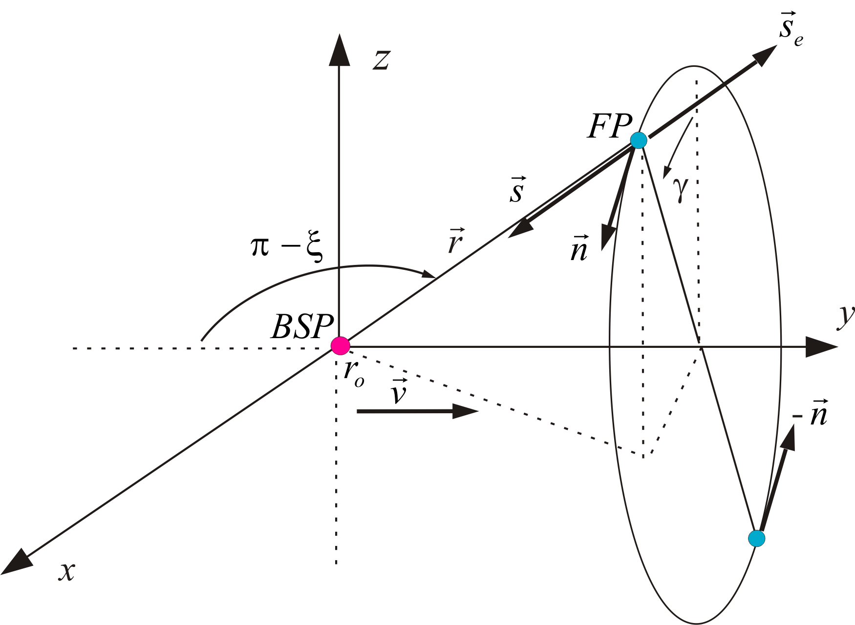
Figure 1. Unit vector ${\bar{s}}_{e}$ for an emitted FP and unit vectors $\bar{s}$ and $\bar{n }$for a regenerating FP of a BSP moving with $v≠c$
In Fig. 1 the vector ${\bar{s}}_{e}$ is a unit vector in the moving direction of the emitted fundamental particle (FP). The vector $\bar{s}$ is a unit vector in the moving direction of the regenerating FP. The vector $\bar{n}$ is a unit vector transversal to the moving direction of the regenerating FP and oriented according the right screw rule relative to the velocity $\bar{v}$ of the BSP.

Conclusion: Basic subatomic particles (BSPs) are structured particles with longitudinal and transversal angular momenta, with positive or negative emitted angular momenta (charge) and with a transversal field $d{\bar{H}}_{n}$ (mechanical momentum and magnetic moment).

2. Gravitation.
The interaction law between FPs of static BSPs (Coulomb) follows the cross product between longitudinal angular momentum $|{\bar{J}}_{s_{1}}×{\bar{J}}_{s_{2}}|=J_{s_{1}} J_{s_{2}}\sin{ }β$ of the FPs, which is zero for the distance $d=0$ between BSPs because of $β=π$.
The differential linear momentum $dp$ on a BSP is generated out of pairs of opposed angular momenta ${\bar{J}}_{n}$ at the regenerating FPs of the BSP. At a moving BSP, opposed pairs of angular momenta are generated at the regenerating FPs because of the axial symmetry of the FPs relative to the velocity of the BSP as shown in Fig. 1.
In Fig. 2 the differential linear momentum $dp_{2}$ at BSP $2$ is generated by pairs of opposed angular momenta ${\bar{J}}_{n_{2}}$ of regenerating FPs.

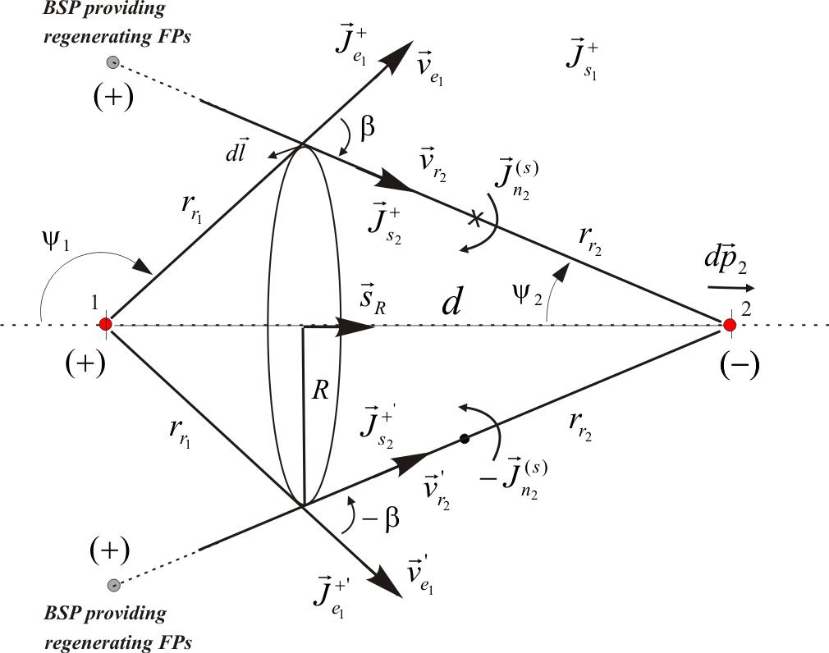
Figure 2. Generation of angular momenta $J_{n}$ at regenerating fundamental particles of two static basic subatomic particles at the distance $d$
Fig. 3 shows the linear momentum between two BSPs as a function of the distance $d$. The variable $r_{o}$ represents the radii of the focus of the BSPs, which are constant for non relativistic speeds.
Nucleons are composed of electrons and positrons which are concentrated in the range of $0≤γ≤0.1$ of the curve of Fig. 3 where the attractions and repulsions between them are zero.
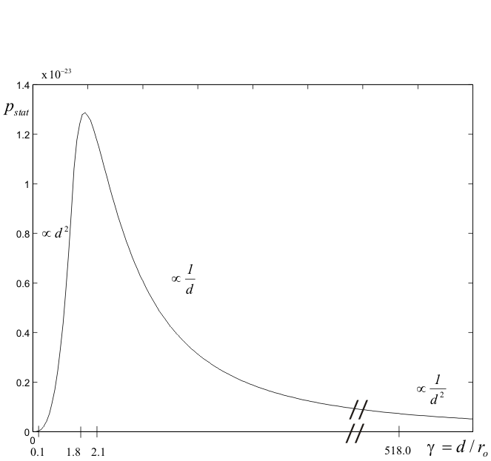
Figure 3. Linear momentum $p_{stat}$ as function of between two static BSPs with equal focal radii $r_{o_{1}}=r_{o_{2}}$
Electrons and positrons of a stable nucleon migrate slowly into the range of $0.1≤γ≤1.8$ polarizing the nucleon, and are subsequently reintegrated with high speed when their FPs cross with FPs of the remaining electrons and positrons of the nucleon, because of $β<π$ as shown in Fig. 4 for Neutron $1$.

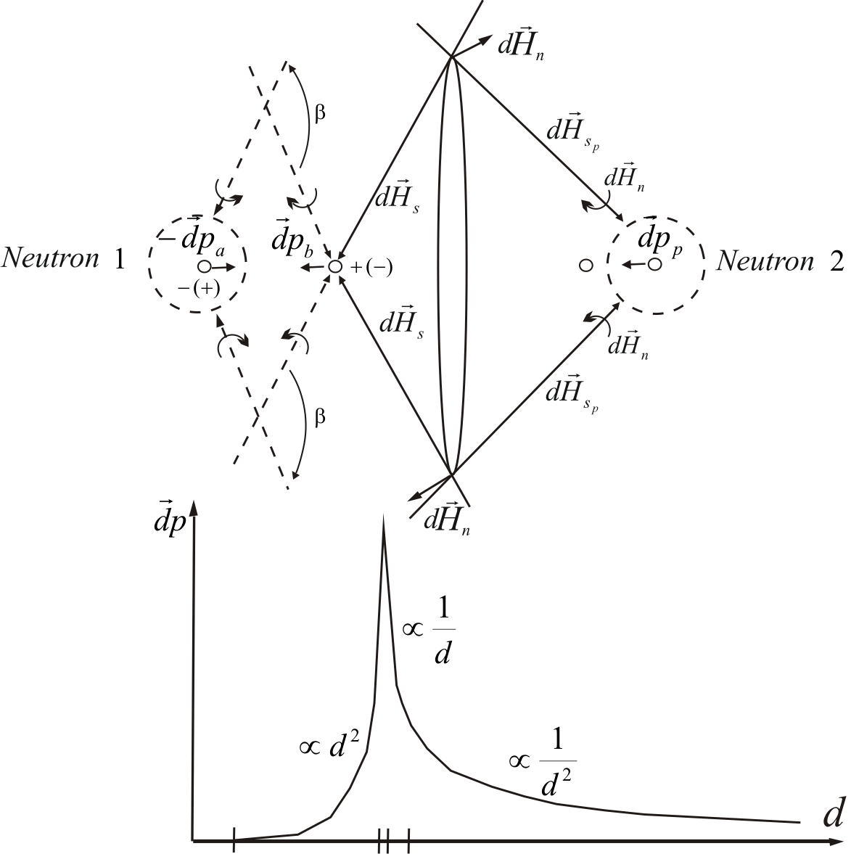
Figure 4. Transmission of momentum $dp$ from neutron $1$ to neutron $2$
The opposed transversal angular momenta ${\bar{J}}_{n}$ responsible for the fields at the FPs of each reintegrating electron or positron of a nucleon, are captured by regenerating FPs of an electron or positron of another nucleon, generating the attracting force between the nucleons as shown in Fig. 4. Reintegrating BSP ’b’ of neutron $1$ hands over its opposed angular momenta to BSP ’p’ of neutron $2$ with the result, that the linear momentum $dp_{b}$ of BSP ’b’ reduces to zero while the linear momentum $dp_{p}$ of BSP ’p’ increases by the same magnitude complying with the conservation law for momentum.
To calculate the gravitation force induced by the reintegration of migrated BSPs, we need to know the number of migrated BSPs in the time $Δt$ for a neutral body with mass $M$.
The following equation was derived in [6] for the induced gravitation force generated by one reintegrated electron or positron

 | $$F_{i}=\frac{dp}{Δt}= \frac{\sqrt{h ν_{n}} \sqrt{m_{p}}}{4 K d^{ 2}} \int{\int_{Grav}{\begin{aligned} \\ \end{aligned}}}$$  $$with \int{\int_{Grav}{=}}2.4662$$ | (6)

where $m_{p}$ is the mass of the electron and $h$ the Planck constant and
 | $$Δt=K r_{o}^{2}$$  $$r_{o}=3.8590⋅10^{-13} m$$  $$K=5.4274⋅10^{4} s/m^{2}$$ | (7)
The direction of the force $F_{i}$ on the capturing BSP is independent of the sign of the reintegrating BSP and is always oriented to the reintegrating BSP.
For two bodies with masses $M_{1}$ and $M_{2}$ and where the number of reintegrated BSPs in the time $Δt$ is respectively $Δ_{G_{1}}$ and $Δ_{G_{2}}$ it must be
 | $${F_{G}=F}_{i} Δ_{G_{1}} Δ_{G_{2}}=G \frac{M_{1} M_{2}}{d^{ 2}}$$  $$G=6.6726⋅10^{-11}$$ | (8)

As the direction of the force $F_{i}$ is the same for reintegrating electrons $Δ_{G}^{-}$ and positrons $Δ_{G}^{+}$ it is
 | $$Δ_{G}=|Δ_{G}^{-}|+|Δ_{G}^{+}|$$ | (9)
and we get that

 | $$Δ_{G_{1}} Δ_{G_{2}}=G \frac{4 K M_{1} M_{2}}{\sqrt{h ν_{n}} \sqrt{m_{p}} \int{\int_{Grav}{}}}$$ | (10)

Because of energy exchange quantization derived in [6] which states that energy is quantized in energy quanta of a resting electron $E_{o}=h ν_{o}$ with $ν_{o}=1.2373⋅10^{20} s^{-1}$ , we replace $h ν_{n}$ by $h ν_{o}$ in eq. (6) and get
 | $$Δ_{G_{1}} Δ_{G_{2}}=2.1493⋅10^{16} M_{1} M_{2}$$  $$Δ_{G_{1}} Δ_{G_{2}}=γ_{G}^{2} M_{1} M_{2}$$ | (11)
and
 | $$Δ_{G}=γ_{G} M with$$  $$γ_{G}=1.4661⋅10^{8} kg^{-1}$$ | (12)

Calculation example: The number of migrated BSPs that are reintegrated at the sun and the earth in the time $Δt$ are respectively, with $M_{⊙}=1.9891⋅10^{30} kg$ and $M_{†}=5.9736⋅10^{24} kg$
 | $$Δ_{G_{⊙}}=2.9162⋅10^{38} and$$  $$Δ_{†}=8.7579⋅10^{32}$$ | (13)

The power exchanged between two masses due to gravitation is
 | $$P_{G}=F_{G} c$$  $$P_{G}= \frac{c \sqrt{h ν_{o}} \sqrt{m_{p}}}{4 K d^{ 2}} Δ_{G_{1}} Δ_{G_{2}} \int{\int_{Grav}{}}$$ | (14)
The power exchanged between the sun and the earth is, with $d_{⊙†}=1.49476⋅10^{11} m$
 | $$P_{G}=F_{G} c= G \frac{M_{⊙} M_{†}}{d_{⊙†}^{ 2}} c$$  $$P_{G}=7.8156⋅10^{19} J/s$$ | (15)

3. Dark matter.
In the previous sections we have seen that the origin of the gravitation force is the induced force due to the reintegration of migrated BSPs in the direction of the two gravitating bodies. When a BSP is reintegrated to a neutron, the two BSPs of different signs that interact produce an equivalent current in the direction of the positive BSP as shown in Fig. 5.

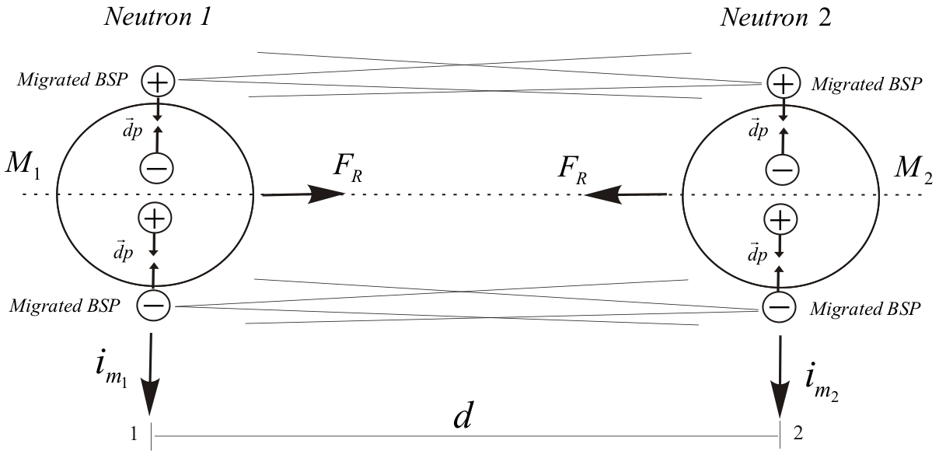

Figure 5. Resulting current due to reintegration of migrated BSPs
As the numbers of positive and negative BSPs that migrate in one direction at one neutron are equal, no average current should exists in that direction in the time $Δt$. It is
 | $$Δ_{R}=Δ_{R}^{+}+Δ_{R}^{-}=0$$ | (16)

We now assume, that because of the power exchange between the two neutrons (15), a synchronization exists between the reintegration of BSPs of equal sign in the direction orthogonal to the distance between the two neutrons, resulting in parallel currents of equal signs that generate an attracting force between the neutrons. Thus the total attracting force between the two neutrons is produced first by the induced force$F_{G}$ and second by the parallel currents $F_{R}$ of reintegrating BSPs.
 | $F_{T}=F_{G}+F_{R}$ with  $$F_{G}=G \frac{M_{1} M_{2}}{d^{2}}$$  $$F_{R}=R \frac{M_{1} M_{2}}{d}$$ | (17)

To obtain an equation for the force $F_{R}$ we start with an equation that was deduced in [6] for the linear momentum when electrons are bent through a crystal, equation that is based on the interaction of parallel currents.
 | $$p_{b}=\frac{1}{4} \frac{5.8731}{64 c} \frac{h ν_{o}}{d} Δl n$$ | (18)

with
 | $$ν_{o}=1.2373⋅10^{ 20} s^{-1}$$  $$Δl=5.2843⋅10^{-11} m$$  $$Δ_{o} t=8.0821⋅10^{-21} s$$ | (19)

The force for one pair of parallel BSPs ($n=1$) is given by
 | $$dF_{R}=\frac{p_{b}}{Δ_{o}t}=\frac{K_{Dark}}{d} with$$  $$K_{Dark}=\frac{1}{2} \frac{h}{Δ_{o}t}$$  $$K_{Dark}=4.09924⋅10^{-14} Nm$$ | (20)
The total force is

 | $$F_{R}=\frac{K_{Dark}}{d} Δ_{R_{1}} Δ_{R_{2}}=R \frac{M_{1} M_{2}}{d}$$ | (21)

We get
 | $$Δ_{R_{1}} Δ_{R_{2}}=\frac{R}{K_{Dark}} M_{1} M_{2}$$ | (22)

or
 | $$Δ_{R_{1}} Δ_{R_{2}}=γ_{R}^{2} M_{1} M_{2} with$$  $$γ_{R}^{2}=\frac{R}{K_{Dark}}$$ | (23)
and
 | $$Δ_{R}=γ_{R} M$$ | (24)

The total attracting force gives

 | $$F_{T}=F_{G}+F_{R}=\left[\frac{G}{d^{2}}+\frac{R}{d}\right] M_{1} M_{2}$$ | (25)

For sub-galactic distances the induced force $F_{G}$ is predominant, while for galactic distances the force of parallel reintegrating BSPs $F_{R}$ predominates, as shown in Fig. 6.
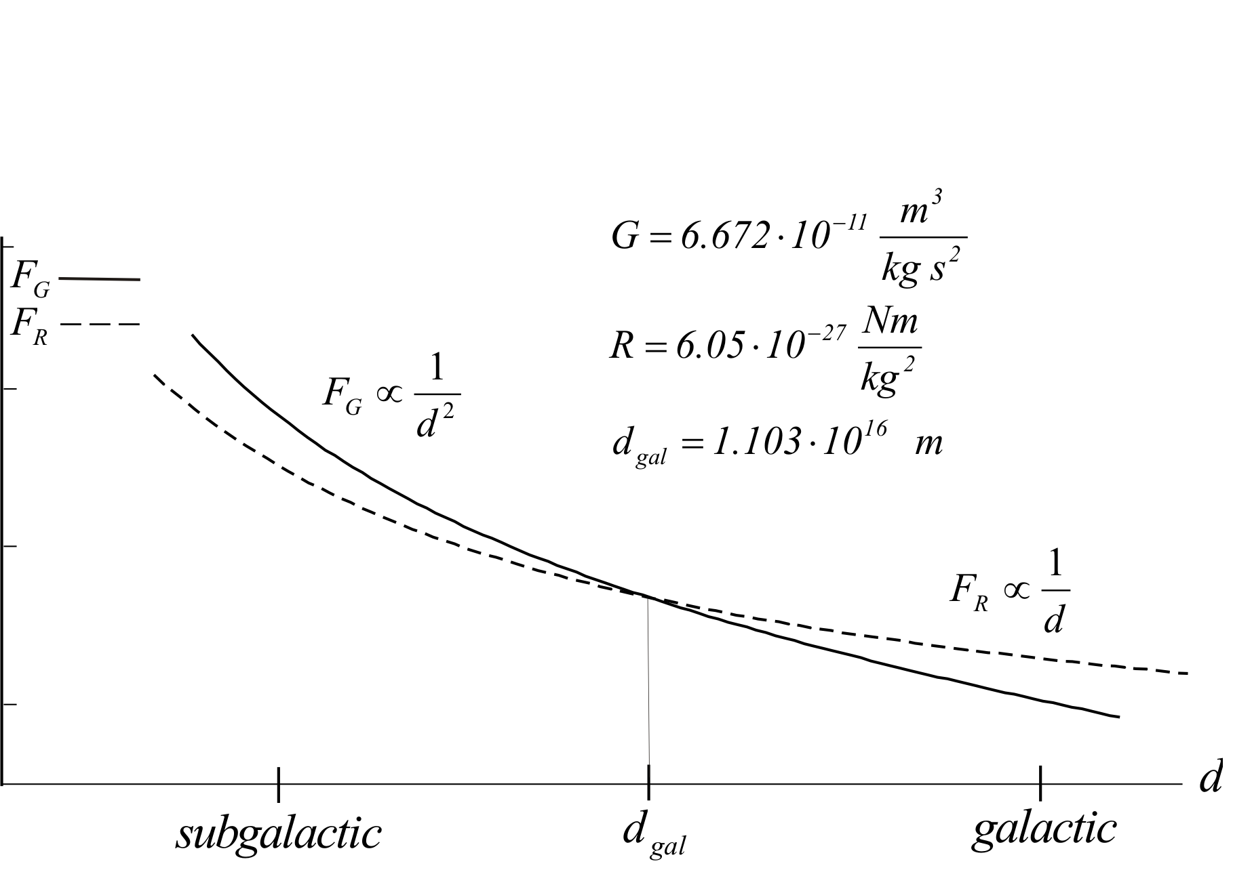
Figure 6. Gravitation forces at sub-galactic and galactic distances.
Calculation example:
For the sun with $v_{orb}=220 km/s$ and $M_{2}=M_{⊙}=2⋅10^{30} kg$ and a distance to the core of the Milky Way of $d=25⋅10^{19} m$ we get a centrifugal force of
 | $$F_{c}=M_{2} \frac{v_{orb}^{2}}{d}=3.872⋅10^{20} N$$ | (26)

With the mass of the core of the Milky Way of $M_{1}=4⋅10^{6} M_{⊙}$ and
 | $$F_{c}=F_{T}≈F_{R}=R \frac{M_{1} M_{2}}{d}$$  $$R=6.05⋅10^{-27} Nm/kg^{2}$$  and with | (27)

 | $F_{G}=F_{R}$we get  $$d_{gal}=\frac{G}{R}=1.103⋅10^{16} m$$ | (28)

justifying our assumption that $F_{T}≈F_{R}$ because the distance between the sun and the core of the Milky Way is $d≫d_{gal}$.
We also have that
 | $$γ_{R}=\sqrt{\frac{R}{K_{Dark}}}=3.842⋅10^{-7} kg^{-1}$$ | (29)

If we compare with $γ_{G}=1.4661⋅10^{8} kg^{-1}$ for the induced force we see that $γ_{R}$ is very small.
Note: The flattening of galaxies´ rotation curve was derived based on the assumption that the gravitation force is composed of an induced component and a component due to parallel currents of reintegrating BSPs and, that for galactic distances the induced component can be neglected.
Note: We also may assume that the synchronization of the reintegrating BSPs in the orthogonal direction of the two neutrons results in parallel currents of opposed signs, generating a repulsive force between the two neutrons.

4. Summary of main characteristics of the proposed model.
The main characteristics of the proposed model, with gravitation a part of it, are:
  - The approach is Lorentz invariant, quantification and probability are inherent to it.
  - The energy of a BSP is stored in the longitudinal angular momenta of emitted fundamental particles. The rotation sense of the longitudinal angular momentum defines the charge of the BSP.
- All the basic laws of physics (Coulomb, Ampere, Lorentz, Maxwell, Gravitation, bending of particles and interference of photons, Bragg, Laue, Schroedinger, Stern-Gerlach) are mathematically derived from the proposed model, proving that the approach is in accordance with experimental data.
- All known forces are derived as rotors from one vector field generated by the longitudinal and transversal angular momenta of fundamental particles.
- The coexistence of BSPs of equal charge in the atomic nucleus does not require the definition of a special strong force nor additional mediating particles (gluons).
- The emission of particles from heavy atomic nucleus does not require the definition of a special weak force nor additional mediating particles.
- Gravitation has its origin in the reintegration of migrated BSPs to nuclei of bodies. No special mediating particles are required (gravitons).
- The gravitation force is composed of an induced component and a component due to parallel currents of reintegrating BSPs. For galactic distances the induced component can be neglected, what explains the flattening of galaxies´ rotation curve (no dark matter is required).
- The interacting particles for all types of interactions (electromagnetic, strong, weak, gravitation) are the FPs with their longitudinal and transversal angular momenta.
- The wave character of the photon is defined as a sequence of BSPs with potential opposed transversal linear momenta, which are generated by transversal angular momenta of FPs that comply with specific symmetry conditions.
- Light that moves through a gravitation field can only lose energy, what explains the red shift of light from far galaxies (no expansion of the universe is required).
- The addition of a wave to a particle (de Broglie) is effectively replaced by a relation between the particles focal radius and its energy. Deflection of particles such as the electron is now a result of the quantified bending linear momentum between BSPs due to the quantification of energy exchange.
- Quantum mechanics constructed with the focal radius instead of the de Broglie wave-length gives a differential equation where the wave function is differentiated two times towards time and one towards space. The uncertainty relations form pairs of canonical conjugated variables between "energy and space" and "momentum and time”. The Schrödinger equation results as a particular time independent case of the wave packet.
- The new quantum mechanics theory, based on wave functions derived with the focal radius, is in accordance with the quantum mechanics theory based on the correspondence principle.
- As the model relies on BSPs permitting the transmission of linear momentum at infinite speed via FPs, it is possible to explain that entangled photons show no time delay when they change their state.
- The two possible states of the electron spin are replaced by the two types of electrons defined by the present theory, namely the accelerating and decelerating electrons.
- The magnetic spin moment $μ_{s}$ that is responsible for the splitting of the atomic beam in the Stern-Gerlach experiment is replaced by the quantized bending moment of parallel currents of electrons.

5. References.
- Albrecht Lindner. Grundkurs Theoretische Physik. Teubner Verlag, Stuttgart 1994.
- Benenson $⋅$ Harris $⋅$ Stocker $⋅$ Lutz. Handbook of Physics. Springer Verlag 2001.
- Stephen G. Lipson. Optik. Springer Verlag 1997.
- B.R. Martin & G. Shaw. Particle Physics. John Wiley & Sons 2003.
- Max Schubert / Gerhard Weber. Quantentheorie, Grundlagen und Anwendungen. Spektrum, Akad. Verlag 1993.
- O. Domann. Definition of a space with fundamental particles with longitudinal and transversal rotational momentum, and deduction of the linear momentum which generates electrostatic, magnetic, induction and gravitational forces. June 2003. http://www.odomann.com/

