Tired Light and
Type Ia Supernovae Observations
Herman Holushko
Richmond Hill, Ontario, Canada
e-mail: holushko@yahoo.com

The phenomenon known as “supernova timescale stretching” was discovered by measuring the observed light curve broadening and by measuring the rate of spectra evolution (aging) for Type Ia supernovae. In modern cosmology this phenomenon is widely considered as one that rules out the “tired light” hypothesis. The redefined “tired light” hypothesis presented in this paper not only agrees with the supernova timescale stretching but actually explains it without employing universe expansion. Using Type Ia supernova spectra template, I have conducted a computer simulation study of light propagation from supernova to observer based on the tired light assumptions. The results of the simulation for “at rest” UBVRIYJHK bands do not contradict the astronomical observations related to light curve broadening and spectra aging. The comparative analysis shows advantages of “tired light” over “accelerated Universe expansion” model.

Introduction
In 2001, a group of cosmologists from Supernova Cosmology Project published an article “Timescale Stretch Parameterization of Type Ia Supernova B-band Light Curves” [1]. While analyzing explosions of Type Ia supernovae, they discovered a dependency of the width of B-band light curves on the supernova redshift. They found that the light curve width is proportional to factor (1+Z), where Z is redshift. In the article they came to the conclusion that this dependency “provides independent evidence for cosmological expansion as the explanation of redshifts”. The conclusion is based on the idea that supernovae with high redshift are receding from us so fast that the light emitted at the end of the explosion travels much longer way than the light emitted at the beginning of the explosion. As a result, the observed light curve gets broaden. The important part of the work is the proof of universality timescale stretching. The authors rule out tired light theories because they “would not yield this slowing of the light curves”.
In 2008 Blondin et al. suggested another approach for measuring the timescale stretching of supernova explosion [2]. They measured timescale stretching by the rate of spectra aging. They found that the spectra of low redshift supernovae changes in a consistent way. The determined the timescale stretching factor by comparing the rate of spectra aging for low and high redshift supernovae. They found that the rate is proportional to 1/(1 + Z) factor, which conforms to the results of Goldhaber group and supports ”homogeneous and isotropic expanding universe”. Blondin et al. also rule out the tired light hypothesis by saying ”this hypothesis does not predict a time dilation effect”.
In my work I show that the tired light hypothesis does not contradict to astronomical observations related to light curve broadening and spectra aging of Type Ia supernovae. Furthermore, these observations can be explained within the tired light paradigm.

Redetermined “tired light” paradigm
Term “tired light” covers a class of theories that explain the redshift by the photon energy depletion effect. These theories differ from one another by physical mechanism of energy depletion. The suggested mechanisms include the following: gravitational drugging, Compton effect [3], atomic secondary emission [4, electronic secondary emission [5], interactions with intergalactic gas [6], plasma redshift [7], Stark effect [8].
Karim Khaidarov suggested the redshift mechanism which is based on the classical idea of interstellar space filled with universally present medium – aether that is the carrier of electromagnetic waves. In this medium, EM waves experience “constant fading, just like waves in the usual isotropic physical media: solids, liquids, gases” [9]. In his work, Khaidarov explains the dependency of supernova magnitudes on redshift presented by Perlmutter et al. [10] from the positions of aether physics.
Khaidarov states that the energy which is lost by light gets spent on heating aether [11]. The temperature of aether in interstellar space is also known as CMB temperature and equals to 2.723 K0. Aether is a physical medium which is attributed by physical properties such as pressure, density, temperature, elasticity, viscosity. The properties of aether define the speed of electromagnetic waves. These physical properties are not constant, they may fluctuate; therefore, the speed of light in a vacuum is not a fundamental constant. It would be hard to imagine that physical waves that are travelling on the same path for billion years will have exactly the same travelling time, with millisecond accuracy. The travelling time of photons emitted from the same source and observed at the same destination varies. Based on the Central Limit Theorem one may suggest that the travelling time has Gauss distribution. The idea of photon travelling time having Gauss distribution was suggested by Alexander Chepick [12][13]. The longer the travelling path, the higher the standard deviation of photons travelling time. Higher standard deviation leads to longer observed duration of supernova explosion.

Computer simulation of light propagation
In my study I express the standard deviation in days and assume that zero redshift corresponds to zero standard deviation. The intrinsic stretch-factor s is not taken into consideration and assumed to be equal to 1. Another assumption is that the standard deviation is the same for all the wavelengths, even though it is possible to suggest that the standard deviation may depend on wavelength. The latter is the subject for a future research.
To test the redetermined tired light hypothesis I have developed a computer program that simulates propagation of photons from supernova to observer. The simulation can be executed in two modes: “tired light” and “standard cosmology”. The program is implemented in C# programming language. It is available for download as open source freeware [14]. I use spectral template of Type Ia supernovae with zero redshift maintained by Eric Hsiao [15][16] for input data. This template is based on more than 1000 spectral measurements and contains data for each day (epoch) of explosion in the range from -20 to 84 epochs. The data for each day contains spectral flux density characteristics in the range from 1000 to 25000 Angstrom binned to 10 Angstrom. Another portion of input data are filter transmission curves for UBVRIYJHK bands. I apply UBVRI transmission data of Johnson-Bessel filters used in MONET project [17]. For YJHK bands I use transmission data of filters used in LBT telescope at Mount Graham International Observatory [18].
The photons get emitted with interval of 0.01 day. On each emission the number of photons for each spectral bin is determined by formula

(1)

- Spectral flux density for certain wavelength and moment of time in supernova reference frame. It is calculated on basis of spectral template using linear approximation.
- Wavelength
- Moment of time in supernova reference frame; on the beginning moment of explosion t=0
- Arbitrary coefficient

The number of photons is a factitious value. The coefficient is chosen in a way that provides number of photons large enough to ensure statistical quality and low enough to have reasonable simulation running time.

The energy possessed by each photon on emission is calculated by formula (2).

(2)

The value of e_{λ}(t) is also a factitious value which is required solely for reconstruction of spectrum at observer site.
For each emitted photon the program calculates the arrival moment of time t’ in the observer reference frame. For “standard cosmology” mode the arrival moment of time is calculated by formula (3).

(3)

Z - Redshift
T₀ - Traveling time of the photons emitted at the beginning moment of explosion.

For “tired light” mode the arrival moment is calculated as follows.

(4)

- Random number generator with Gauss distribution
- Mean of photons travelling time
- Standard deviation of photons travelling time entered as input parameter
Values of T₀ and T are chosen arbitrary. The only consideration is that they should be essentially larger than any observed duration of explosion. At observer site, for each received photon the values of wavelength, energy and arrival time are known; therefore it is possible to reconstruct spectra of received light with or without redshift. The non-shifted spectra can be determined using formula (5). From here on I use term “non-shifted” instead of “at rest” because in the tired light model both supernova and the observer are at rest (in cosmological scale).

(5)

A non-shifted light curve in terms of flux at certain band is determined as follows.

(6)
- Filter transmission coefficient for specific wavelength
A non-shifted light curve in terms of magnitude is determined as follows.
(7)

- Maximum flux in B-band
The simulation output data includes spectra, flux light curves and magnitude light curves that are mapped to epochs in a way that epoch 0 corresponds to the moment of t’ when flux in B-band has maximum value.

Light curve broadening in UBVR bands
The fact that spectral template of Eric Hsiao ends on 85th day since B-maximum imposes certain limitations on simulation results. The problem is that the photons that would be issued after 85th day, but with the travelling time less than the mean, do not contribute to the simulation results. In order to cut off incorrect output data I use the rule of “three sigma”. For example, if the standard deviation of travelling time σ = 10 days, then the results after 55th day should be ignored.
The magnitude light curves (non-shifted) for various standard deviations in UBVR bands are shown with some magnitude offset in Figure 1.
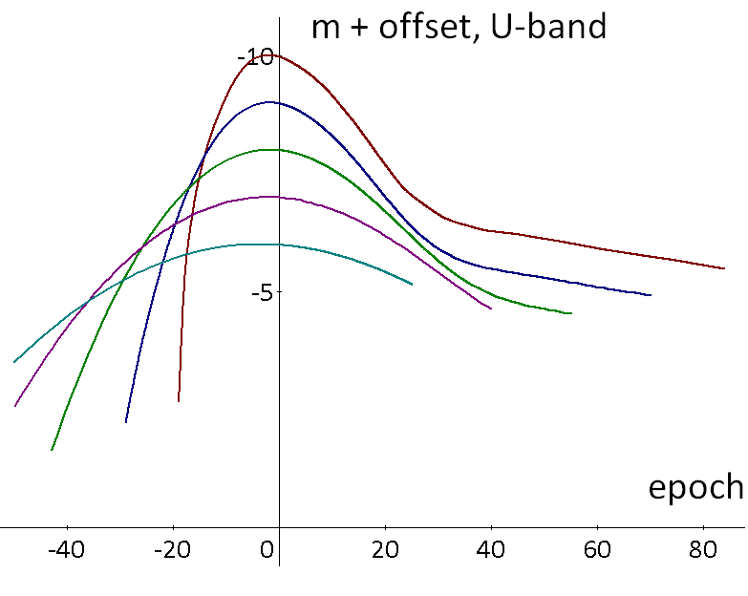
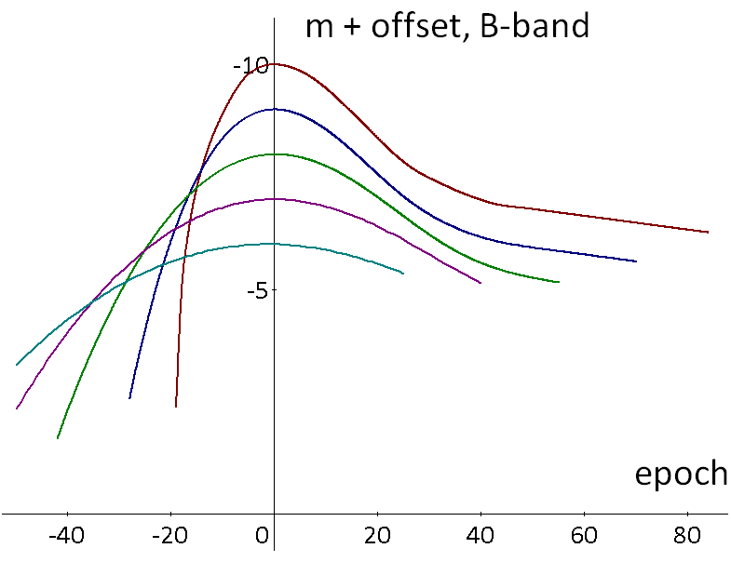
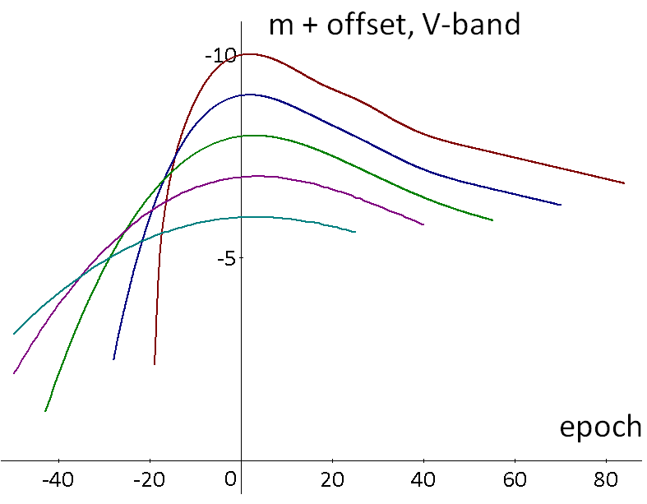
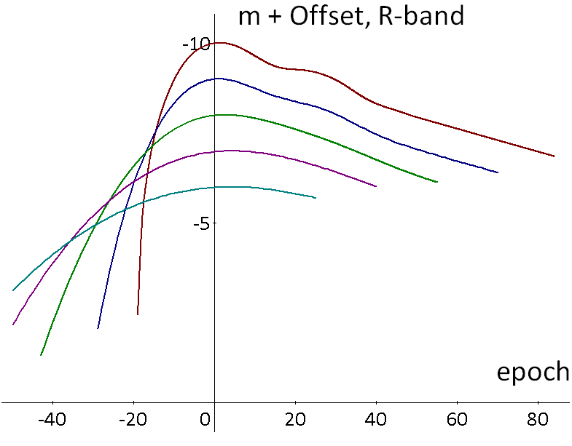
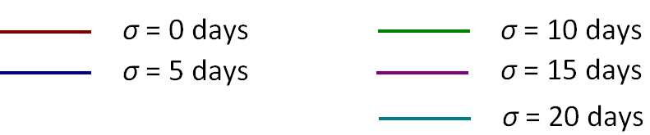

Fig. 1. The magnitude light curves in non-shifted UBVR bands
The width-factor w of timescale stretching was determined as a ratio between light curve widths with non-zero and zero standard deviations. The measurements were taken for rising and falling fragments of the light curve as well as for the whole curve at certain magnitude offsets (Δm) from maximum.
The measurement results in graphical form are shown in Figure 2 in form of dependency of width-factor w on standard deviation of travelling time σ for various fragments and magnitude offsets.

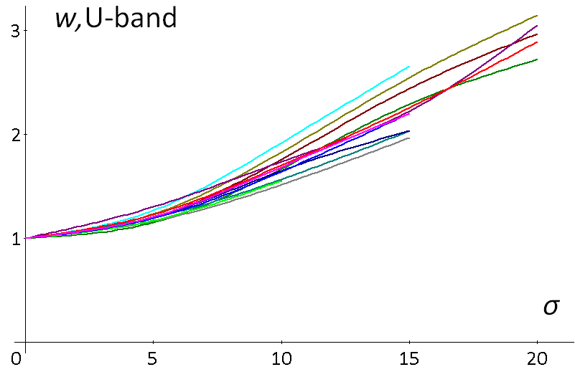

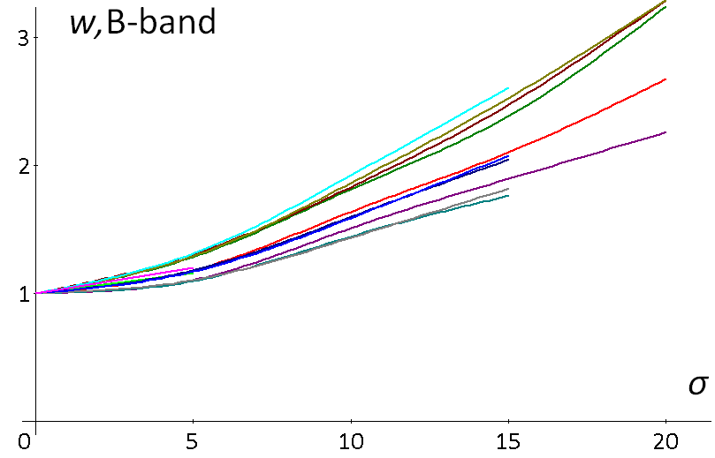

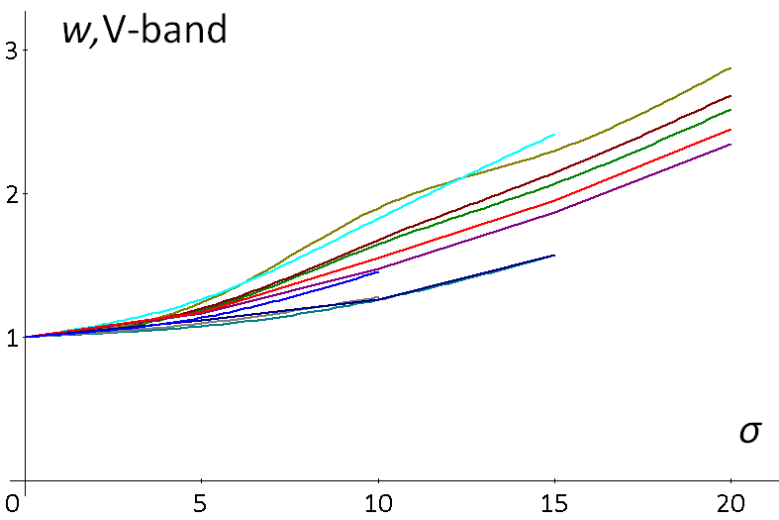

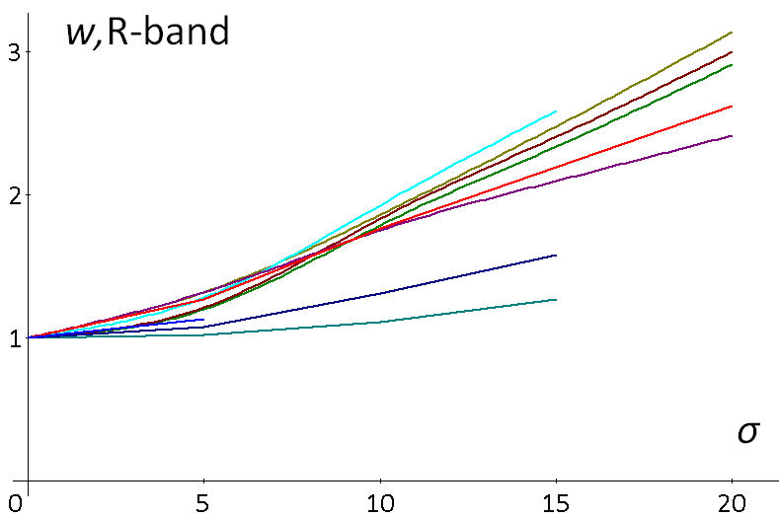

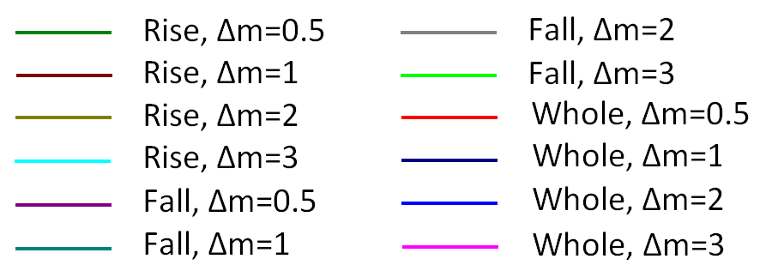

Fig. 2. Dependency of width-factor on standard deviation of photons travelling time in non-shifted UBVR bands

The width-factor measurements presented in Figure 2 show that timescale stretching is not universal in tired light model. It varies depending on the band, magnitude offset and the fragment of a light curve. This contradicts to the results reported by Goldhaber et al. [1]. The Goldhaber group was analyzing timescale stretching of Type Ia supernova light curves in B-band using the method of Composite Light Curve on the basis of photometric measurements of 12 low redshift supernovae from Calán/Tololo Survey and 35 high redshift supernovae reported by The Supernova Cosmology Project (SCP). They found it remarkable that the final composite light curve (Figure 1f in [1]) appeared homogeneous. This result was presented as proof of the universality of timescale stretching. The intermediate transformations applied while building the composite light curve were based on the values of width-factor w and stretch-factor s measured by Perlmutter et al. [10] for the SCP high-redshift supernovae. The Perlmutter group has measured light curve widths, width- and stretch-factors by fitting observed photometric points to B-band light curve template and applying timescale stretching factor 1+Z universally. No wonder why Goldhaber's composite light curve looks so homogeneous. In simple words the logic of the Goldhaber group can be expressed like this: If A is true then A is true, therefore A is correct. The proof of the universality of timescale stretching based on such logic cannot be accepted.
The light curves for UBVR bands in terms of normalized flux are shown in Figure 3. The flux is normalized to the unity of flux maximum at zero redshift.

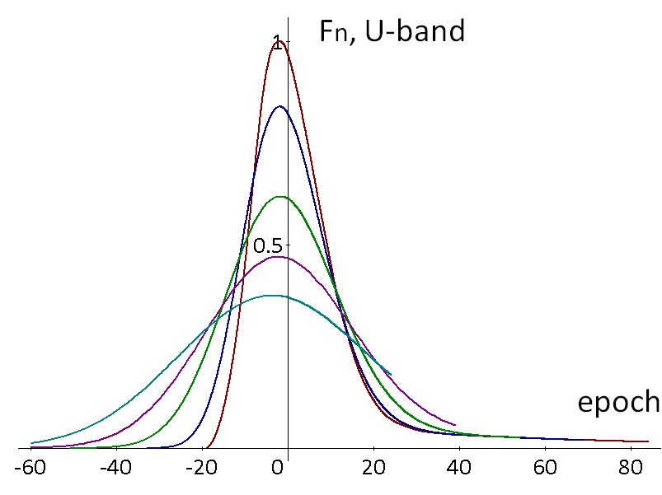
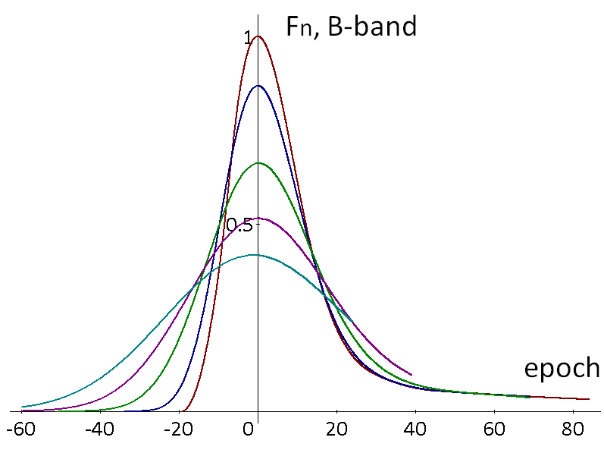
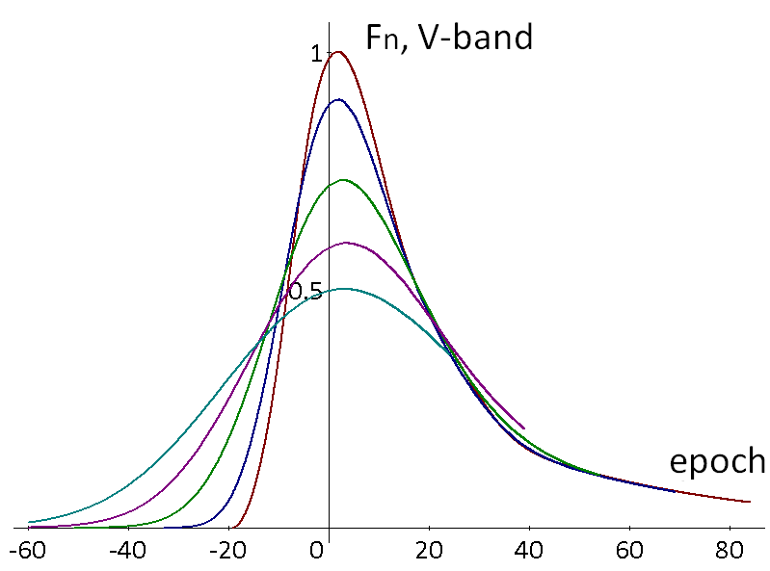
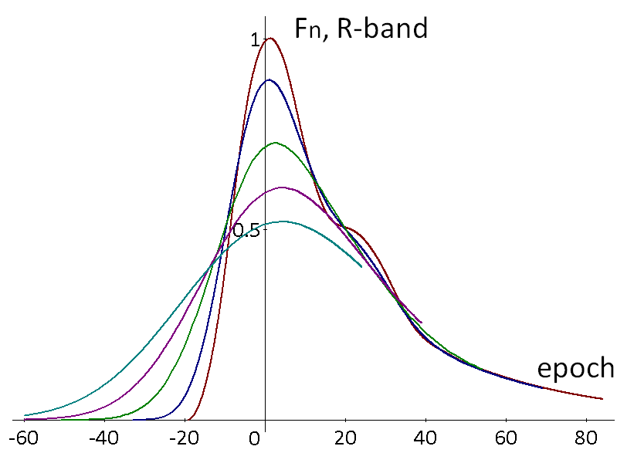
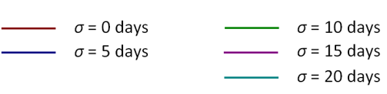
Fig. 3. Normalized flux light curves in non-shifted UBVR bands

Light curve broadening in IYJHK bands

The magnitude light curves (non-shifted) for various standard deviations in IYJHK bands are shown in Figure 4 with some magnitude offset.

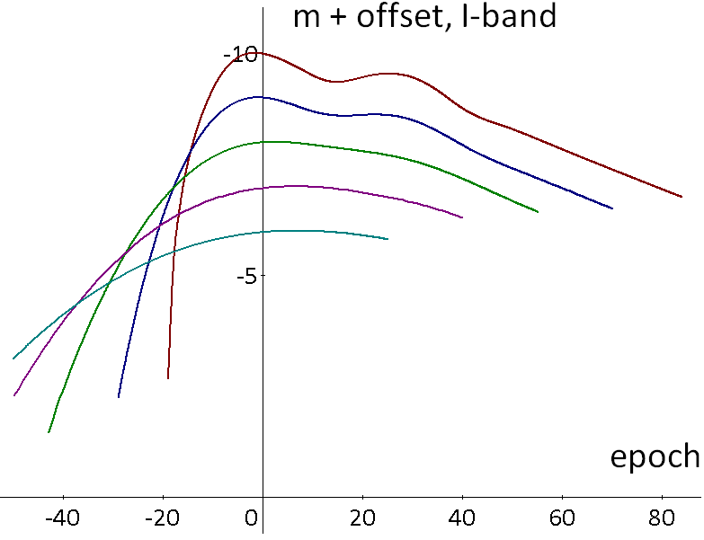

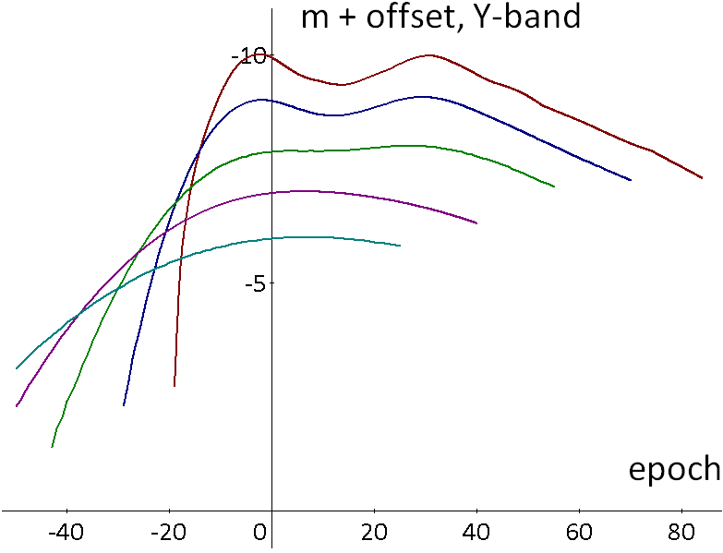

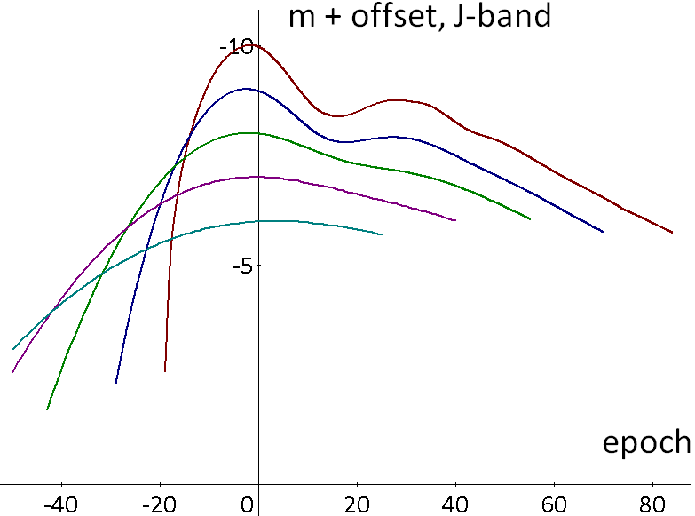

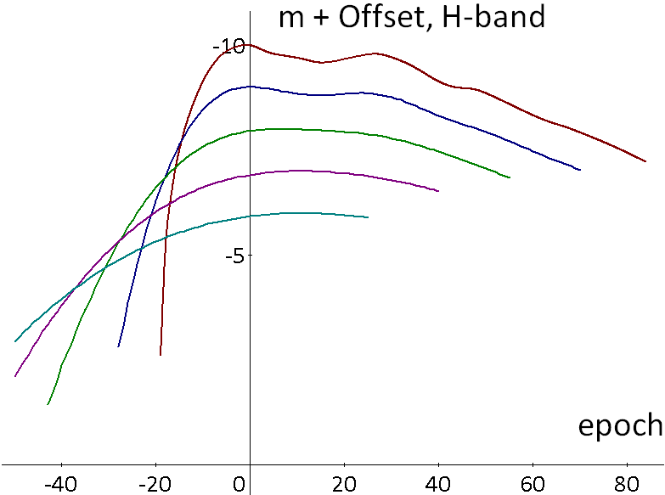

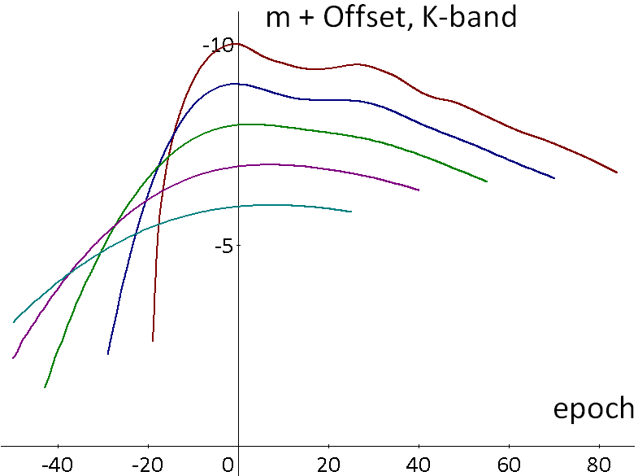

Fig. 4. The magnitude light curves in non-shifted UBVR bands

Width-factor for light curves in IYJHK bands cannot be measured separately for rising and falling parts as two maximums in a curve gradually transform into one with the increase of standard deviation of travelling time. So the width-factors were determined by measuring the total width. The results are presented in Figure 5.

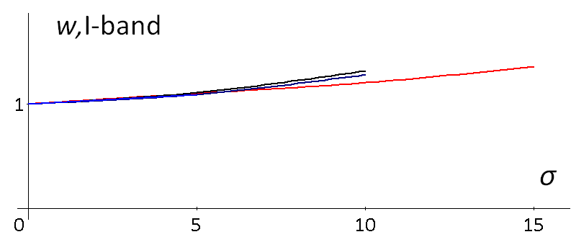

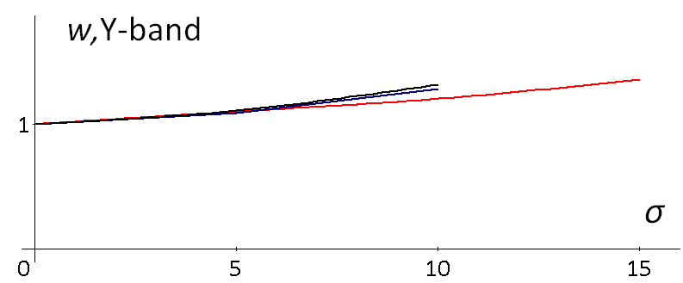

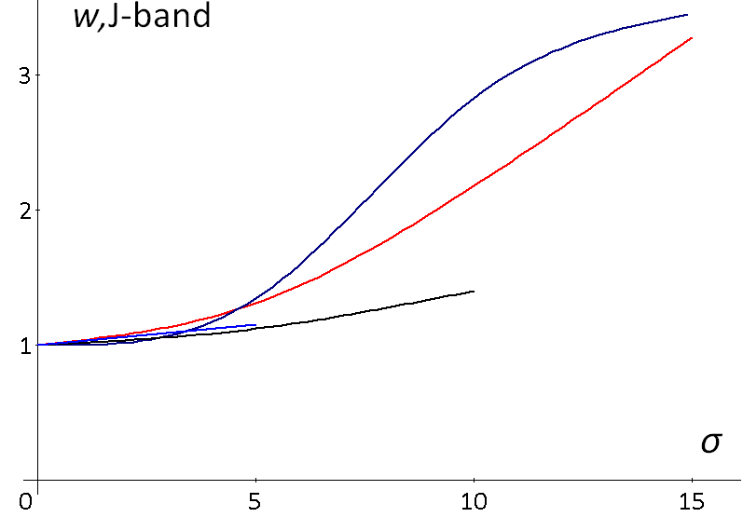

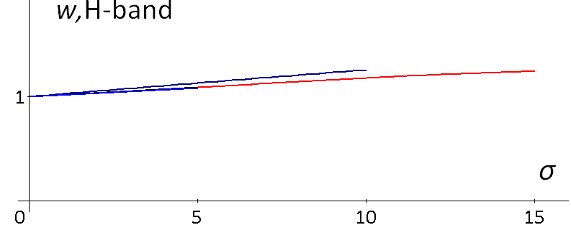

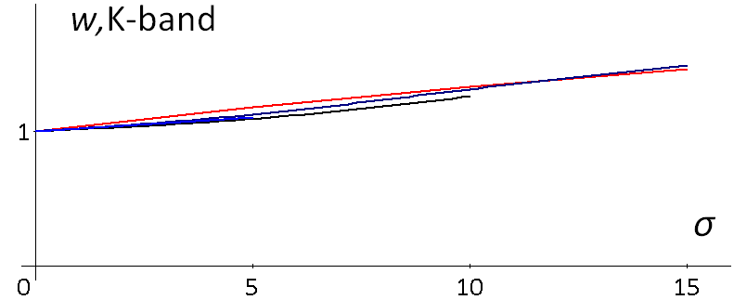
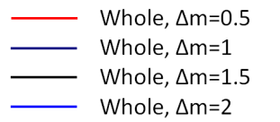

Fig. 5. Dependency of the width-factor on standard deviation of photons travelling time in non-shifted IYJHK bands

The light curves for IYJHK bands in terms of normalized flux Fn are shown in Figure 6. The flux is normalized to the unity of flux maximum at zero redshift.

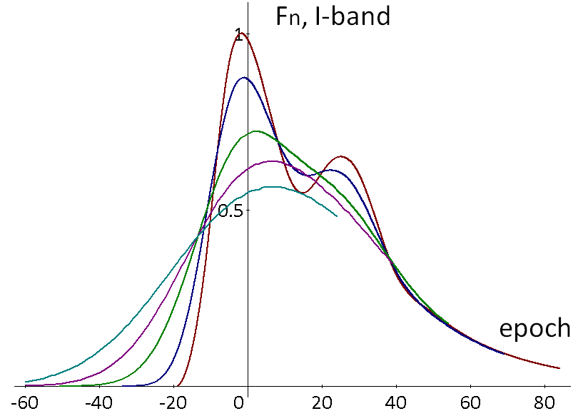

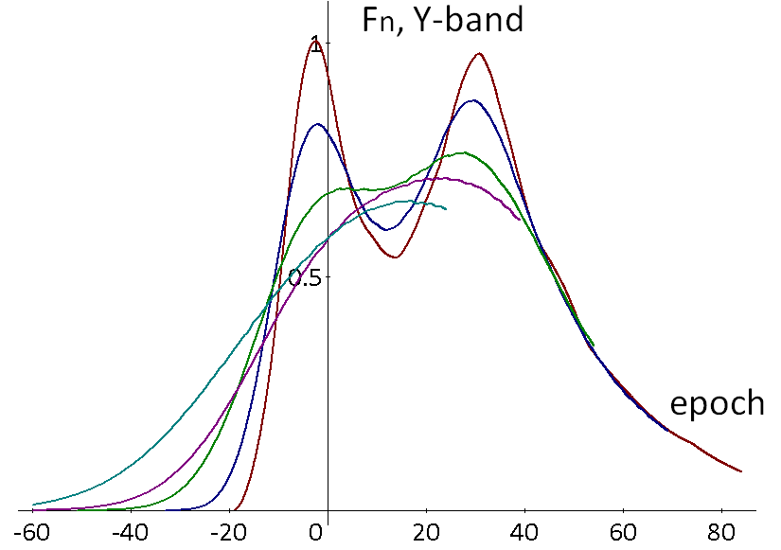

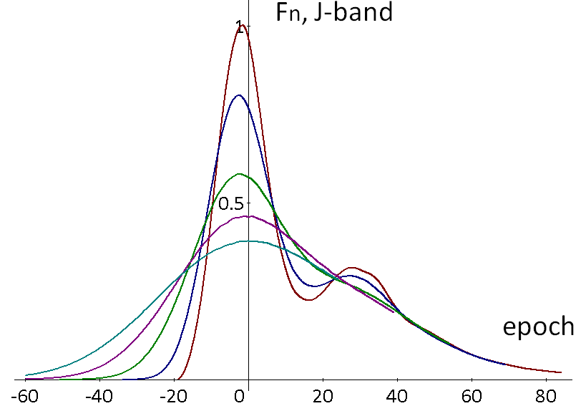

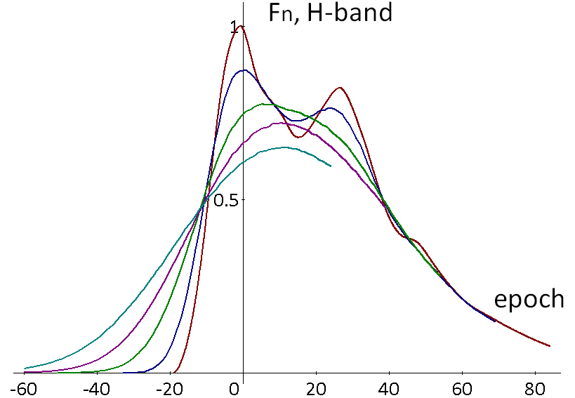

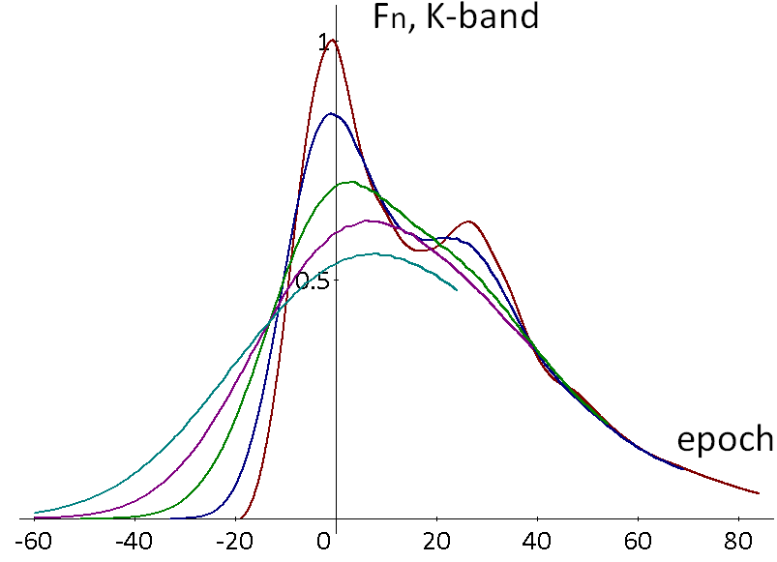

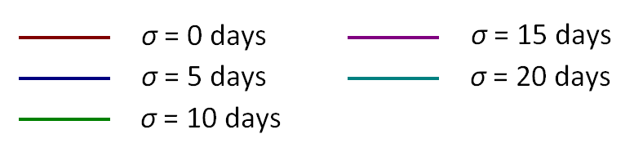

Fig. 6. Normalized flux light curves in non-shifted IYJHK bands

Figures 4 and 6 show that with the increase of the standard deviation of travelling time, the second maximum gradually disappears from the IYJKH light curves. This can be used as a good test for the validity of tired light paradigm.
In order to validate this result against available observations I reviewed photometric measurements in non-shifted (”at rest”) I-band for 21 high-Z supernova available at The Carnegie Supernova Project web-site [19]. None of the SNs have photometric measurements that provide clear indication of the presence or absence of the second maximum. One may consider SN 05D4cw as matching a light curve template with two maximums but on the other hand it has only three photometric points.
The photometric observations in infrared and near-infrared bands available today for high-Z supernovae cannot be used to confirm or rule out the tired light hypothesis. These measurements should be more systematic and have better frequency and accuracy. However, it is possible to say that at least the tired light hypothesis does not contradict to available observations in infrared and near-infrared bands.

Spectra Aging
In the presented tired light model the photons issued at the same time will reach the observer on different days. This means that the observed spectra will differ from the original. The conducted simulation study shows that with the increase of standard deviation of travelling time the spectrum gets more blurry but still remains recognizable as Type Ia. Figure 7 shows spectrum at epoch 0 for various values of σ.

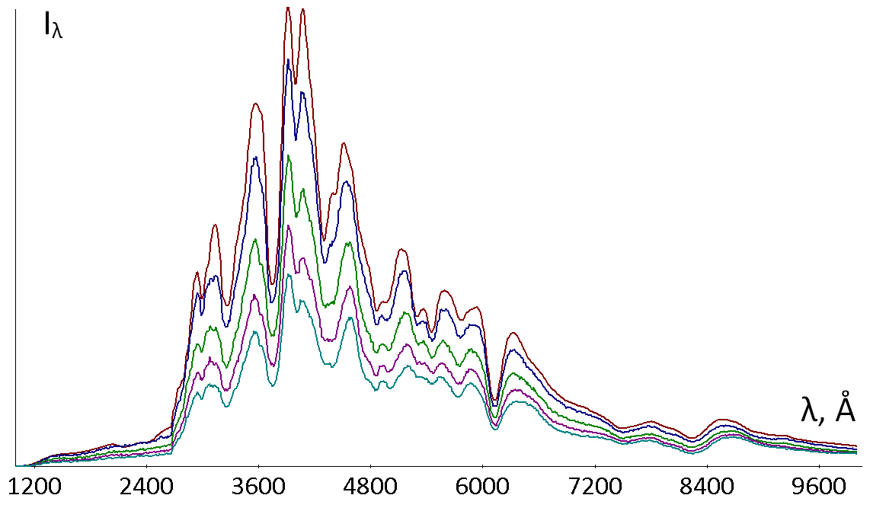

Fig. 7. Spectra for different σ at epoch 0

The fact that the spectra remain recognizable makes it possible to conduct spectra aging study using the approach suggested by Blondin et. al [2]. In order to do that I have normalized each epoch spectrum of certain standard deviation to the unity of maximum spectral flux density at this standard deviation. The wavelength r range for the spectra is from 3000Å to 7000Å. Then I matched normalized spectra of each epoch at σ>0 to normalized spectra of each epoch at σ=0 using the least square method. The results of the matching process are shown in Figure 8. The software that I have developed for matching spectra is available for download as open source and freeware [20].

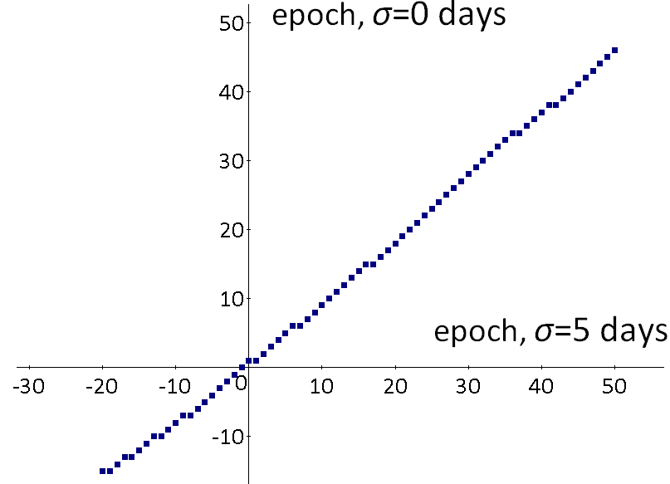

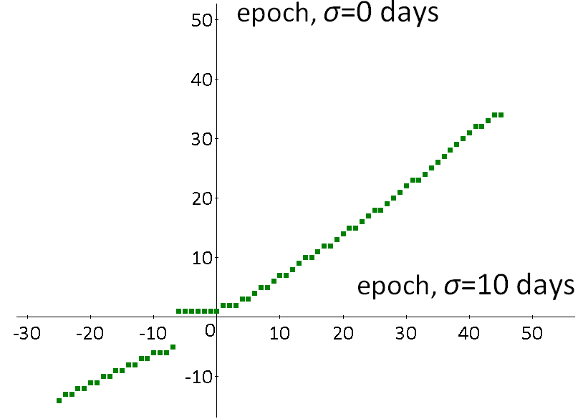

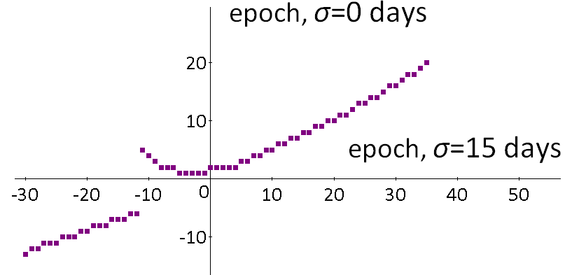

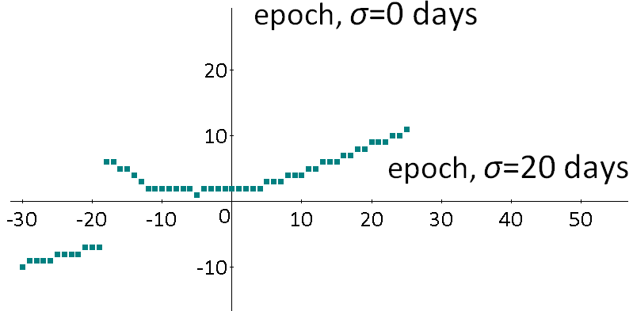

Fig. 8. Matching spectra for different σ

Blondin et al. matched spectra for epochs in the range from 0 to 30. The results of matching the simulated spectra after epoch 0 are shown in Figure 9.

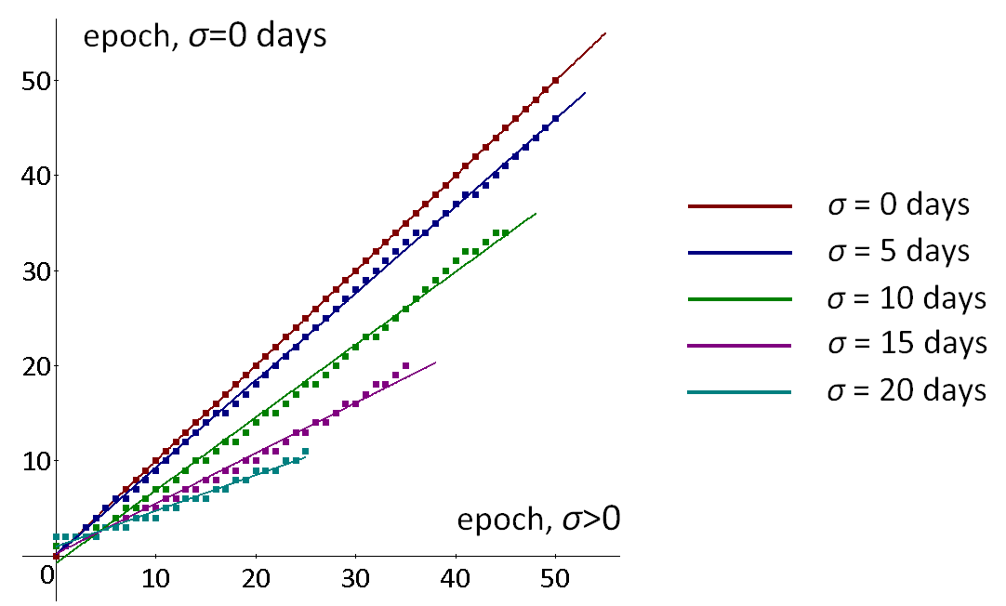

Fig. 9. Matching spectra after epoch 0

The matching points fit to right lines very well, which indicates that the tired light model is in consistence with the results of Blondin et al.
The significance of the results of spectra aging study conducted by Blondin et al. is that they were obtained without applying any subjective fitting. According to Blondin et al. the linear coefficient k of matching line is related to redshift as k=1/(1+Z). Assuming that the results of Blondin et al. are correct it is possible to establish relation between Z and σ. To be precise, it is not known if σ is the same for all wavelengths. So in this relation σ should be regarded as weighted average for the range 3000...7000Å. The relation between Z and σ is shown in Table 1 and Figure 10.

Table 1. The relation between redshift z and standard deviation of travelling time σ

σ | k | Z
0 | 1.000 | 0.000
5 | 0.917 | 0.090
10 | 0.766 | 0.305
15 | 0.529 | 0.890
20 | 0.376 | 1.657

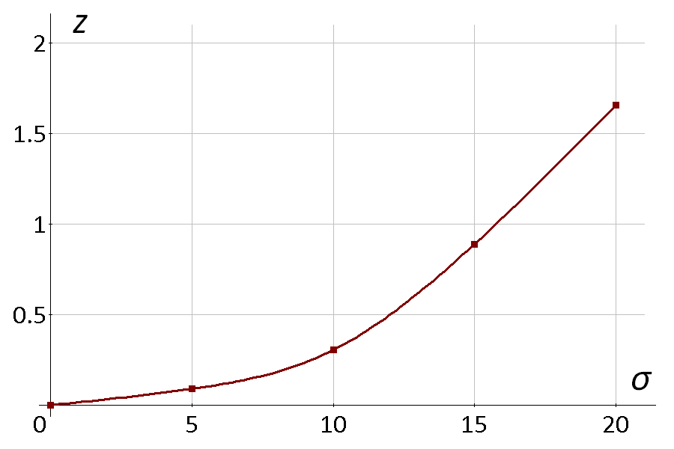
Fig. 12. Dependency of redshift on weighted average of σ

Discussion
The redefined tired light model suggests the mechanism explaining timescale stretching effects for Type Ia supernovae. The conducted simulation study shows that observations related to light curve broadening as well as for spectra aging do not contradict to the tire light model. Therefore ruling out the tired light model suggested by modern cosmology is not justified. Tired light has the following advantages over the “expanding Universe” model.

- It returns physical meaning to light as waves in medium.
- Eliminates the need for mysterious “dark energy”
- Eliminates absurdity of superluminal velocity (relative to Earth) for the stars with redshift Z>1
- It is aligned with Tolman test which shows that Universe does not expand [21][22].

In order to confirm or rule out “tired light” or “expanding Universe” model by timescale stretching effects for Type Ia supernovae, the directions of further research should be the following:

- Universality of stretching parameter should be tested for different bands, fragments of light curve and magnitude offsets without fitting to universally stretched light curve templates.
- Systematic observations are required to detect presence/absence of the second maximum in infrared and near-infrared bands for high-Z supernovae.
- On determining the type of high-Z supernova, the absence of the second maximum should not be used as a criterion of categorization.
- Spectra aging study should be conducted for epochs before 0.
- Expanding spectra template for Z=0 at least up to 120 epochs after 0 will extend simulation results for tired light model.

References
[ 1 ] G. Goldhaber et al., “Timescale Stretch Parameterization of Type Ia Supernova B-band Light Curves”, The Astrophysical Journal, vol. 558:359-368 (2001)
[ 2 ] S. Blondin et al., “Time Dilation in Type Ia Supernova Spectra at High Redshift”, The Astrophysical Journal, 682:724-736 (2008)
[ 3 ] F. Zwicky, "On the Red Shift of Spectral Lines through Interstellar Space", Proceedings of the National Academy of Sciences of the United States of America, 15:773-779 (1929)
[ 4 ] P. Marmet, “A New Non-Doppler Redshift”, Physics Essays, 1:24-32 (1988)
[ 5 ] L. Ashmore, “Recoil Between Photons and Electrons Leading to the Hubble Constant and CMB”, Galilean Electrodynamics, 17, 53-57 (2006)
[ 6 ] G. Corriveau, "The 3K background emission, the formation of galaxies, and the large-scale structure of the Universe", Physics Essays, 5:39-43 (1992)
[ 7 ] A. Brynjolfsson, “Redshift of photons penetrating a hot plasma”, arXiv:astro-ph/0401420v3 (2004)
[ 8 ] C. S. Chen et al, "Investigation of the mechanism of spectral emission and redshifts of atomic line in laser-induced plasmas", Optik - International Journal for Light and Electron Optics, 120:473–478 (2009)
[ 9 ] K. Khaidarov, “Eternal Universe”, viXra:1302.0153 (2003)
[ 10 ] S. Perlmutter et al., “Measurements of Ω and Λ from 42 High-Redshift Supernovae”, The Astrophysical Journal, 517:565-586 (1999)
[ 11 ] K. Khaidarov, “Temperature of Aether and Redshifts”, Borovoe, (2005), http://bourabai.kz/redshifts-e.htm
[ 12 ] A. Chepick, "Supremum of the Interaction Speed of the Matter", Spacetime & Substance, 82:122-124 (2002)
[ 13 ] A. Chepick, "Explanation of width- and stretch-factors for Type Ia Supernovae" (2002), http://redshift0.narod.ru/Eng/Stationary/Redshift/S_factor_En.htm
[ 14 ] H. Holushko., Simulation Software SNSim, http://www.holushko.net/TiredLight/SNSim.zip
[ 15 ] E. Hsiao et al., “K-Corrections and Spectral Templates of Type Ia Supernovae”, The Astrophysical Journal, 663:1187-1200 (2007)
[ 16 ] Eric Hsiao Page, Spectral Template of Type Ia Supernovae,
http://supernova.lbl.gov/~hsiao/uber/hsiao_template.tar.gz
[ 17 ] The MONET Project. Available Filters, http://monet.uni-goettingen.de/foswiki/MonetObserving/Filters
[ 18 ] Large Binocular Telescope (LBT) Mount Graham International Observatory. Filters LUCIFER1, http://www.lsw.uni-heidelberg.de/users/agermero/calculator/docu_html/ node29.htm
[ 19 ] The Carnegie Supernova Project. High-z CSP Supernovae http://obs.carnegiescience.edu/CSP/data/highzSNel
[ 20 ] Herman Holushko, Software for matching spectra SpectraAging, http://www.holushko.net/TiredLight/SpectraAging.zip
[ 21 ] D. S. L. Soares, “Sandage versus Hubble on the reality of the expanding universe” (2008), arXiv:physics/0605098v3
[ 22 ] E. J. Lerner, “Evidence for a Non-Expanding Universe: Surface Brightness Data From HUDF”, AIP Conf. Proc. 822:60-74 (2005), arXiv:astro-ph/0509611v2

