The point of unification in theoretical physics
James E. Beichler
PO Box 624, Belpre, OH 45714
e-mail: jebco1st@aol.com

It would seem to many physicists that the unification of physics within a single paradigmatic theory has been the primary goal in science for only the past few decades, but this would not be true. Unification was the original goal of Einstein and a few other physicists from the 1920s to the 1960s, before quantum theorists began to think in terms of unification. However, both approaches are basically flawed because they are individually incomplete as they now stand. Had either side of the controversy just simplified their worldview and sought commonality between the two, unification would have been accomplished long ago. The point is, literally, that the discrete quantum, continuous relativity, basic physical geometry and classical physics all share one common characteristic – a paradoxical duality between a dimensionless point and an extended length in any dimension – and if the problem of unification is approached from an understanding of how this problem relates to each paradigm all of physics could be unified under a single new theoretical paradigm.

Introduction
Every physical theory since the days of the ancient Greek philosophers has fallen prey to the same problem: What is the difference between a point and an extension in space or time? General relativity describes matter and energy as a metric of curvature, yet the theory falls apart at various singularities. Quantum theorists debate whether particles are extended bodies or dimensionless points. So both views are unique but suffer from similar problems. The Standard Model of particles is based upon the reality of point particles, as are the quantum loop and superstring theories, but all such theories suffer from the same fundamental problem – how can dimensionless point particles be extended to account for the three-dimensional space?
On the other hand, there is as yet no theorem or method, whether mathematical or physical, that can be used to generate an extended space of any dimensions, let alone our common three-dimensional space, from individual points. Yet it is generally understood in geometry that every continuous line contains an infinite number of dimensionless points. Modern mathematics contains many continuity theorems that prove this very fact. At best, modern mathematicians have only partially overcome this difficulty in calculus, the mathematics of change and motion, by defining a derivative at a point as a limit rather than a reality. The metric differential geometry of Riemann, upon which general relativity is based, takes advantage of a similar mathematical gimmick and only addresses the curvature of n-dimensional surfaces that approach zero dimension or extension without ever reaching that limit. Even the Heisenberg uncertainty principle falls victim to a variation of this same difficulty. The uncertainties in position and time can never go to zero since the corresponding uncertainties in momentum and energy will become infinite. These similar difficulties define the central problem of physics and unification.
Quantum theory, relativity theory and classical theories in physics and mathematics are not so different when viewed within this context as is generally thought. The evidence is clear; the question of how points in physical space are able to form dimensionally extended lines, surfaces or measurements must be discovered before unification in physics can be completed. Both relativity and the quantum theory work and they both work very well as they are, so they are both equally fundamental and necessary to any new unified theory. Neither theory is more fundamental than the other. Recognizing and accepting this equality is the second step toward unification. Once the fact that both paradigms are prone to the same problem in the concept of a point is accepted, solving this problem will become the rallying point for unification. That is the only possible point where unification can occur in theoretical physics.
Toward that end, it will be shown that an extended geometry can be constructed from individual dimensionless points under special conditions. The resulting theorem in physical mathematics gives a great deal of insight into both the physical origins and meaning of the quantum as well as its relationship to relative space and time. The method used is actually implied in Riemann’s [1] original 1854 development of the differential geometry of surfaces as well as elsewhere in physics and mathematics. This theorem generates a three-dimensional space with exactly the properties observed in our commonly experienced three-dimensional space and could thus be considered a physical reality theorem.

The central problem of physics

2.1. Point mathematics
Calculus and other methods of calculation used in all of physics ultimately depend upon a rigorous mathematical definition of instantaneous velocity or speed.
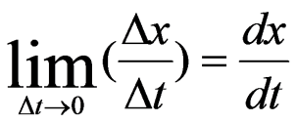 (1)
This definition depends on two fundamental ideas: (1) a moment or instant of non-zero time must exist; and (2) space and time are unbroken continuities that emerge from an infinite number of connected dimensionless points. This notion differs from the discrete in quantum theory in that space and time cannot be discontinuous although a quantum limit within the context of either the uncertainty in momentum or the uncertainty in energy could be approached. This situation creates a logical paradox that has gone completely misinterpreted in science, where mathematics is accepted completely and wholly as applicable to physical situations without question or limitations. In other words, there seems to be a gross conceptual divide between the mathematical system of calculus and Heisenberg’s interpretation of reality. Otherwise, quantum mechanics and other quantum models are considered completely non-geometrical.
Space-time theories in general assume extension-geometries, while general relativity is based on the concept of a metric extension in which the slope or the amount of curvature of space can be determined as a small volume of three-dimensional space shrinks and approaches the zero point limit.
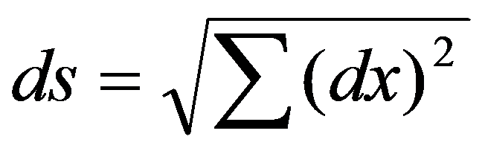 (2)
Put another way, while both geometry and calculus use extensions to explain the concept of a point or use an extension-based geometry to explain space itself, no method or logical argument by which points in space could generate extensions, let alone the extension-based geometry necessary to represent the concepts of space and time, exists. The closest method that exists in science is the quantum method of perturbation which merely smears a dimensionless point over an already existing three-dimensional space. This quantum method gives rise to such misconceptions as a fuzzy point, quantum foams and quantum fluctuations to explain the continuity of the lowest possible level of reality.
A mathematical method of generating an extended space or time from points should have been developed long ago since the inverse logical argument is a necessary requirement for mathematical rigor in both geometry and arithmetic (calculus), but such a method has never been developed. The problem has never even been identified or discussed by mathematicians. This oversight creates a gaping hole in mathematical logic, to put it lightly, especially in cases where it applies to physical realities such as our commonly experienced three-dimensional space.
The solution to this problem would be to develop a mathematical theorem that guarantees the physical reality of any given space if that space can be generated from dimensionless points. However, there remains a single barrier to doing so. To form a continuous extension, two points must at least be contiguous, i.e., making contact or touching, but that would be impossible. So the major obstacle to solving this problem is how to define continuity relative to contiguity. A conceptual definition of contiguous dimensionless points must be established before continuity can be assured. Yet two dimensionless points could never be made contiguous by contact because contact would render them ‘overlapping’ or coincident simply because they are dimensionless. However, there is a way to indirectly solve this abstract mathematical paradox: Two independent dimensionless points could only be considered contiguous without actually depending on contact between them if and only if they were so close that no other dimensionless point could be placed between them to separate them. This situation is hard to imagine, but the concept is mathematically and logically valid.
Take two dimensionless points, A and B, in close proximity to each other. In order to generate a one-dimensional continuous extension from them, these two points must find positions contiguous to each other. But having no dimensions in themselves for reference as to their relative positions to each other, this cannot be accomplished. However, they are only restricted to being dimensionless in the dimension(s) they share in real three-dimensional space.
According to Gödel’s [2] theorem, all that can be proven within a system is the internal consistency of that system. The validity (truth) of that system can only be determined logically from outside of the system. So, all that present mathematics or physics can determine – prove or verify in either case – is the logical consistency of the system based upon their theorems and/or theories of the three-dimensionality of space. A reality theorem in physical mathematics would therefore necessitate a higher four-dimensional embedding space (manifold) to guarantee that the three-dimensioned space could be generated from dimensionless points. This very solution to the problem is implied in Riemann’s original development of the concept of space curvature whereby an n-dimensional space is embedded in an n+1-dimensional manifold.
If perpendicular lines in the external embedding direction are from both contiguous points A and B, these lines would normally remain parallel and a distance AB apart in the embedding direction no matter how far they are extended. This does nothing to verify the reality of the three-dimensional space.
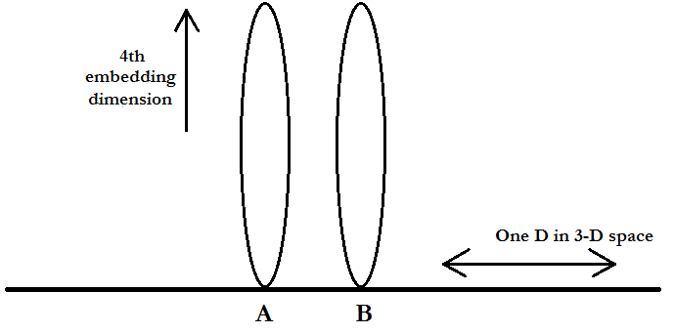
However, if the three-dimensional space is internally curved in a second dimension, then the lines drawn from the dimensionless points would draw closer three-dimensionally the further they are extended in the fourth direction. This method thus requires the minimum of a two-dimensionally curved one-dimensional line in a further embedding space (manifold) to distinguish reality. Once the extended lines in the embedding direction have moved at least as far as the infinitesimal distance AB between them they would meet.
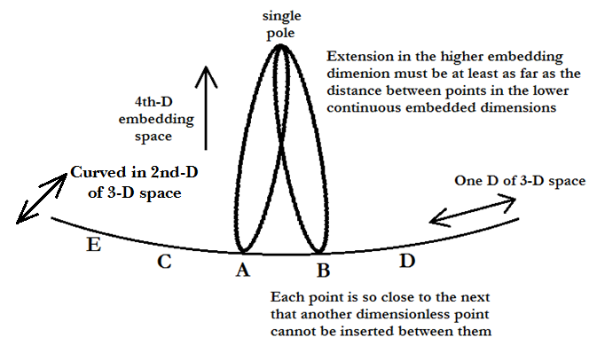
The extensions in the fourth direction would then turn back to the other side of the three-dimensional space and return to the points from which they originated, maintaining and guaranteeing continuity of the dimensionless points in three-dimensional space.
Another point C is contiguous to A and lies at the same infinitesimal distance from A, but in the opposite direction in three-dimensional space. Under the same procedure, C and A would also coincide at one point in the embedding direction that is at least equal to or greater than the infinitesimal distance between them in three-dimensional space. In fact, A, B and C will all come together at the same point in the embedding direction. If two more points to either side of B and C are added – designated as D and E – they would also coincide at the same point in the fourth direction. Eventually an infinite number of points to either side of B and C would converge and form a closed space in one of the three-dimensions of three-dimensional space. All of these points would coincide at the same point in the higher fourth dimension of space.
When the same procedure is conducted for the other two dimensions of three-dimensional space, all points extended in the fourth direction of space would coincide at a single point that is at least as far from three-dimensional space as the sum of an infinite number of infinitesimal distances that separate the infinite number of points that make up the closed three-dimensional space. The real three-dimensional space that is formed by this logical procedure would be internally double polar spherical, but the embedding higher-dimensional space would be single polar spherical and at least as large as all of the dimensions in the real closed three-dimensional space. This single polar structure has important and previously unrecognized consequences for physics. This embedding space is exactly the type of physical hyperspace proposed by William Kingdon Clifford [3] and envisioned by other mathematicians in the late nineteenth century after they had been introduced to Riemann’s generalized differential geometry.

2.2. Point physics
This type of structure for the embedding space (Riemann’s manifold concept) is clearly implied in the classical electromagnetic concept of the magnetic vector potential. The vector potential is defined as B=del cross A, where B is the magnetic field strength and A is the vector potential. The del function or operator is defined as
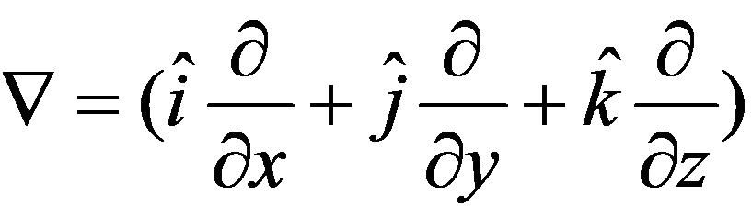. (3)
As this equation indicates, the del function operates in all three dimensions of space simultaneously, so its cross product with the vector potential A yields the magnetic field B in three-dimensional space. Therefore A must be perpendicular to all three dimensions of normal spaces simultaneously and thus extended in the fourth dimension of space.
Electromagnetic theory describes two different types of fields, the electric field E and the magnetic field B, that coexist but are interdependent. Both fields are three-dimensional, but each is directionally different in normal space. The E field interacts with charged bodies radially toward a center point, but B interacts with moving charges centripetally around the central point yielding the combined force as described by the Lorentz equation:
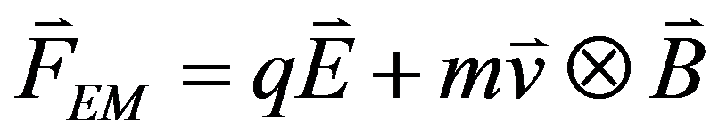. (4)
The cross product in the second term implies a four-dimensional component as compared to the three-dimensional components of the first term. The scalar E field is similar to the scalar gravitational field in that they are both radially directed and can be expressed by metric or extension geometries. However, a metric geometry cannot be used to describe the vector potential since the second term is centripetally directed around a point center; hence the force is derived from the cross product. Instead, a point-based geometry is implied by magnetism.
The physical role of point geometries was first noted by William Kingdon Clifford [4,5] in the 1870s. Clifford [6] is better known for ‘anticipating’ general relativity by stating that matter is nothing but curved space and the motion of matter is nothing but variations in that curvature. Yet when he developed his theory of matter, he did not use Riemannian geometry and he shied away from gravity, instead working toward a theory of magnetic induction based on an hyperspatial point geometry of his own design using biquaternions. His biquaternions represented magnetic vector potentials extended in the fourth dimension of space. Clifford’s theoretical work is all but forgotten today, but it did influence the further development of geometry by Felix Klein [7], who published his version of Clifford’s geometry after Clifford’s early death, and Élie Cartan [8] who developed a point geometry of spinors based on Clifford’s efforts and later developed [9] his own physical unification model. Cartan’s geometry was then used by Einstein [10] in his 1929 attempt to unify general relativity and electromagnetic theory, utilizing a concept called distant parallelism.
A group of Russian scientists have since tried to revive the 1929 Einstein-Cartan geometric structure of space-time to describe a new form of gravity based on the concept of a torsion field [11]. This concept is also related to the efforts of scientists to develop a concept of gravitomagnetism based on an equation first written by Oliver Heaviside [12] in 1893.
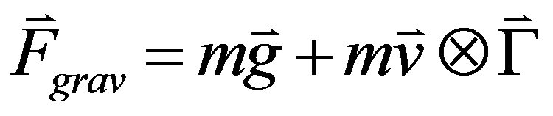 . (5)
Heaviside only came upon this formulation through an analogy between electromagnetism and gravity rather than any new theoretical insights. All of these scientists have been unknowingly trying to reinterpret gravity in terms of some form of combined point/extension geometry, but they have missed the point of unification by not placing their interpretation of these equations in those terms.

Standard unification models
Modern quantum unification theories do not really try to unify gravity theory (either Newtonian or relativistic) and the quantum in as much as they try to completely replace general relativity and classical physics. However, doing so would be impossible since the quantum theory is incomplete with regard to gravity. It simply ignores any possible effects of gravity at the quantum level of reality. Therefore, unification on the basis of the quantum would be more of an overthrow or coup d’état of the relativity paradigm. This attitude is so deeply ingrained in the quantum worldview that the large particle colliders designed to verify certain aspects of the quantum theory do not take gravity into account and their results should therefore be suspect. Quantum theorists just assume that the quantum theory will eventually explain everything, but simply identifying the carrier particle of gravity as a graviton and assuming it will eventually explain gravity does absolutely nothing to explain gravity or unify the quantum and relativity.
For his part, Einstein envisioned the four-dimensional space-time continuum of our world as a unified field out of which both gravity and electromagnetism emerged. He further hoped that the quantum would emerge as an over-restriction of field conditions. However, from the perspective of the fourth spatial dimension the four-dimensional expanse is filled with a single field of potential that is the precursor to everything that exists in three-dimensional space – gravity, electricity, magnetism, matter, quantum, life, mind and consciousness. These physical things are just different aspects of field interactions modified by the physical constants that describe the nature of the single unified field.
This worldview introduces a certain duality to our existence that has already been discussed to some extent in science as wave/particle duality. Its nature as an unsolvable but necessary paradox has dominated the scientific debate for several decades. Einstein, Bohr, Heisenberg, and Schrödinger as well as other scientists have all fallen prey to the duality of worldviews, although it is perhaps more accurate to say that they have been held prisoners by it. This duality, whether it is called yin and yang, male and female, or certainty and uncertainty, is built into the very fabric of space-time. In physical geometry, this duality takes the form of the difference between a space made from dimensionless points and one made from extensions.
The four mathematical conditions that yield a three-dimensional space that is similar in characteristics to our normally experienced space are quite straightforward. The first two are easily recognized: (1) a one-dimensional line extending in the fourth direction from a dimensionless point in three-dimensional space (Kaluza’s A-line) must form a closed loop; and (2) all such lines must be of equal length. These are the same mathematical conditions that Theodor Kaluza [13] placed on his five-dimensional extension of general relativity in 1921. Oskar Klein adopted the Einstein-Kaluza structure in 1926 [14] in the first of his several attempts to quantize general relativity. The subsequent Kaluza-Klein physical model of space-time was adopted and expanded by the superstring theorists in the 1980s. Consequently, all such physical models of space-time suffer from the fact that they are incomplete without considering the other two conditions describing the higher embedding dimension.
The third and fourth conditions are not so readily recognized, at least not for the last century. These ideas were popular in the late nineteenth century when scientists first searched for curved space in the distant stars. Otherwise, the conditions are straight forward: (3) The lines extending into the higher dimension must be at least as long as the longest possible circumference line encircling three-dimensional space; and (4) All such lines must pass through a single common point or pole. This means that the fourth dimension of space must be macroscopically extended, just as Einstein and his colleagues [15, 16] proved in the 1930s, while the fourth dimension must have the geometry of a single-polar closed Riemannian surface. Each of the one-dimensional lines extended in the fourth direction of space (Kaluza’s A-lines) would work like a Möbius strip in that each and every point in three-dimensional space would have an inherent half-twist to it, without which rotational motions would be impossible in three-dimensional space. This idea is presently unknown in either science or mathematics.
Clifford envisioned this same structure for four-dimensional space in the 1870s, but the physical consequences imposed by these necessary conditions are far more important to modern physics. They rule out the possibility that the superstring theories which depend on infinitesimally small and compactified higher dimensions could possibly represent physical reality. All such physical theories and models, including the Standard Quantum Model of particles, are no more than highly accurate approximation methods that do not really portray material reality as it is because they cannot offer any rationale or method for the emergence of three-dimensional space from the dimensionless point-particles that they theorize. All quantum field theories suffer from this same problem.
The half-twist associated with each point of our real three-dimensional space means that rotations of extended lines around a central point are possible. In other words, three-dimensional space can be characterized by its support of either translational or rotational motions, which just happens to be observationally and experimentally true. Furthermore, the characteristic twist in each point easily accounts for the half-spin of elementary material particles and, in fact, establishes a requirement that all real material particles must have half-spins. Only protons, neutrons, electrons (muons and tauons) and neutrinos are real material particles, meaning, of course, that all of the geometrical points within the space they occupy are constrained by the half-spin, i.e., the point-lines extending into the fourth dimension are bundled together by the same half-spin. All other hypothetical particles are artificial constructions and temporary intermediate energy states characterized by spins of 0 and 1. In a strict philosophical and mathematical sense, all points in three-dimensional space correspond to each other and co-exist with one another since all points in three-dimensional space pass through the same single pole in the higher dimension. They all become one at the single pole. This single simple fact is more than sufficient to explain quantum entanglement.
Einstein’s [17] original gravity theory utilized a double polar Riemannian sphere to model gravity as four-dimensional space-time curvature, but he only considered curvature an internal or intrinsic property of the four-dimensional space-time continuum. In this case, Einstein’s positivistic leanings just got the better of him because he could have instead interpreted the curvature as extrinsic and thus requiring a fourth dimension of space without changing the mathematical model. Unfortunately, positivism was the dominant philosophical force in the earlier interpretations of both general relativity and the quantum theory. In both cases, positivism rendered both theories incomplete, misled advancing science and still does so. Furthermore, the Riemannian geometry that Einstein used is only a metric or extension-based geometry, which cannot possibly account for the physics of the individual points in space. Since classical electromagnetic theory implies the corresponding existence of both extension and point-based geometrical structures, all of his attempts to unify gravity and electromagnetism were incomplete from the start. But then Newtonian gravity only necessitates an extension-geometry, which also misled Einstein’s unification attempts.
This difficulty, however, does not mean that the task of unification is impossible. Quite the contrary. Einstein was on the right track when he adopted Kaluza’s five-dimensional space-time framework in the late 1930s as well as when he adopted Cartan geometry in 1929 and the symmetric/anti-symmetric tensor calculus [18,19] after 1945. All of these geometric systems offer a limited form of a combined point- and extension-geometric structure. But Einstein failed to realize two potential solutions. The first was that a combination of these two geometries through a Kaluza five-dimensional structure could lead to a single field theory. Secondly, Einstein never fully realized that the quantum could not possibly emerge naturally from an over-restriction of the mathematics as he hoped because the quantum is itself a fundamental and necessary property of the space-time continuum. Einstein’s model relied upon the fact and truth of a connection between space and time to form space-time, so the quantum, which can only be seen or accessed when changes in space and time are considered independent of one another, could never have emerged in Einstein’s mathematical researches. Planck’s constant is the binding constant for space and time
Put another way, the quantum is all about function (physical processes) and relativity is all about structure (form). Together they form a duality in which certain areas of physical reality overlap, but neither one can completely replace the other within our commonly experienced four-dimensional space-time continuum. Both are necessary to work together, but they can work independently under the proper conditions. For their part, modern quantum theorists do no better because they dismiss geometry altogether and in so doing they develop and rely on incomplete pictures of quantized processes. Function cannot exist without form. So they develop statistical excuses as a substitute or alternate mapping system to mistakenly replace the geometric structure of space-time. Statistical methods merely smudge out the dimensionless points of space and time into surfaces to establish an alternate mapping of space and time and thus mathematically mimic true geometric extensions.
Proponents on both sides of the debate – quantum theorists and relativists – need simply look at reality and analyze what they are doing in a serious critical manner to find the theoretical keys to unification. Then, and only then, will the method of unification become obvious. In reality there is no fundamental difference between the physics of Newton, Einstein, Bohr, Heisenberg, DeBroglie or Schrödinger that cannot be overcome. When the central problem is successfully identified, there is no real need for inventing artificial mathematical and physical gimmicks such as virtual particles, particles whose existence can never be verified, strings, superstrings, branes and many more dimensions of space than are necessary. Scientists have failed to realize why the difference between the quantum and relativity exists and have therefore missed the only solution of how to unify them.

The quantized space-time continuum
Physicists need to ask ‘what is the quantum and how, exactly, does Planck’s constant fit into our commonly experienced material world?’ In spite of all the grandiose successes of the quantum theory, many of the top theorists have admitted that they have no idea what the quantum is or what it all means. Without these last pieces of the puzzle, these questions cannot be adequately answered and unification cannot proceed any further than the past dismal failures of scientists.
The real conceptual discrepancy derives from the simple fact that the uncertainties in momentum and energy, as expressed in the Heisenberg uncertainty principle, are in themselves completely and totally fundamental physical quantities that need not be further reduced into more fundamental quantities such as mass, speed and time. The fundamental nature of momentum and energy are implied by the conservation laws of momentum and energy. Heisenberg’s uncertainty principle can only work its mathematical magic if the momentum and the energy are truly fundamental, even more so than space and time, such that they represent a simple concept of physical ‘change’ without direct reference to corresponding quantities of space, time and mass.
So, ‘is it possible to change position, represented by the uncertainty in position (spatial change), and momentum while there is no corresponding change in time?’ This question is physically nonsensical yet it is directly implied by the Heisenberg uncertainty principle. Moreover, this notion is the root of Einstein and others’ declarations that quantum mechanics is incomplete. If momentum and energy are not fundamentally unique and independent quantities, then the Heisenberg uncertainty principle is not fundamental enough to determine either material or physical reality without reference to ‘hidden variables’.
From the perspective of the macroscopic world, it is quite evident that the momentum and energy of moving material objects have real values at every infinitesimal point location along their path through space. Mathematical proofs of continuity guarantee the unbroken continuity of physical reality. However, quantum theorists claim that continuity is not necessarily true on the quantum level of reality where the ‘discrete’ quantum rules. The quantum notion of ‘uncertainty’ in position, time, momentum and energy, by design, represents a mathematically ideal (although not necessarily an actual or even practical) isolated or ‘discrete’ event that occurs completely independent of past and future events at an individual unconnected point in space. In other words, there is no reason, whether scientific or mathematical, to conclude with anything approaching any certainty that momentum and energy are completely fundamental quantities at the subatomic realm of physical reality (as are space, time and mass) other than a faith in their a priori assumption by quantum scientists and philosophers that they are.
This point of contention between the classical and quantum worldviews can be better illustrated by a comparison between space-time and the dimensionless point or ‘moment’ of time that lies at the origin in a space-time diagram. The origin of the axes corresponds to a discrete quantum point ‘event’ which occurs at a particular location in three-dimensional space. On the other hand, the coexistence of relative time and relative space only implies the existence of a ‘point’ in space-time where their axes meet. This point would be the same point that is theorized in the mathematics of calculus when the limit of the time interval grows small enough that it approaches zero time during the measurement of an instantaneous velocity or speed.
However, recognizing the existence of that point alone is insufficient to explain either the physical importance or the significance of that point.
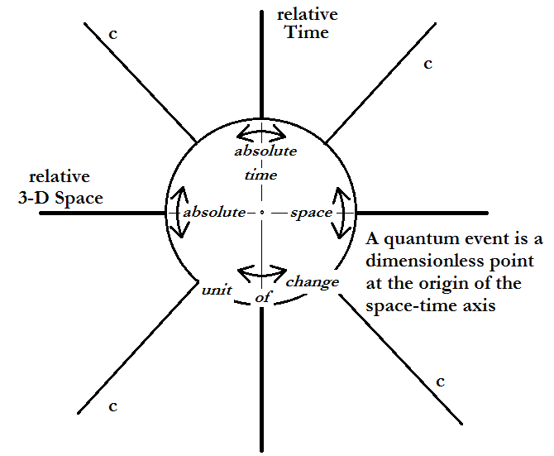
The time and space axes inside the ‘unit of change’ are essentially absolute because they refer only to the ideal geometrical point center. If momentum and energy are completely fundamental, then reality must be limited to an indistinct extension of space and time surrounding the origin of the axes. Hence there is a ‘zone’ of misunderstanding and contention surrounding the point origin of the space-time axis, which can be called the fundamental or quantum ‘unit of change’. Different paradigms interpret the ‘zone’ bounded by the basic ‘unit of change’ differently, hence the fundamental problems and discrepancies between the quantum, relativistic and Newtonian worldviews and therein lays the central problem of physics.

4.1. The misconception of indeterminism
At this point in the analysis, quantum physicists and philosophers would normally invoke concepts of indeterminism and argue that the whole of the universe is inherently indeterministic. Yet both indeterminism and determinism are false concepts and have no place in real science. Even though quantum events may correspond to individual dimensionless points in space which can be defined at the origin of the space-time axis while all of geometry is derived from dimensionless points, there is no reason to automatically conclude that each and every point in space simultaneously represents a quantum event. Discrete quantum events are completely unconnected to other discrete quantum events by definition. However, changing from the dimensionless existence of a point at the center of the ‘fuzzy zone’ to a dimensioned existence relative to the whole universe poses a problem when the quantum event becomes a four-dimensional space-time reality by collapse of the wave function. Put another way, the dimensionless point at the location where the space and time axes come together – the independent idealized space-time ‘now’ of the observed event – can occupy only one of an infinite number of possible locations or orthogonal directions (thus the ↕↔ symbols used in the diagram) corresponding to the x, y, z, and t axes of normal space-time.
The idealized point ‘event’ must conform to the already established direction of relative time because time goes on, or moves forward, external to the ‘fuzzy zone’ surrounding the ‘event’ once it has been observed (or measured) by something external to the ‘fuzzy zone’, i.e., the observer. When the time-axis of the single quantum event collapses from all of its infinite number of possible orientations around the central point in the ‘fuzzy zone’ and aligns with the flow of time surrounding it, its spatial axes automatically align with the external spatial directions x, y, and z that define the common external three-dimensional space. Only then does the event conform to the rules and restrictions on reality established by the universe as a whole and thus become a relativized physical reality.
This model is not entirely unique. A very important precedent exists for this particular interpretation of the quantum paradox in the concept of a Hilbert space of infinite dimensions. Each unique point-located event establishes its own independent relative space-time framework, but there are an infinite number of point-locations in this singular universe created by the event and all are pegged to their own central event point at the origin of the space-time axis. So the problem of ‘uncertainty’ inside the ‘fuzzy zone’ bounded by the ‘unit of change’ reduces to the singling out of one of the infinite number of possible axes orientations rather than a ‘collapse of the wave function’ that extends throughout all of space. This alignment establishes the event’s ‘reality’ in the normal space-time continuum. If a wave explanation still seems necessary, then it may be easier to think of the collapsing wave function as representing a longitudinal wave shrinking or ‘collapsing’ along a line in the fourth direction of space rather than a transverse probability wave extended over the whole of three-dimensional space while still centered on one individual point in the space-time continuum.
The quantum point structure of an infinite-dimensional space-time first suggested by Hilbert [20] is intimately related to the mathematical concept of a Hilbert Space. (See for example Brody and Hughston [21]) Hilbert space is a purely mathematical projective space of rays that is non-linear with curves and described by Riemannian metrics. A precedent for this interpretation already exists in general relativity and Hilbert’s work is also reminiscent of Clifford’s earlier work on hyperspaces. Hilbert [22] used such a construction to develop his own general relativistic structure of space-time at about the same time that Einstein initially developed general relativity. Einstein noted Hilbert’s contribution for developing an alternate derivation of his theory while Hilbert gave full credit for the discovery of general relativity to Einstein.
The probability of an infinite number of possible orientations of space-time axes spinning around randomly within the ‘unit of change’ or fuzzy point before collapsing into a singular unique alignment with the normal ongoing passage of time axis is far more realistic than the alternative quantum explanation of the pre-collapse wave packet spread across the whole of the universe as a probability cloud. Yet this picture limits the indeterminate nature of the quantum to inside the ‘unit of change’. Logically speaking, all of the probability is thus wound up inside the ‘fuzzy zone’ and the universe is still left deterministic outside of the ‘fuzzy zone’, at least until the collapse of the wave packet brings the event into alignment with external deterministic reality as well as Newtonian physics.
Thus we have a simple interpretation of quantum theory that corresponds well to the model of reality posed by both special and general relativity. Both the indeterminism of the quantum inside the ‘fuzzy zone’ and the determinism of relativity outside of the ‘fuzzy zone’ coexist to create physical reality. The width of the ‘fuzzy zone’ in both space and time is defined by the quantum, so the quantum is and can be nothing other the smallest possible measurement that yields a physically real event according to the rules of our universe as expressed by physics.
In the end, scientists ‘create’ the uncertainty that they normally attribute to the whole of nature by their attempts to mimic ideal mathematical abstractions on the stage of physical reality. We are truly creating our own abstract reality by experiment, but it is not and cannot be the reality of our external world. The smaller we make the ‘unit of change’ size limit, either by abstraction or experimental measurement, approaching the zero point, the greater the radical ‘change’ of orientation of the event point’s axes, the harder it becomes to align the time axis of the point to the external passage of time and thus the external space-time geometry. This creates a greater uncertainty in the ‘quantum measurement’ and, in fact, is the source of the measurement problem in quantum theory. The very notion that the universe as a whole is indeterministic is based on false logic as is determinism.

4.2. Hidden variables and Planck’s constant
The situation described is reminiscent of a moving particle that is confined to bounce around inside an ideal box (closed surface) that is decreasing in size and volume. Although its energy remains constant, the particle’s motion grows increasingly more erratic and random as the box’s volume decreases because the particle bounces off of the interior wall of the box more and more often as the box shrinks. Both the erratic motion of the particle and the shrinking size of the box can be equated to the ‘basic unit of change’. It is normal to associate Planck’s constant with both, depending on the circumstances, but in reality Planck’s constant is related only to the size of the box and not the erratic nature of the motion which is only indirectly proportional. Meanwhile, the uncertainty of position at any given point of space in the box is tied to the erratic motion of the particle, not the shrinking size of the box. As the volume of space in which the particle is confined during measurement (which yields the uncertainty in the position) approaches the outer surface of the particle, the randomness of the motion of the particle increases exponentially until the box surface (technically a measuring device) coincides with the outer surface of the particle and its motion (momentum) ceases altogether. This marks the ‘collapse of the wave function’.
On the other hand, the energy density of the particle, with constant kinetic energy over a decreasing volume of the box, increases as the box shrinks. Mathematicians could abstract this situation and say the energy density approaches infinity (zero point energy) as the box’s volume goes to zero. But the volume of the box can never go to zero; the volume of the box can only grow as small as the particle size at which time the radical motion of the particle must go to zero because there would be no room in the box for the particle to bounce around. Instead the uncertainty tied to the erratic motion would go to zero as the box stopped shrinking at the point of ‘collapse’, rather than when the box’s size shrinks to zero. At this juncture, mathematics and physics begin to part ways. According to physics, the box would assume the shape of the particle (a fixed but non-zero point location in space) as momentum goes to zero and the energy in the erratic motion would be converted.
Clearly the mathematics and physics of the situation do not match each other. In fact, the mathematics yields physically impossible answers. The same is true for the mathematical formalisms of quantum mechanics, which is the main source for problems and discrepancies between the quantum theory and other physics paradigms. The uncertainty in position may have gone to zero to define the measurement event, but the point location in space never went to zero. The corresponding randomness in motion (uncertainty in momentum) went to a maximum value, but when the measuring container closed in on the particle the momentum must have gone to zero as energy was apparently, but not necessarily, lost to or absorbed by the container. In this case, the center point of the particle would correspond to the axis of the space-time diagram describing the event.
Before this moment, the motion of the particle was only known by the uncertainties in position and momentum, but at the moment of ‘collapse’ (energy exchange) the uncertainties in energy and time were automatically invoked. At that moment, the two different forms of the uncertainty principle became equated, eliminating any reference to Planck’s constant. The uncertainty relationship reduces to
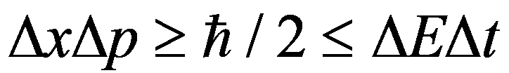 (6)
which simplifies to become
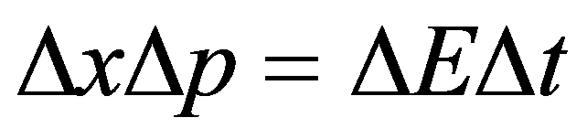. (7)
Given this last relationship, both the equations of special relativity and Newton’s second law of motion can be derived [23] by noting how the uncertainties involved change relative to one another. In other words, when the moment of measurement occurs, a ‘collapse’ of uncertainty reestablishes the relationship between the quantum event and the relative space-time continuum, as designated by the space-time diagram, and the quantum situation reduces to a problem in normal classical physics.
There had been ‘hidden variables’ in the quantum uncertainty relationships all along. They were always in the background, but never invoked by the Heisenberg uncertainty principle until the moment of collapse. There was never any accounting for time (position in time) in the relationship between the uncertainties in position and momentum before the ‘collapse’, nor would there have been any accounting for position (spatial location) if the uncertainty relationship between energy and time had been applied to the problem instead. Time and space, respectively, are the ‘hidden variables’ in the Heisenberg uncertainty principle, yet there is also an unsuspected ‘hidden variable’ in the classical view of space-time, and that is Planck’s constant. When space and time are reunited as space-time, Planck’s constant is subdued, so Planck’s constant, which does not normally appear in either Newtonian or relativistic physics, must always be hidden in the background of classical physics as the binding constant for space and time. Quantum uncertainty only comes from the scientific attempt to artificially separate space and time in the measurement process.
When the quantum event – a measurement, observation or other material interaction – occurs at a specific moment in time, the uncertainty would lie along the vertical axis of the space-time diagram invoking the application of ΔEΔt≥h and position in space is ignored. When it occurs at a point in space along the horizontal axis it would invoke the relationship ΔxΔp≥h. Together, these would create the ‘sphere’ or ‘fuzzy zone’ of uncertainty surrounding the zero point of the space-time diagram representing the mathematically idealized (rigorized) quantum event. This ‘fuzzy zone’ of uncertainty would amount to what some have called a ‘fuzzy point’ and others call ‘quantum fluctuation’. Quantum foams and other such explanatory gimmicks are no more than quantized visualizations of Newton’s absolute space or Einstein’s continuum with the slight addition of possible random quantum fluctuations at different points in absolute space. The ‘fuzzy zone’ is spread out over a greater but shrinking volume of space until the measurement is completed, at which time the density of the ‘fuzziness’ goes to a maximum value and Planck’s constant is invoked.
In reality, quantum theory is only supposed to deal with unrelated and physically unconnected events (unless entanglement can be taken into account), so the empty space and time between different independent events cannot be characterized by any one individual event. The only possible justification for doing so would be the probabilistic nature of quantum mechanics and the corresponding spread of the wave function over space prior to the moment when the wave function collapses to the single point at the origin of the space-time diagram to create ‘reality’, as quantum theorists would say. However, the mathematical model of a wave that corresponds to a particle that is somehow spread like warm butter over the whole universe is nothing more than a prosthetic gimmick and red herring. Mathematical possibilities such as those represented by the wave function do not necessarily represent physical realities before the wave collapses.
The shrinking box or surface is not that bad an analogy, nor is it unprecedented. An imaginary closed surface surrounding a real object would normally be called a Gaussian surface in mathematics. It is a useful and often used analytical tool in physics. When the ideas and analogies of the shrinking box are applied to nature a new and startling result emerges – The shrinking box analogy provides a realistic description of how the Schrödinger wave function collapses to form an extended material particle during a quantum interaction event or alternately how the quantum energy of a light wave is absorbed as a photon, while the erratic process of axes alignment inside the box (unit of change) describes a corresponding purely quantum mechanistic and indeterministic view of the event.
In the real world, this limit – the quantum limit – could be used to explain the creation of either a pseudo-particle or a real particle. The energy density in the box would either convert to a momentary semi-stable field resonance or become a real particle as the quantum limit (basic unit of change) of the box is reached. Which case occurs depends on the extent to which the particular situation conformed to the geometrical restrictions of reality, i.e., real particles must have half-spin. If the limit is approached in such a manner that uncertainty inside the ‘fuzzy zone’ collapsed and the resulting quantity conformed to the completely to the geometric restrictions of space then a real particle such as an electron or positron would emerge from the process. Otherwise a momentary ‘energy resonance’ (such as a Higgs boson) would emerge or be created, but it would almost instantaneously deteriorate into some other form of energy or a real particle (particles) with energy because it does not meet the minimum physical (geometrical) requirements of the universe for reality, i.e., half-spin. This is exactly what occurs in high energy physics experiments such as those conducted at the Large Hadron Collider at CERN.

Single Field Theory
The resulting theoretical structure is called ‘single field theory’ or just SOFT. The term ‘single’ is used instead of ‘unified’ because Einstein’s less comprehensive attempts envisioned the field as a unification of other common fields whereas other fields are actually specialized structures within the single field. In any case, the quantum can now be incorporated into this model quite easily. First of all we have the new relationship between classical electromagnetism and modified Newtonian gravity.
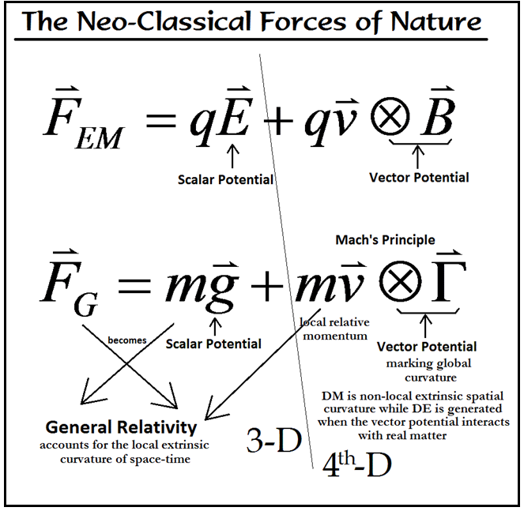
In both the Lorentz equation for electromagnetism and the corresponding gravity equation the first terms represent three-dimensional scalar potential fields while the second terms represent three-dimensional contributions to force by four-dimensional vector potential fields.
Like magnetism, the new additional gravitational force acts centripetally around a central mass. The velocity (v) represents the orbital speed due to the central mass. The new variable Γ represents the gravitational influence of all other (non-local) material bodies in the universe on the local action. In essence, Γ represents the overall or global curvature of the universe, so the cross product between Γ and the orbital momentum yields the higher rotational speeds of stars and star systems orbiting galactic cores. This effect would influence all orbital speeds around any central material bodies and thus accounts for the small speed increases NASA has detected in artificial satellites that slingshot around planets and the sun. It would also account for the slightly higher than expected speeds of the Voyager satellites that are presently exiting the solar system. This model also yields other testable predictions [24,25], but this venue is too short to list them all.
Like electromagnetism, a secondary equation relates the quantity Γ to a new gravitational vector potential.
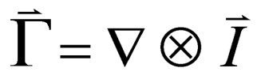 (8)
The gravitational vector potential I is the source of Dark Energy, thus Dark Matter and Dark Energy are directly related. But the I also stand as for inertia. Inertia is a point property of material bodies as opposed to the gravitational inertia which is a metric property of the curvature. The total mass inertia of a body is the collective property of all the points within the body that fit under the spatial curvature representing gravitational mass. Thus we have a new equivalence principle that goes beyond that used in general relativity.
The concept of point inertia also explains the source of the Higgs boson in the Standard Model of particles. The Higgs boson is not an exchange particle since the idea of particle exchange to create the mass of a moving body is just a mathematical gimmick (or artifact) that corresponds to individual inertial points under the metric curvature of space and the Higgs field is none other than the space-time continuum of general relativity. However, outside of the boundaries of an extended material particle the very points of space under the curvature Γ are points of Dark Energy. So Dark Energy is no more than gravitational vector potential in open space.
After the cross product is completed, the second gravitational term would take the form
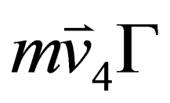 . (9)
The vector v₄ is a velocity in the fourth direction of space whose three-dimensional projection yields the true three-dimensional orbit speed of a material body. However, writing the term in this fashion opens other possibilities, primarily the momentum can now be related to a DeBroglie matter wave, yielding
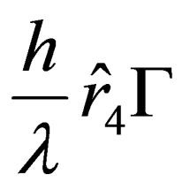 . (10)
The DeBroglie matter wave forms the basis of Schrödinger’s wave mechanics, so gravity in the form of this modified Newtonian equation has now been quantized. Given the fact that electrons orbiting atomic nuclei in each of the principle quantum orbits form whole numbers of DeBroglie matter waves, the electronic shells in atoms can now be explained utilizing space-time curvature. Incoming light waves with specific magnetic vector potentials A can be absorbed by electron’s whose own magnetic vector potential A just matches them for the proper quantum leap to other orbits.
This formulation also indicates that the DeBroglie matter wave extends in the fourth direction of space as a longitudinal wave and is thus equivalent to the modified Newton model of space as well as the Einstein-Kaluza five-dimensional model of space-time. These findings indicate that the quantum forces a limit to measurement that is restricted to the fourth dimension of space as it affects how our normal three-dimensional space evolves in time. In other words, Planck’s constant is a coupling constant for four-dimensional space and time that manifests in both conscious acts of measurement and non-conscious physical interactions (entanglements) in three-dimensional space.
Since continuity is a physical property of both space and time, the fundamental interaction between the single field and space-time would be limited by an ‘effective width’ of three-dimensional space in the fourth direction of the embedding space. The ‘effective width’ of space would be characterized by Planck’s constant or rather proportional to the fine structure constant (α = e²/4πε₀ħc) which would further consolidate electromagnetic theory into the model as well as electromagnetism into the fundamental structure of space-time. The lowest energy state, corresponding to the principle quantum number of n = 1, of the three-dimensional universe would be equivalent to the primary ‘sheet’ surface with this ‘effective width’. Each succeeding ‘sheet’ would be stacked on top of the other (giving continuity) in the fourth direction of space, corresponding to succeeding quantum numbers.
Einstein’s original formulation of general relativity in terms of tensors representing the curvature of space time yielded a simple equation of the form
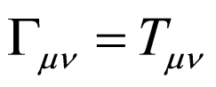 . (11)
The tensor Γ represents the space-time curvature while the energy-stress tensor T represents local matter associated with the curvature. It is commonly understood that this equation says matter curves space-time and the space-time curvature moves matter. However, this equation cannot account for Dark Matter and Dark Energy because it only represents the metric geometry implied by the original form of Newton’s gravitational equation F=mg. The new term extending Newtonian gravity to include point geometry must also be represented.
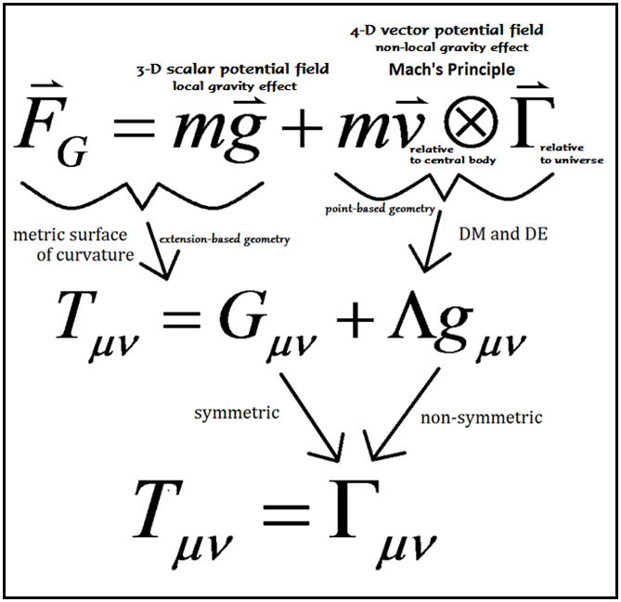
The second term becomes the Newtonian equivalent of what is called lambda CDM in the later version of Einstein’s tensor equation. It is now being used successfully to explain the Cold Dark Matter surrounding galaxies, but the origin and meaning of the Lambda CDM term has so far eluded scientists. The source of the Lambda CDM, as well as all Dark Matter and Dark Energy in the universe, can now be found in the new Newtonian term. Lambda CDM is a product of the point geometry in the modified Newton gravity equation. Furthermore, the equation can be stated more clearly by changing the new four-dimensional Einstein equation
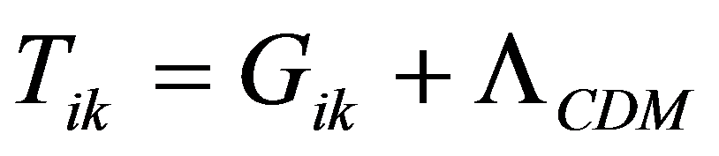 (12)
to a five-dimensional form. Our normally experienced reality is just a space-time projection of the five-dimensional space-time tensor.
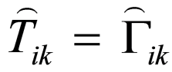 (13)
In this last formulation, the five-dimensional Γ tensor has two parts, one symmetric and the other non-symmetric. The symmetric part represents the metric curvature and projects to G_{ik} in normal space-time, while the non-symmetric portion represents the new point geometry contribution of Dark Matter and Dark Energy in normal space-time.

Conclusion
In some respects the single field and five-dimensional space-time are mathematically and perhaps even physically indistinguishable, which begs the question whether or not they are inseparable. They are not, however, inseparable because a primary difference between the two does in fact exist and it can be specified. This difference rests in the simple fact that the single field varies in density from one position in the fourth direction of space, but the density clumps (particles) and variations are apportioned (by Planck’s constant h) and relative (by the speed of light c) to both the quantization and geometry of our normally experienced four-dimensional space in the overall five-dimensional space-time. Normal space-time is essentially the collection of dimensionless points from which it is constructed. The material extensions in normal space-time that we call elementary particles are thus arbitrary (in the sense that the original creation of elementary particles occurred at random positions throughout the full extension of three-dimensional space) and limited by the quantized geometry of five-dimensional space-time.
However, these extended material bodies are given meaning, relevance and limit by the single field which occupies the whole extent of space-time as characterized by the quantum (h), electric permittivity (ε_{o}) and magnetic permeability (μ_{o}). In other words, elementary particles are governed in their most basic interactions as well as their original evolution (creation) by the two physical constraint constants – Planck’s constant (h) and the speed of light (c = (μ_{o}ε_{o})^{-½}). Planck’s constant is a property of the space-time continuum while the speed of light is a property of the single field that fills the space-time continuum. They combine together to yield our physical and material reality. The permittivity ε_{o} is the binding constant for the three-dimensions of normal space, the permeability μ_{o} is the binding constant of normal three-dimensional space to the fourth dimension of space – they are the constants that characterize the single field – and Planck’s constant is the binding constant of four-dimensional space to time.

7. References
[1] Riemann, Bernhard. (1854, 1873). “On the Hypotheses which lie at the Bases of Geometry.” Nature 8; 14-17, 36, 37.
[2] Gödel, Kurt. (1931) Monatshefte für Mathematik und Physik 38: 173-98.
[3] Clifford, William Kingdon. (1873) “Postulates of the Science of Space”, Contemporary Review, (1874): 360-376; Reprinted in Lectures and Essays, London: Macmillan. Volume 1: 295-323.
[4] Clifford, William Kingdon. (1873) “Preliminary Sketch of Biquaternions”, Proceedings of the London Mathematical Society (12 June 1873): 381-395; Reprinted in Mathematical Papers: 181-200.
[5] Clifford, William Kingdon. (1882) Mathematical Papers. New York: Chelsea Publishing, 1968.
[6] Clifford, William Kingdon (1870) Transactions of the Cambridge Philosophical Society, 2 (1866/1876): 157-158; Reprinted in Mathematical Papers: 21-22.
[7] Klein, Felix. (1890) Nicht-Euklidische Geometrie.
[8] Cartan, Élie. (1922) C. R. Acad. Sci. (Paris) 174:593–595.
[9] Cartan, Élie. Ann. Éc. Norm. 40: 325–412 and 41: 1–25; 42: 17–88; (1926); Acta Math. 48: 1–42.
[10] Einstein, Albert. (1929) Observatory 51: 82-87; Sitzsber Preuss Akad Wissen 1: 2-7; And (1930) Mathematische Annalen 102: 685-697.
[11] Beichler, James. (2006) “Alternative Physical Models of the Universe.” In Life and Mind. Victoria: Trafford: 239-262. Online at www.neurocosmology.net/sci%20revolutions.html.
[12] Heaviside, Oliver. (1893) “A gravitational and electromagnetic analogy.” The Electrician 31: 81-82.
[13] Kaluza, Theodor. (1921) Sitzungsberichte der Preussischen Akademie der Wissenschaften 54: 966-972.
[14] Klein, Oskar. (1926) Zeitschrift fur Physik 37, 12: 895-906; Nature 118: 516; (1927) Zeitschrift fur Physik 46, 188-208.
[15] Einstein, A. and P. Bergmann. (1938 Annals of Mathematics 39, 3: 693-701.
[16] Einstein, A., P.G. Bergmann and Valentine Bargmann. (1941) Theodor von Karman Anniversary Volume. Pasadena: Cal. Tech.: 212-225.
[17] Einstein, A. (1915) Berliner Sitzungsberichte (part 2): 844–847.
[18] Einstein, A. (1945) Annals of Mathematics 46, 4: 578-84.
[19] Einstein, A. (1956) Meaning of Relativity, 6th Edition. Calcutta: Oxford and IBH Publishing.
[20] Hilbert, D., Lothar Nordheim, and J. von Neumann. (1927) Mathematische Annalen 98: 1–30, doi:10.1007/BF01451579
[21] Brody, Dorje and Lane P. Hughston. (1999) Online at arxiv.org/pdf/quant-ph/9906086v2.pdf.
[22] Hilbert, D. (1915) Göttinger Nachrichten: 395-407.
[23] Beichler, James. (1996) “Bubble, Bubble, Toil, and Trouble!” Online at http://www.neurocosmology.net/yggdrasil.html.
[24] Beichler, James. (2010) "The Physical Origins of Dark Matter and Dark Energy". In Ether Space-Time and Cosmology, 3, Physical vacuum, relativity and quantum physics. Apeiron. Online at http://www.neurocosmology.net/5-d%20cosmology.html.
[25] Beichler, James. (2013) Four Pillars of Wisdom. An ebook to be published.

