FUTURE POSSIBLE ENERGY/PARADIGM REVOLUTIONS FROM ULTRA-COLD MATTER AND NANOSCIENCE DISCOVERIES: HISTORICAL CONTEXT OF CURRENT RESEARCH AND OVERVIEW OF DEVELOPING TRENDS
Don Reed
54 Barnsdale Ave. West Seneca, NY 14224
torsionpower@yahoo.com
Presentation for the 20th NPA Conference, Univ. of Maryland, College Park, Md, (2013)
Abstract: In the last three decades, the confluence of two streams of research have resulted in some of the most heretofore unknown innovative, energy-transformative and potential paradigm-shifting developments in the history of science and technology. These are due to both the fruits of the nano-science revolution and those stemming from ultra-cold matter applications as exemplified by the Bose-Einstein condensate. Through examining a wealth of specific research results from each of these areas, some of surprisingly serendipitous nature, this paper will attempt to show that many of the discoveries that have been made in these arenas point to possible new understanding of the quantum engine that underpins physical reality, and its relationship to electromagnetism and gravitation at both microscopic and large-scale regimes of nature. It is hoped that ulltimately this new knowledge will subsequently also guide us in achieving the coveted goal in our quest to harvest energy from the quantum vacuum.

1 INTRODUCTION
As a result of the revolution in nanoscale research and ultra-cold matter developments, a vast panoply of technological applications have been developed that not only underscore the inauguration of unprecedented ultra-efficient modes for generating, transforming and transmitting energy through precise control and manipulation of molecular- or atomic-level electronic components, but has captured the imagination of experimentalists and theorists alike due to unexpected serendipitous phenomena not observable on the macroscale of nature, not predicted by current scientific paradigms and understanding. I t is the latter effects that deserve a closer examination since they possibly portend a new understanding of foundational physics laws when elements of nature are carefully scrutinized and probed from various microscopic levels of physical reality. By examining some of these key discoveries, both those in nanoscale research and ultra-cold matter applications, it is the focus of this paper to underscore those particular phenomena that most clearly exemplify this evidence in order to crystallize the currently perhaps only dimly perceived paradigm leaps for transforming the current extent of our knowledge.
One of these areas of physics that might be amenable to a re-evaluation of some of its foundational principles is standard Maxwellian electrodynamics. Indeed, there are non-trivial differences between conventional and nano-electromagnetics that can only be accounted for once the conceptual foundations of the nanoscale problem are taken into consideration. First, once the scale of the electromagnetic problem is pushed down to the nano-world, the discontinuity of matter becomes more manifest. This leads to important corrections which must be introduced to conventional (macroscopic) electromagnetics. Those corrections are not just quantitative, but most importantly there are fundamental conceptual modifications that must be considered in order to understand how the problem at the nano-scale level presents something new to the electromagnetic community. Some of these corrections that must be taken into account for a successful description of electromagnetics at the nanolevel are:
(i) The size effects (e.g., quantum confinement)
(ii) The non-local effects (e.g., spatial dispersion)
The size effects relate to the quantum mechanical phenomena of confinement. Since, according to de Broglie’s hypothesis, each particle has a wave associated with it, electrons existing in very small dimensions will undergo resonator-type quantization effects which are due to imposing the boundary condition of the spatial structure on the wave-function. This generally results in new behavior that is not present in the original bulk material response functions. Thus the treatment of the boundary of a lower-dimensional structure is tricky because there is no unique natural interface between different domains. The choice of the boundary conditions depends on the method used to handle the mechanical problem at the afore-mentioned interface between different media. One recent development showing how such an extension of Maxwell' equations can encompass description of the energetics of carbon nanotubes is given by S. M. Mikki and A.A. Kishk [1]. Accordingly, they point out the important issue of the requirement of averaging the fields and the influence of the Heisenberg uncertainty principle, where knowing both the charge distribution (analog to position) and the current density (momentum-velocity analog) at the nano-level to any level of accuracy is not possible. This leads to the problem of stochastic fluctuations, an inherently quantum phenomenon, subsequently requiring replacement of the classical fields and variables by operators associated with statistical distributions.
Nevertheless, after all these standard quantum differences between the electrodynamic behavior of bulk matter at room temperatures compared to the corresponding energetics of nano-level matter are taken into account, there are as yet other heretofore possibly unexpected subtle but important differences between these two regimes of matter. Accordingly, it will be shown how this empirical evidence could reveal the potential for sharpening our understanding of how wide the role is that the principles of quantum mechanics could actually play in the wheelwork of nature; moreover, by more closely examining that role, to foster the development of new ways to energetically manipulate matter at the molecular or atomic levels to possibly even engineer the quantum vacuum itself.
Pursuant to this admittingly ambitious goal, section 2 will examine the necessity for a fresh re-examination of the foundational principles of Maxwellian electrodynamics that should be mounted in the wake of the discovery of the “missing”4th circuit element: the nano-enabled so-called “memristor”. Section 3 shows how new liquid-based nano-level modalities for both abundant/efficient hydrogen generation and the unprecedented application of unique solar-energy protocols for almost instantaneous heat generation and ~100% distillation of ethanol, can lead to a new understanding of possible unsuspected quantum-generated thermal barriers at molecular levels, in direct violation of standard classical thermodynamically accepted modes of heat transfer. Section 4 demonstrates from new evidence gained from examining of nano-confined water that certain novel ground-state quantum effects imply possible unfathomed efficient modes of water transport through biological channels. Along these lines, in section 5 it is revealed how nanoparticles may exhibit quantum effects that have been previously thought to exist only at atomic levels. Finally we round off our study in section 6 to show how new protocols using Bose-Einstein condensates applied to macroscopic electric circuits – for sensing ultra-low levels of electromagnetic activity - may have even serendipitously revealed the existence of the long sought-for longitudinal modes of electromagnetic wave propagation.
2 THE MISSING “MEMRISTOR” AND MICROSCOPIC ELECTROMAGNETISM: EVIDENCE FOR CHANGE IN SOME BASIC CONCEPTUAL FOUNDATIONS?
The resistor, the capacitor, and the inductor are the three well known, basic two-terminal circuit elements. In 1971, Leon Chua postulated a fourth, the memristor [2], on the basis of symmetry arguments to complete the structure of circuit theory. The memristor was predicted in the context of electrical circuit theory. Circuit theory has two fundamental relations, which derive from Maxwell's equations by separating out the electric and magnetic parts. The involved integrations of the free charge and current densities result in the charge Q and current I, respectively. This leads to the current-charge relation that defines the current I as the time derivative of the electrical charge Q:
I = dQ/dt (1)
The integration of the magnetic field B results in the flux φ, while the electric field E integrates to the induced voltage U. Flux φ is the magnetic flux and also called “flux-linkage” because it links the magnetic field to the magnetically induced voltage. Thus results the second fundamental relation, the voltage-flux (or flux-linkage) relation, which relates the voltage U to the time-derivative of the flux φ :
U = dφ/dt (2)
It is important not to confuse the two fundamental relations with the two fundamental laws of circuit theory. The laws are (1) The conservation of charge, which leads to Kirchhoff’s node rule (all currents into and out of a circuit’s network node sum to zero: ∑ I = 0). (2) Energy conservation, which leads to Kirchhoff’s node rule (all voltages around any closed loop in the network sum to zero: Σ U = 0). These two are not the source of the fundamental circuit theory relations. Energy and charge are also conserved in a hypothetical world without magnetic flux, where flux could be merely defined as the integration of a voltage over time consistent with Eq. (2).
Moreover, the two fundamental circuit theory relations are like two opposite edges of a tetrahedron (Fig. 1), suspending the four fundamental circuit variables I,Q,U, and φ at its corners. Eq. (1) provides I and Q while Eq. (2) holds for U and φ. This tetrahedral symmetry is what underlies the prediction of the memristor. There are four further edges of the tetrahedron: Q to U, U to I, φ to I, and φ to Q. These correspond to four further binary relations apart from the two fundamental relations.
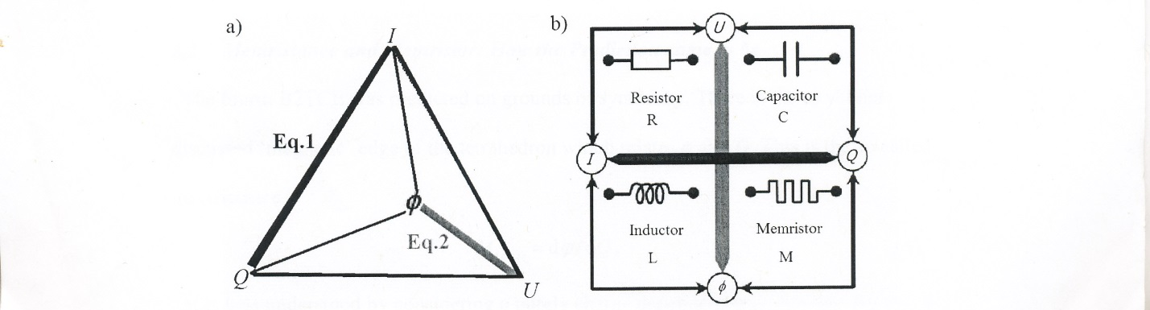
Fig. 1 Schematics of the symmetry that accounts for the memristor: (a) the tetrahedron spanned by the four fundamental circuit variables, (b) the relations and circuit symbols of the four basic two-terminal circuit elements that correspond to the unlabeled edges in (a).

The four binary relations lead us directly to the basic two-terminal circuit elements, the first three of which are well known. The capacitor with capacitance C(U,Q) = dQ/dU , the resistor with resistance
R(U,I) = dU/dI, (3)
and the inductor with inductance L(U,I) = dφ/dI. All of these are “basic” in the following sense: (1) As indicated by their symbols (Fig. 1), they have only two terminals – in and out, or plus and minus. (2) They are passive, meaning that they do not supply any energy. (3) The word “basic” also refers to the fact that they are independent of each other (i.e. they span a space much like a basis of linearly independent vectors in a vector space or axioms). For example, one can't connect resistances and capacities together and end up with a circuit having inductance. Moreover, very simple devices are close analogies of these elements, which is as far as we introduced them, theoretical entities. The simplicity of existing devices is explicitly not what the term “basic” implies.
The fourth basic two-terminal circuit element was predicted on the grounds of symmetry due to the as yet not discussed “magnetic“ edge of the tetrahedron which relates φ and Q. This is the so-called memristance.
M(φ,Q) = dφ/dQ. (4)
M is best understood by considering a purely charge dependent M (Q). Rewrite Eq. (4) as dφ =M(Q)dQ and integrate this over time. Eq. (1 ) and Eq. (2 ) tell us that the result is: (dφ/dt) /( dQ/dt ) = dU/dI , or
U(t) = M(Q(t))I(t) . (5 )
Comparison with Eq. (3) shows that M( Q) is a resistance. Its units, i.e. the standard units of φ divided by Q, are the same as that of resistance R, namely the Ohm (Ω). The derivation also shows that this resistance depends upon the charge Q(t). In other words, the resistance seems to “remember” or “memorize” the charge that has passed through it; hence the term “memristance”.
Despite these rather compelling theoretical arguments to account for the operational principles of this missing circuit element, it took almost 40 years after Chua first postulated it for the memristor to be described for the first time as a physical system by a group of researchers at the HP lab in California. In this model, called the coupled ionic and electronic transport model [3], they used a very thin film TiO2 sandwiched between two platinum (Pt) contacts with a total length D, and doped on one side of the TiO2 with oxygen vacancies which are positively charged ions, as shown in Fig. (2).
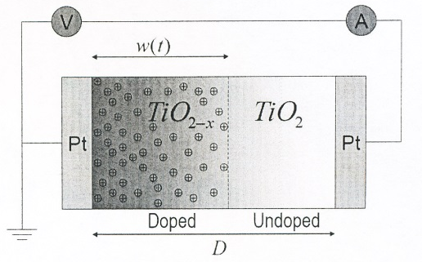
Fig. 2 Cross-section of TiO2 memristor consisting of
a high conductive (doped) and a low conductive (un-
doped) part placed between two platinum electrodes
Therefore, there are two thin films, one is doped and the other is undoped. Such a doping process produces two different resistances: one is high resistive (poorer electrical conductor- undoped) and the other is low resistance (conducts current well – doped). The total resistance – or, strictly speaking, the memristance – of this two-component system is the sum of the doped and the undoped part. What makes this system a memristor and not a resistor is the presence of the dynamic state variable w defining the boundary between the two parts with high and low conductance. For this particular memristor w is proportional to the electric charge. This internal state variable w and consequently the total resistivity of the device can be changed by applying external voltage bias. When current is passed through this memristor, the boundary between the high and low conductive states is shifted either to the left or to the right with time. It can be thought that the charge carriers push this boundary back and forth. This means that the total memristance of the system is either reduced or increased depending on which direction the charge carriers flow. Consequently, the resistance of the film as a whole is dependent upon how much charge has passed through it in a certain direction, which is reversible by changing the direction of the current. Thus, passing current through the memristor in one direction will increase the resistance while changing the direction of the applied current will decrease the memristance. Within different memristic systems, it may not be ions but perhaps in the film induced metallic precipitates that lower the resistance of the film. As the width w of the doped region grows, the resistance of the whole film decreases. The overall current and the impurity current are proportional to each other. Therefore, the overall resistance depends directly on the charge that has already passed through the film. Memristance is displayed only when both the doped layer and the depleted layer contribute to resistance. When enough charge has passed through the memristor that the ions can no longer move, the device enters hysteresis. The most common U – I characteristics is a 'figure of 8' or a pinched loop, as shown in Fig. (3).This phenomenon has been discovered in thin films that are a few nanometers thick (D ~ 5 nm), because the mobility of the impurities is small. The doped region grows slowly (dw << D) and the time over which the resistance changes is proportional to the film's thickness squared (t ~ D2). Hence the effect is not detectable in a macroscopic sample; a five micrometer instead of five nanometer thick sample will lead to a million times smaller effect. The other reason for memristance being a thin film effect is the instability of the memristor as a device generally. What reminds of the originally proposed memristor is that the film sandwiches are two-terminal circuit elements and that their resistance changes according to the charge that has passed already. Also we can see that the expression of the memristance (Eqn. (4)), does not explicitly involve magnetic flux, although the memristor is defined as a relation between flux and charge. Thus, it has been speculated that the reason such a long time passed from when the memristor was first postulated until it was described as a real device (2008) was because people were searching among systems involving magnetic flux, which made the chase much more difficult.

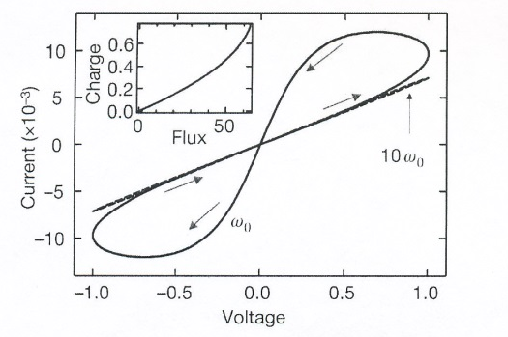
Fig. 3 Pinched loop I-U characteristics in
memristor. The memristance depends on
the amount of the electric charge that has
passed through the device. Inset figure
shows that memristors require non-linear
Q-φ plots.
Considering the potential practical import of the advent of the memristor, this innovation certainly represents a new nano-modality for many novel efficient analog computing protocols [4], that for a long time have solely been the theoretical province of digital quantum-computation methods utilizing quantum superposition and the principle of entanglement [5]. Indeed, recently such uses for memristor-based protocols have been suggested and are now in the planning stages of eventual implementation [6]. Also, a boost in the understanding of neuromorphic theories of cognition at all levels of species in nature may be in the offing making the memristor a possible key tool in expanding the uses of the tools of physics in a cross-disciplinary manner to many other areas of science [7]. However, perhaps more significantly the conceptual reality represented by the memristor may, at the very least, help in suggesting new ways of viewing Maxwell's equations, or perhaps in possibly leading to a welcome re-examination of circuit theory in general, for a more comprehensive understanding of the relationship between the four electromagnetic concepts of charge, current, voltage and flux at all levels of nature.
3 NEW MODALITIES FOR ON-DEMAND GENERATION OF HYDROGEN AND PHOTO-THERMAL HEATING EFFECTS USING CARBON- AND SILICON-BASED NANOPARTICLES
Solar energy has garnered much interest for its potential to provide power for a variety of processes without relying on fossil fuels. Although large-scale solar thermal installations are being developed for electrical power generation, an alternative and presently unfulfilled need is in compact solar energy sources that drive processes directly, in addition to the production of electrical power. These types of compact smaller scale solar energy converters could directly enable a range of applications, both in first-world countries and in resource-poor locations. Pursuant to this goal, light-to-heat conversion by conductive nanoparticles, under laser illumination, has been shown to induce dramatic localized heating and even vaporization of the host medium [8]. Yet laser protocols for this purpose are impractical, cumbersome and energy-consumptive.
Recently, scientists at Rice University in Texas discovered that it is possible to create steam in seconds by focusing sunlight on nanoparticles immersed in an ethanol-water mixture [9]. The nanoparticles – either carbon or gold-coated silicon dioxide beads – have a diameter shorter than the wavelength of visible light, allowing them to absorb most of the light’s energy. Larger particles would have scattered much of the light. Moreover, quite astoundingly, this process does not involve requirement of heating the fluid volume. In all, about 80% of the light’s energy nanoparticle goes into making steam, whereas 20% is ‘lost’ in heating the water. In the focused light, as depicted in Fig. (4), a nanoparticle rapidly becomes hot enough to vaporize the layer of water around it, and becomes enveloped in a bubble of steam, insulating it from the ambient water mass. Insulated in this fashion, the particle heats up further forming more steam. It eventually becomes buoyant enough to rise floating to the surface and hits/merges with the other bubbles. At the surface the nanobubbles release their steam into the air, then, sinking down into the vessel bottom and absorbing the focused light, the process begins again. The nanoparticles are never used up and thus act as catalysts for the reaction.
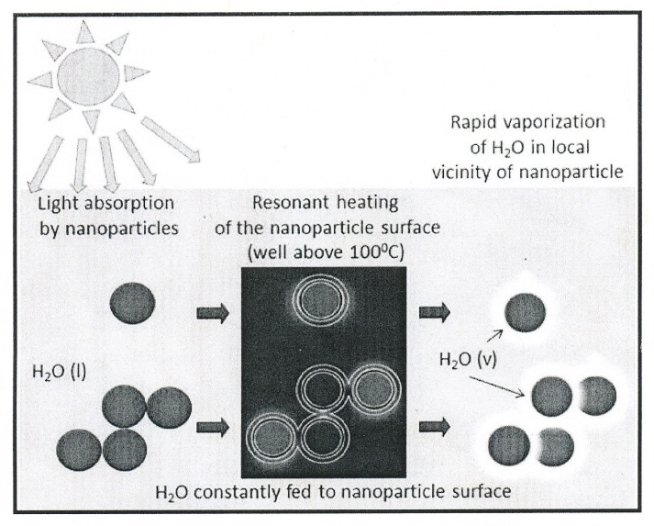

Fig. 4 Schematic of solar steam generation cycle utilizing carbon or
gold -coated nanoparticles.
Because there is no need to heat the fluid, the process is intrinsically more efficient than any vapor-producing method that requires volume heating of the fluid in macroscopic quantities, such as conventional thermal sources. Besides the totally unexpected result from their endeavors, the Rice group noted that, applying the specific parameters in this experiment to the conventional differential equation modeling macroscopic heat transfer in liquids, another mystery was uncovered for the team to ponder. Although this equation classically predicts a steady state temperature increase of the surrounding water of 0.04° C, this value is much too small for any bubble formation, in marked disagreement with the almost instantaneous steam generation in the current experiment. The team speculated this might be due to the conventional model for heat transfer neglecting the interfacial thermal barrier between the nanoparticle and surrounding water as demonstrated in this protocol. Once a bubble has formed around the nanoparticle, the conventional model which assumes direct contact between nanoparticle and the water, clearly fails because the thermal conductance of water vapor is significantly smaller than that of water. The team concluded by acknowledging that the explanation for this new effect is indeed an open question and will require future testing of a more refined model. Moreover, the effect as all the more intriguing in that it has been shown to occur even when the nanoparticles were immersed in an ice-bath (see Fig. 5).
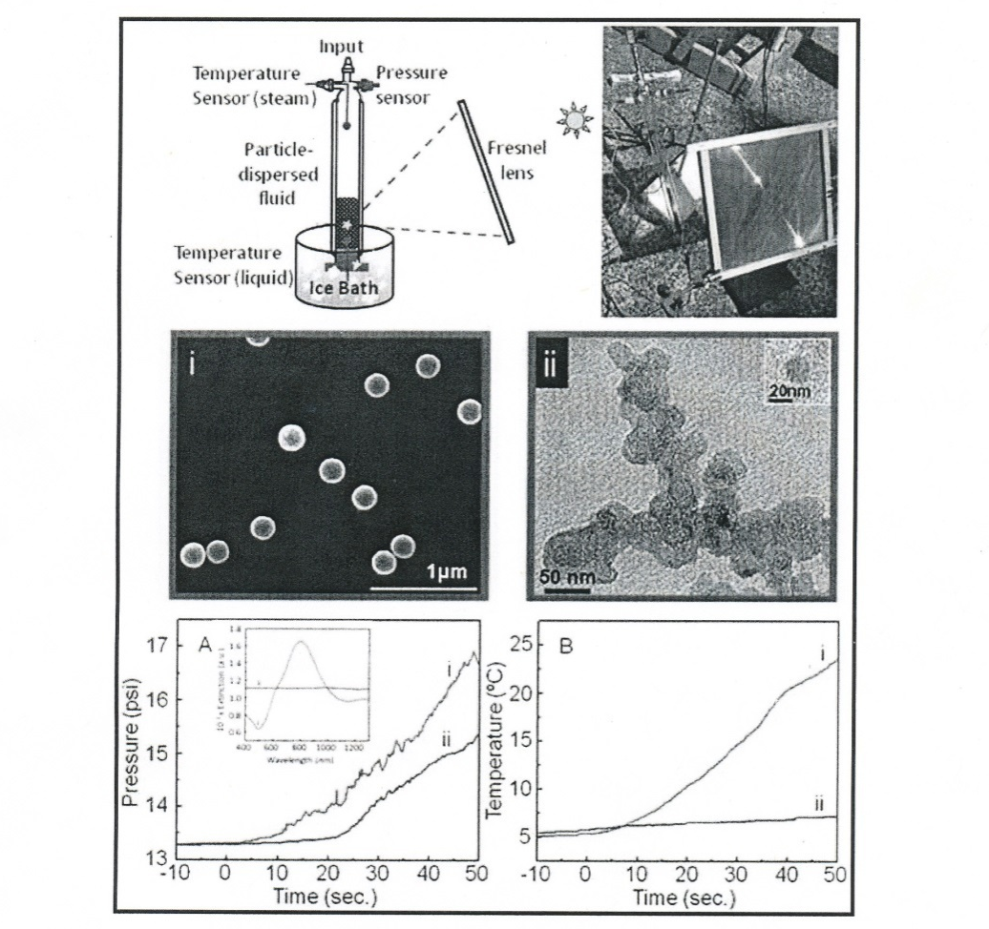
Fig. 5 Pressure-temperature evolution over time of solar steam generation
in ice-bath conditions, for (i) SiO2/Au nanoshells, and (ii) carbon particles
dispersed in water under solar exposure.
A possible clue to solving the mysteries described above might be had by considering that this protocol also can separate mixtures of water and other substances (distillation) more completely than is usually possible. For example, with normal distillation of a water-alcohol mixture, not more than 95% pure alcohol can be produced. In this experiment, 99% alcohol can be collected. Apart from the extraordinary wealth of compact solar energy applications that can be implemented from this discovery, such as distillation, desalinization, and sterilization/sanitation processes in resource-poor locations, these findings perhaps more significantly cast serious doubts on the conventional macroscopic models for proper description of thermal transport between nanoparticles and their environment, suggesting that possible unsuspected quantum energetics may actually be responsible for the peculiar thermal barriers at the nanoparticle liquid-vapor bubble interface that the current classical paradigm is unable to account for. In addition, this particular example may not be the only case where such unique forces are at work. The serendipitous discovery to be described next, may also be pointing us in this direction.
Splitting water to produce hydrogen is of paramount interest in energy storage, catalysis and fuel cell applications [10]. If hydrogen can ever be used to deliver energy for wide commercial applications, one of the requirements is finding a fast, inexpensive method to produce hydrogen. Conventional means of splitting water include electrolysis, thermolysis, photocatalysis or using a substance that chemically reacts with water, such as aluminum, zinc and silicon [11]. However, silicon-water reactions have typically been slow and uncompetitive with other water spitting techniques [12]. Yet, silicon does have other theoretical benefits such as being abundant, stable and possessing a high energy density [13]. Further, upon oxidation with water, silicon can stoichiometrically release 2 moles of hydrogen per mole of silicon, or 14% of its own mass in hydrogen. For these reasons, scientists at the University of Buffalo recently decided to take a closer look at silicon, specifically silicon nanoparticles, which had not been previously studied for hydrogen generation [14]. Because nanoparticles have a much larger surface area than larger particles or bulk silicon, it was consequently expected that the nanoparticles could generate hydrogen more rapidly than larger size silicon [15].
Again, completely unexpected results were obtained from this study that far exceeded the scientist’s expectations [14]. The reaction of 10-nm size silicon particles with water produced a total of 2.58 moles of hydrogen per mole of silicon (surpassing theoretical expectations), taking 5 sec. to produce 1 mmole of hydrogen. In comparison, the reaction with 100-nm silicon particles yielded only a total of 1.25 moles of hydrogen per mole of silicon, taking about 14 min. to produce each mmole of hydrogen. For bulk silicon, total production was only 1.03 moles of hydrogen per mole of silicon, taking a time of a full 12.5 hr. to produce each mmole of hydrogen. For a rate comparison, the 10-nm silicon generated hydrogen 150 times faster than 100-nm silicon and 1000 times faster than bulk silicon. The bar graph in Fig. 6 shows these dramatic differences.
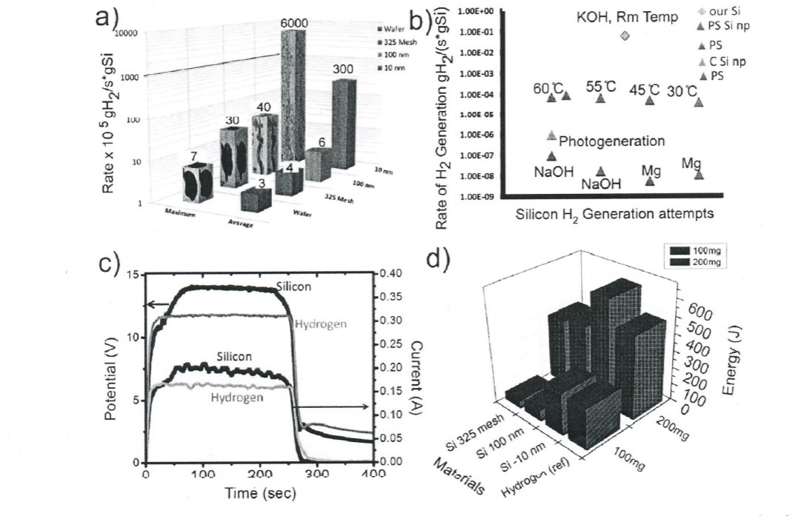
Fig. 6 Comparison of hydrogen generation rates for silicon in this (a) and other (b)
studies and fuel cell performance using hydrogen generated on-demand (c) and (d).
In addition to producing hydrogen faster than larger silicon pieces, the 10-nm silicon also produces hydrogen significantly faster than aluminum and zinc nanoparticles. Compared to aluminum, silicon reacts faster because because aluminum produces a denser and more robust oxide on its surface, which limits the reaction. On the other hand, silicon mostly forms soluble silicic acid. Compared to zinc, silicon is simply more reactive, especially at room temperature.
Although the larger surface area of the 10-nm silicon compared with the larger silicon pieces contributes to its fast hydrogen production rate, nevertheless it was found that surface area alone cannot account for the huge rate increase that the scientists observed. The surface area of 10-nm silicon is 204 m2/g, about 6 times greater than the surface area of 100-nm silicon, which is 32 m2/g, but the former generated hydrogen 150 times the rate of the latter. The researchers attribute this to the difference in the silicon etching process of the two piece sizes. They found that for the 10-nm particles, etching involves the removal of an equal number of lattice planes in each direction (isotropic etching). In contrast, for the 100-nm and larger particles, unequal numbers of lattice planes are removed in each direction (anisotropic etching). Consequently, the larger particles adopt non-spherical shapes that expose less reactive surfaces compared to the smaller particles which remain nearly spherical, exposing all crystal facets for reaction. Larger particles also develop thicker layers of oxidized silicon byproducts through which water must diffuse. Both of these factors limit the rate of the reaction on larger particles.
The key advantage, noted by the researchers, of this new mode for hydrogen generation by silicon oxidation is its simplicity. Using this approach hydrogen is produced rapidly, at room temperature, and without requisite external energy sources of electrical, thermal or optical nature. All of the energy input is effectively stored in the silicon which then can be used for hydrogen generation in portable applications. Once again we are led to the inescapable conclusion that nano-scale phenomena are not only harbingers of future currently unplumbed modes of energy generation, but possibly represent a window into new revolutionary physical worldviews that feature unsuspected activity of the quantum vacuum at molecular levels of nature. The following recent studies on nano-confined water certainly corroborate this conjecture.
4 UNPRECEDENTEDED ENERGETIC EFFECTS OBSERVED IN NANO-CONFINED WATER
The key to the remarkable properties of water is the hydrogen bond interconnecting the water molecules. It is usually regarded as classical and electrostatic. However, many observations are inconsistent with that picture. Crystallizing this notion is fresh evidence that has recently emerged that suggests that water confined in nanospace is both quantum coherent and proton superconducting by quantum delocalisation, which goes beyond classical jump conduction. One prime investigation that convincingly revealed this surprising finding, was conducted at the University of Houston from a team led by physicist George Reiter [16]. They used deep inelastic neutron scattering (DINS) to measure the distribution of momentum of the protons in the water molecules. The momentum of the proton is mainly determined by the wave-function of the proton's ground state. Using water confined in 16 Angstrom inner diameter double-walled carbon nanotubes (DWNT) and 14 Angstrom single-walled nanotubes (SWNT), this team found that there is significant overlap of the electronic wavefunctions of the donor and acceptor molecules in the hydrogen bond. The electronic structure of bulk water may thus possibly be a connected network, and that this network may respond differently than the interacting molecule model would suggest. In this experiment, marked differences in the DINS cross-sections of the momentum distribution of the protons were noticed with the SWNT compared to the DWNT protocols. Compared to bulk water, the width of the Compton profile narrows in the case of water in the SWNT, and broadens for the water in the DWNT. Both of the cylindrical vessels for the water have diameters differing on average by two Angstroms, and contain similar average densities of water, and yet the water responds completely differently in the two cases to the confinement. The team concluded that the quantum state of the protons is then extremely sensitive to the confinement, and responds to the global configuration of the hydrogen bond network. The departures of the momentum distribution of the protons from that of bulk water is so great that, as the team concluded, in essence the nano-confined water can properly be described as being in a qualitatively different quantum ground state than bulk water. Thus, the sensitivity to confinement coupled with the large departures from the momentum distribution for a single water molecule, are most likely due to correlated proton motion in the ground state of the system. This allowed the team to claim that there must be a quantum coherence length associated with these correlations. Moreover, equally surprising was the finding that proton momentum distribution in nano-confined water was also a function of temperature factors. Inexplicably, the momentum distribution in the SWNT was temperature-independent, whereas the DWNT data showed strong temperature-dependence, at a large range of temperatures from 5 K to room temperature (see Fig. 7). In further experiments, Reiter and colleagues discovered that water confined in a space dimension of 2 nm or smaller have protons that are coherently delocalized in two momentum states, in 'double wells' [16]. The team concluded by conjecturing that this new research may be instrumental in promoting a new model for water transport in biological channels. Since the kinetic energy per proton is higher in the confined space of the nanotube by 34 meV than it is in bulk water, the changes to the proton zero-point energy with confinement is clearly significant for water entering or leaving the biological energy channels. The quantum state of the water in these channels may also then be significant for energy transport through the channels, which is orders of magnitude greater than orthodox classical continuum flow theories would predict. The changes in the zero-point motion of the protons in confined water, as in living cells for instance, can be expected to play a significant role in the energetics of the cells, where typical distances between components are on the order of 20 Angstroms (~2 nm).
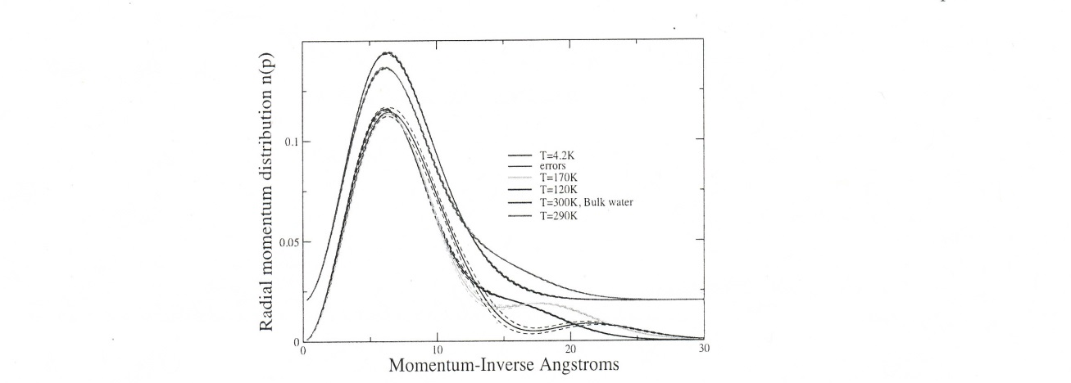
Fig. 7 Momentum distribution of the water protons in 16 A°
DWNT as a function of temperature, compared with that of
bulk water at room temperatures.

Following on the heels of this discovery is the recent revelation concerning the mechanical properties of nano-confined water layers. A pleasing resolution of earlier contradictory findings is presented by Peter Hoffmann and team of Wayne State University in the US, writing with Shivprasad Patil of the Indian Institute of Science Education and Research, Pune, India [17]. In an experimental tour de force, they used Atomic Force Microscopy (AFM) to make precise measurements of the of phase during sinusoidal oscillations of the film thickness with an amplitude that is less than the diameter of a water molecule, giving them access to the important linear-response region, which was essentially inaccessible to most prior measurements. Their main result is that, provided the confined film is formed at a rate that exceeds some critical value, water confined between the oscillating AFM tips and a single crystal (mica) shows progressively more sluggish mechanical relaxation as the film thickness decreases below 3-4 diameters of the water molecule. In liquids, stresses dissipate quickly, whereas in ideal solids, stresses persist indefinitely. The higher this relaxation time, the more 'solid-like' the liquid behaves. Thus the increase in effective viscosity is largest at slower approach speeds. At faster compression rates, the liquid responds elastically in the ordered state, exhibiting high elastic stiffness and low damping. The fact that the damping is reduced when the stiffness is increased, means that when the liquid is ordered (i.e., when the gap is an integer multiple of the molecular size), it has a strong elastic response (stiffness), but a weak dissipative response (damping). Mechanically the liquid behaves 'solid-like' in this regime. See Fig. 8 below for a depiction of the specific protocol involved.
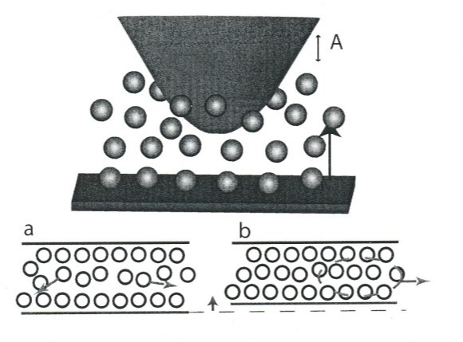
Fig. 8 Schematic showing the mica substrate approach
the AFM tip, while water molecules are confined in the
gap. (a) the confined water not exhibiting ordered layers;
(b) further compression orders molecules collectively in
vertical layers and diffusion is prevented

At first, viscous losses at a fixed frequency rise together with the stored elastic energy, but when the thickness is sufficiently small, the viscous losses pass through a maximum and subsequently decrease. It is worth noting that this behavior is characteristic of supercooled fluids when temperature is lowered or pressure is raised. This study indicates that confined liquids are neither like bulk fluids or crystalline solids. They appear to be an intermediate kind of matter whose finite size and surface-fluid interactions impart unique structural, thermodynamic, and dynamic properties. While their inherently heterogeneous character and sluggish relaxation times are reminiscent of the quantum energetics associated with supercooled fluids, the team suggests that it would be valuable to test this with a wider array of experiments.
5 MYSTERIES REVEALED FROM STUDY OF GOLD NANOPARTICLES AND FUTURE RELATED POSSIBLE NON-INVASIVE HEALING MODALITIES
Gold nanoparticles (GNP) currently command an intense and very broad research activity because of their peculiar properties. Whether it is in catalysis, optics, electronics, medical diagnostics, drug or gene delivery, sensing or theranostics, new applications have been found daily for the unique properties of these materials. All these desirable features, bound together in one nanometric piece of matter, possibly self-organized due to its ligands, make functionalized GNP a vital entity for nanosciences. About a decade ago a report was published with magnetometry data showing that gold nanoparticles, quite surprisingly, could also be magnetic, with features that the usual rules of magnetism were unable to explain. Many ensuing experimental papers confirmed this observation, although the reported magnetic behaviors showed a great variability, for unclear reasons. There has ensued a strong debate on whether this magnetism is intrinsic to the gold atoms forming the nanoparticle or whether it arises from extrinsic effects at the surface, impurities or other possible sources of a magnetic signal. Some of the more surprising recent incarnations of such novel magnetic behavior is the observation of paramagnetic or ferromagnetic properties in nanoscaled materials which are diamagnetic (i.e., non-magnetic) in the bulk. This type of behavior has been observed in metal oxide nanoparticles and nanocrystalline films [18], as well as typically paramagnetic (e.g., Pd [19]) and diamagnetic (Cu,Ag,Pt [20]) metal nanostructures. The latter include gold-based nanoparticles. Now, whereas the ferromagnetic metals (Fe,Co, and Ni) have an imbalance of spin-up and spin-down 3d electronic energy levels, the band structure of gold and its computed density of states reveals gold (in bulk) has a balanced spin-up and spin-down electrons, and thus is normally diamagnetic [21]. This predicted diamagnetism is in agreement with the experimentally observed negative susceptibility and diamagnetism of bulk gold [22]. Yet striking results are obtained when SQUID magnetometry is performed on functionalized GNP, such as dodecanethiol-coated ones. Rather than being diamagnetic, as expected, the nanoparticles can be found to be para- or ferromagnetic at room temperature and above. With all this wealth of experimental evidence, it has been determined that the magnetism of GNP is either induced by the SQUID setup, or that it can originate solely from the magnetic polarization of the individual gold atoms.
Various theories and explanations have been advanced to explain the magnetic properties of Au and other metallic nanoparticles. The possibilities that have been suggested roughly fall into three categories. The magnetism could result: (a) from the surface atoms of the metal cluster being more numerous than the core ones [23]; (b) the formation of covalent bonds between surface atoms and the ligands [24]; (c) electrons trapped in giant orbits circling around single domains of ligands (e.g., thiols) [25] or in a shell below the surface [26]. Even though the observed magnetic properties are strikingly unconventional, most of the theories proposed so far to explain them have been based on extensions of known principles. Regardless, none of these theories satisfactorily explain all the observations and in particular the obvious lack of reproducibility. This situation has recently been somewhat illuminated by the research of Gareth Nealon and team at the Universite de Strasbourg, France [27]. In weighing all the previously inconsistent data, this group postulated that the magnetism in gold nanoparticles (and other metals) could possibly very well originate in self-sustained persistent currents. In mesoscopic rings smaller than the electrron’s phase coherent length, currents can flow ‘forever’, even if the metal is not in a superconducting state, under the condition that the ring circles around a magnetic flux line, as depicted in Fig. 9 below.

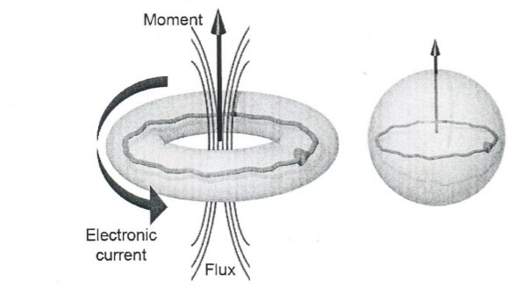
Fig. 9 Schematic representation of persistent currents
in a ring and in a nanoparticle
The magnetic moment of the ring can have the same direction as the applied magnetic field (paramagnetic response), or the opposite (diamagnetic response) depending on whether the number of conduction electrons is even or odd [28]. Dissipationless current flow in a resistive circuit looks counterintuitive, but is indeed possible if this peculiar state is the ground state of the system.
It is generally considered that the proof of the existence of persistent currents in a ring structure is the observation of an h/e or h/2e periodicity of the current when the applied magnetic field is swept [29], known as the Aharonov-Bohm (A-B) effect. Yet, generating a single flux quantum Φ = h/e ~4.14 X 10-15 Tm2 in a 2.1 nm loop would require a ~1200 T magnetic field, which is clearly out of reach for today’s state of the art technology. Also, to observe these currents, the temperature has to be sufficiently low to reduce the probability of inelastic scattering from phonons and other electrons, and the ring circumference must be sufficiently short that phase coherence of the electrons is preserved around the ring. Such persistent currents are thus usually observed in rings with a diameter smaller than 1 µm and temperatures lower than 1 K. The team was able to transpose this theory to nanoparticles at room temperature considering the previous experimental observation by several groups that demonstrated such currents to exist in rings made of Cu, Au, Al or semiconductors [30]. These currents would be induced by the magnetic field which is applied in most magnetic measurements, in particular SQUID magnetometry. They posited that the magnetism of GNP is of orbital origin and due to conduction electrons being driven by persistent currents. They demonstrated that this hypothesis is not only plausible but can also reconcile all of the previous experimental facts, in particular showing that the persistent currents would decrease exponentially with increasing temperature up to the so-called Thouless temperature. For 2 nm diameter nanoparticles, the Thouless temperature is over 104 K. Even a particle below the size of 20 nm could be able to sustain persistent currents up to 300 K. These reasons would explain the temperature independent magnetism in GNP. Although, as they acknowledged, obtaining direct proof of the existence of such persistent currents in GNP will be challenging, they suggested that near-field microscopy techniques could be used for this purpose. For instance, by attaching a GNP to the cantilever of an AFM, when placed in a magnetic field, the vibration frequency would be sensitive to any extra force generated by the magnetic moment of the nanoparticle [29]. If the moment is field-induced and non-permanent, no extra force should be perceived in zero field. They also suggested exploiting the Aharonov-Bohm effect by subjecting larger Au (or other metallic nanoparticles) to high magnetic fields to look for such A-B oscillations in their magnetic response. Given the orbital nature of the magnetic moment, the team also said that it would be worth trying magneto-optical experiments using circularly-polarized light to probe the magneto-plasmons.
Given that the phenomenon of persistent currents has only been up to now postulated to only exist in association with either atomic-level entities and sub-atomic particles, and macroscopic ultra-cold superconducting matter [31], certification of the existence of such perpetual current flow in molecular GNP at room temperatures would definitely represent a paradigm change in our very conception of magnetic fields and their global role in nature. Moreover, from a practical standpoint of specific uses of GNP, this paradigm-shift may be closer to the horizon than is currently suspected. Accordingly, in the last few years new potentially spectacular GNP-mediated non-invasive healing modalities, to be described next, have been investigated that have promise for future use.
Nanomedicine, in general, is an emerging field that offers great promise in the development of non-invasive strategies for the imaging, diagnosis and treatment of disease. The application of nanomaterials to the biohealth arena is an exciting prospect given that most cellular chemical and enzymatic interactions occur on the nanoscale. Therefore, the ability to manage or modify these processes with engineered molecules, or to affect diagnostic or therapeutic changes on a nanoscale level, could provide significant gains in medical care and represents a new frontier in therapeutics. Just such an advancement has been developed for the implementation of this frontier in nanomedicine.
Although RF (radio-frequency) and microwave electromagnetic fields have been used for tissue heating for many years, renewed attention has been given to the EM-field approach following developments by inventor John Kanzius, who devised a method combining a non-contact, capacitively coupled electric field arrangement with electrically conductive GNP to heat tissue [32], In Kanzius’ method, RF current passes through a medium without physical contact and the transmitter-receiver pair, thus avoiding the need for contact electrodes. Initial studies demonstrated that low concentrations of conductive nanoparticles consisting of gold nanospheres [33] or carbon nanotubes [34] cause dramatically increased absorption of RF energy, which is then dissipated in the form of heat. GNP have been the primary catalyst for the technique for many reasons – besides being excellent conductors of electrical and thermal energy, they are easily prepared and synthesized due to their presence of a characteristic surface plasmon resonance (absent in all other organic-based nanoparticle systems). Moreover, more pertinent to this protocol, their surface chemistry is relatively simple and surface modification (attaching biomolecules including proteins, antibodies, drugs and DNA) can be done fairly easily, they have a high surface area that allows multiple drug loading on a single particle, and are biocompatible while not eliciting toxic effects.
Accordingly, once the GNPs are internalized, they have provided non-specific RF targeting to human gastrointestinal cancer cells in vitro to produce intracellular heat when exposed to the external RF field. GNPs appear to be taken into the cancer cells by endocytosis with evidence of cytoplasmic vesicles containing GNPs observed from TEM (transmission electron microscopy) images (see Fig. 10 below). Exposure of GNP-bearing human cancer cells to this external RF field in this manner has produced observable dose-dependent lethal injury in 96% of these cells, while leaving healthy tissue relatively unharmed. As can be seen in Fig. 10, panel 1, where GNP are irradiated with RF energy, significant loss of nuclear stability and prominent vacuolization of pancreatic cancer cells is evident. With this evidence, it has been determined that ideally GNPs ultimately also hold promise for being targeted to malignant cells in vivo by attaching certain tumor-specific or tumor-related targeting molecules such as antibodies, peptides, or pharmacologic agents.

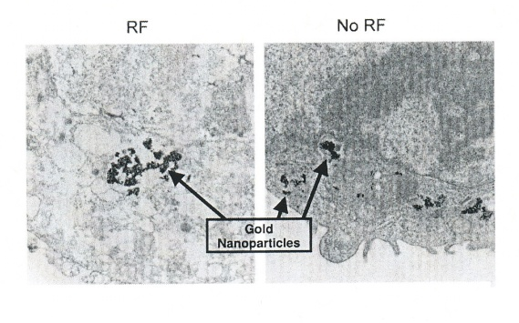
Fig. 10 TEM microscopy of pancreatic cancer cells
treated with 67 µ M/L gold nanoparticles. Left panel:
after 2 min. of external RF treatment; Right panel: No
RF treatment.
While excitation of GNP by RF produced by the Kanzius device, has indeed shown excellent promise as an effective protocol for treating certain forms of cancer, there are perplexing mysteries associated with this process that have arisen as well. The most prominent of these is the fact that attributes the destruction of cancer cells to application of a precise frequency of 13.56 MHz. This situation becomes more of a conundrum considering that in 2007 Kanzius demonstrated a device that quite unpredictably generated flammable hydrogen-containing gas from salt-water-solution by the use of radio waves - at this same exact frequency [35]. Moreover, this result was obtained with a mere 200 Watts of power of RF energy, whereas the standard protocol for water dissociation utilizing electrolysis requires power orders of magnitude greater. Closely echoing a theme that has been a major thread throughout the current paper, this discovery was made accidentally while Kanzius was researching the possible use of radio waves for desalination. The reader should note that what is also significant about these discoveries beyond their potentially useful and effective nature in treating cancer, is the recurring role played by serendipity that is also associated with Kanzius' discovery process. For some reason, apparently outside the present understanding of today's physics, the coupled systems of radio-frequency transmission and nanoparticle structure, at that precise frequency, produces enough heat that is directed in precise fashion microscopically and so far in vitro, to render malignant tumor-specific tissues powerless via subsequent apoptosis. Our final example of recent novel phenomena not only continues to underscore this basic unpredictability of results, but if reproduced could possibly also harbor the seeds of what many may view as a necessary extension of the current classical Maxwellian electrodynamics.
6 ULTRA-COLD MATTER PROTOCOLS AND THE IMPORT OF ASSOCIATED SERENDIPITOUS DISCOVERY
Since the mid-90s the pursuit of scientific discovery and advancement has been aided immensely by advent of the exotic matter state known as the Bose-Einstein condensate (BEC). It would even be fair to say that few developments in physics in recent times have made an impact on the practice and philosophical foundations of quantum mechanics in particular, more than this unique atomic matter state. Because of the wealth of new phenomena that the condensates display, and the precision and flexibility with which they can be manipulated, ever since they were first produced in 1995, interest in them have grown explosively in communities of experimental atomic physics, quantum optics, many-body physics and theoretical physics as well.
At very low temperatures matter has been shown to exhibit such exotic counter-intuitive behavior, whereby a large fraction of the atoms, usually in a dilute alkali gas, will go into the lowest energy quantum state. In essence a separation is effected – one part condenses, the rest remains as a saturated ideal gas. In a BEC atoms are all locked into all of the same attributes; they are literally quantum mechanically indistinguishable in the same location and with the same properties, displaying what is called quantum degeneracy. Similar to the counter-intuitive nature of quantum entanglement or quantum superposition, such facts greatly conflict with our conventional ideas associated with our perception of physical substance. As a consequence of experimentation with the BEC phenomenon, corresponding discoveries during the first decade of the millennium have brought forth surprises and unexpected revelations in regards to our previous limited understanding of the properties associated even with phenomena normally relegated to the classical macroscopic realm of mainstream physics. One of the most remarkable of these advances pertain to the precise control of speed of a light signal, particularly the recent achievement of slowing light to a crawl and ultimately ‘storing’ or stopping the progress of light for a few seconds [36]. It is especially significant that the Bose-Einstein condensate has been instrumental in providing the means to actually accomplish such astounding feats. In this context, the BEC has been used in an unprecedented manner to produce an enormously varying index of refraction of laser light, subsequently creating a huge reduction in the group velocity of the speed of light [37].
Curiously, this phenomenon and many similar subsequent discoveries associated with the BEC, too numerous to cite [37], were complete surprises, not even predicted to exist prior to its appearance on the stage of physical research. In many cases these discoveries have even illuminated and sharpened physicists’ understanding of laws associated with phenomena already canonized in the annals of physical discovery. Indeed, in the eyes of this author, this attribute of the condensates – the serendipitous quality of this exotic matter state – has been one of the key characteristics that continues to drive research in this area forward with no expected end in sight in the near future. Just such a potentially important discovery was made recently that was so unexpected that the researchers involved thought at the outset that it was a mistake or fluke in their recordings. This is related to recent experiments that have been successful in bringing clouds of ultra-cold alkali atoms close to the surface of copper current conducting wires [38]. Those clouds have been prepared below and above the critical temperature for Bose-Einstein condensation and in all cases a fragmentation of the atomic distribution has been observed which suggests the presence of an as yet unexplained potential caused by the conductors. This result demonstrates that ultra-cold atoms, as provided by a BEC, can be used as an ultra-sensitive probe for magnetic fields in the vein of SQUID apparatus [39]. The probing principle is based on the force that is acting on the atoms in a static magnetic field. It is proportional to the gradient of the magnetic field modulus [40] and results in a change of the atomic distribution which can be imaged by standard techniques. The spatial dependence of the magnetic field modulus can be probed by moving the atomic cloud within the magnetic field. This is possible by using optical forces [41] or by means of magnetic potentials. In the latter case, the sample field to be measured and the trapping field may superimpose. Fig. 11 shows the setup of the experiment. In addition to the field generated by the conductor, two homogeneous fields are present, one oriented perpendicular to the wire (bias field) and the other oriented parallel to the wire (offset field). The bias field Bbias together with the usual circular field of the conductor form a linear magnetic quadrupole field with a vanishing magnetic field along a line parallel to the wire and separated from its center by a distance . Here I is the current in the conductor. Perpendicular to the line of vanishing magnetic field, its modulus increases linearly with the distance and forms a waveguide-like trapping potential for ultra-cold atoms [41]. While the transverse motion of the atoms is confined by the potential, the atoms can move freely along the longitudinal direction. A hypothetical longitudinal component would generate an additional
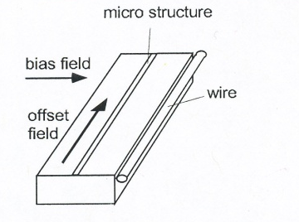
Fig. 11 The trap set-up, showing two conductors used mirco-fabricated copper conductor path (width 30µm) and ordinary copper wire (90 µm); with addition of perpendicular bias field, a waveguide is formed. The offset field generates a non-vanishing longitudinal component.
longitudinal potential that can be detected by observing the atomic distribution along the wire. Just such a longitudinal magnetic
field component was observed in this experiment. It is three to four orders of magnitude smaller than the usual circular field but
still strong enough to trap the atoms in the longitudinal direction. The atomic distribution shows a pronounced periodicity of 200-
300 µm which corresponds to a similar modulation of the anomalous field component at the location of the atoms.

The possible influence of longitudinal electromagnetic field components on a macroscopic scale, although inconsistent with the
foundations of standard electromagnetic theory, has been a subject of concern of many researchers over the years, from the
original inspiring seminal experimental work of Nikola Tesla [42], to the current courageous forays into
this aspect of the possible necessity for extension of classical electrodynamics [43]. One notable compelling paper in this vein is
the recent work by Lee Hively and G.C. Giakos which, via examining certain specific experiments currently inexplicable with
Maxwellian theory, have theoretically formulated the possible existence of a charge-fluctuation-driven scalar wave, having
energy but not momentum, as well as a second longitudinal-electric wave with energy and momentum [44].

At any rate, these findings associated with a possibly quantum-mediated weak but measurable longitudinal magnetic field component, detected via BEC protocols alluded to above, coupled with the important certification of the discovery of the memristor, may ultimately portend new understanding associated with even standard classical Maxwellian electrodynamics.
CONCLUSIONS AND PROSPECTS
This journey that has been taken focusing on specific recent discoveries in either nano-scale research or revelations from ultra-cold matter phenomena only serves to highlight the theme, perhaps yet not fully appreciated by mainstream physics, of the surprisingly considerable influence of quantum factors - normally a standard feature of atomic scale - on the molecular and larger scales of nature. Although the aim of this paper is not to particularly formulate new specific worldviews or paradigm changes, the more modest goal is sought of showing the reader the importance of considering such various serendipitous related phenomena that, by their very nature, can serve a springboard for the seeds of such future possible revolutions in physics. Perhaps this recent flurry of serendipitous phenomena is pointing us to consider the distinct possibility that the realms of nature in which the principles of quantum mechanics holds sway, may be much wider than is currently suspected. As we have seen from this current investigation, empirical evidence supporting this is amply evident from a wide panorama of scientific disciplines. To summarize these important findings: (1) the new ways of generating steam by nano-scale dynamics which puts in direct jeopardy the standard classical mechanical Fourier law of heat transfer by positing a yet unprobed quantum-generated thermal nanobubble barrier [9], as well as possible new quantum-mediated effects ultra-sensitive to the mere nano-confinement of water [16,17]. (2) the compelling evidence that has been advanced for a re-examination of the currently unquestioned acceptance of the standard laws of classical Maxwellian electrodynamics applied even to nano-levels of nature, exemplified by the existence of the memristor at nanoscales of application [3], coupled with the possible existence - again at molecular levels - of a surprising miniscule but measurable “longitudinal” magnetic field component revealed through unique fragmentation of Bose-Einstein condensates of alkali atoms as applied to macroscopic circuit elements [38]. In this regard, the advent of the forthcoming era of so-called “mem-components” in miniscule circuitry [6] is definitely upon us with the inevitable further scrutiny of this apparently heretofore unplumbed novel relationship between charge and magnetic flux, even in the province of regimes normally ascribed to macroscopic fields. In concert with this, as has been suggested by the inspiring work of Lee Hively [44] and others [43], a modification of even the classical law of charge conservation, in conjunction with appropriate extensions of quantum mechanics, might even be on the horizon.
Accordingly, as if on cue, certain other recent experimental work in Feb. 2013 definitely corroborates these speculations, as it has been found that the activation energy required for the diffusion of the aromatic ring-like molecule known as pyrrole over a metal (copper) surface is much larger than that arrived at by standard semi-classical calculation for activation energy [45]. Instead, the team led by Barbara Lechner at the Cavendish laboratory, found that the correct activation energy to loosen the pyrrole’s bond from the metal surface could only be accounted for by factoring in the contribution of the molecule’s quantum zero-point energy. Indeed, as they puzzled out this mystery, the researchers found that the zero-point energy, normally expected to be too small to influence the molecule’s internal motion, is unexpectedly sensitive to the exact site occupied by the molecule on the metal surface, changing the very nature of the energy landscape and correspondingly, significantly affecting the molecule as a whole as it moves across that surface [45]. Another theme represented by these findings and the related ones associated with new evidence on nano-confinement of water, is the key “contextual” quantum factors present at many scales of nature, some currently unexpected, which could shape the very evolution of physical systems. The author’s companion recent papers represent a more in-depth investigation of this possible aspect of natural law at both microscopic and large-scale realms of nature [37,46].
REFERENCES
[1] Mikki, S.M. & Kishk, A.A.,”Electromagnetic scattering by multi-wall carbon nanotubes”, PIER, 86, p. 111, (2008).
[2] Chua, L.O.,”Memristor-The missing circuit element”, IEEE Trans. Circuit Theory, 18, p. 507, (1971).
[3] Strukov, D.B., Snider, G.B., Stewart, D.R. & Williams, R.S., “The missing memristor found”, Nature, 453, p. 42, (2008).
[4] Massimiliano, Di Ventra, Pershin, Y.V., “The parallel approach”, Nature Physics, 9, p. 200, Apr. 2013.
[5] Aczel, A., Entanglement: The Greatest Mystery in Physics, John Wiley & Sons, Inc., (2003).
[6] Massimiliano, Di Ventra, Pershin, Y.V. & Chua, L.O.,”Circuit elements with memory: memristors, memcapacitors and meminductors”,arxiv:cond-mat.mes-hall/0901.3682, 23 Jan 2009.
[7] Pershin, Y.V., Di Ventra, M., “Experimental demonstration of associative memory with memristive neural networks”, Neural Networks, 23, p. 881, (2010).
[8] Govorov, A.O., Richardson, H.H., “Generating heat with metal nanoparticles”, Nano Today, 2, p. 30, (2007).
[9] Neumann, O., Urban, A.S., Day, J., Lal, S., Nordlander, P. & Halas, N., “Solar vapor generation enabled by nanoparticles”, ACS Nano, XXX(XX), Nov. 2012.
[10] Khaselev, O., Turner, J.A.,”A monolithic photo-electrical chemical device for hydrogen production by water splitting”, Science, 280(S362), p. 425, (1998).
[11] Goller, B.,, Kovalev, D. & Sreseli, O., “Nanosilicon in water as a source of hydrogen: size and Ph matter”, Nanotechnology, 22, p. 305402, (2011).
[12] Kale, P., Gangal, A.C., Edla, R. & Sharma, P., ”Investigation of hydrogen storage behavior of silicon nanoparticles”, Int J Hydrogen Energy, 37(4), p. 3741, ( 2011).
[13] Bahruji, H., Bowker, M. & Davies, P.R., ”Photo-activated reaction of water with silicon nanoparticles”, Int J Hydrogen Energy, 34(20), p. 8504, (2009).
[14] Erogbogbo, F., Lin, T., Tucciarone, P.M., LaJoie, K.M., Lai, L., Patki, G.D., Prasad, P.N. & Swihart, M.T., “On-demnd hydrogen generation using nanosilicon: Splitting water without light, heat or electricity”, NanoLetters, 13, p. 451,( 2013).
15 http://phys.org/news/2013-01-nanosilicon-rapidly-electricity.html.
[16] Reiter, G.F., Kolesnikov, A.I., Paddison, S.J., Platzman, P.M.,Moravsky, A.P., Adams, M.A. & Mayers, J., “Evidence of a new quantum state in nano-confined water”, arxiv:cond-mat.mes-hall/1101.4994, Jan. 27, 2011.
[17]Khan, S.H., Matei, G.,Patil, S. & Hoffmann, P.M., “Dynamic solidification in nanoconfined water films”, arxiv:cond-mat.soft/1006.3320, Jun. 16, 2010.
[18] Sundareson, A., Rao, C.N.R., ”Ferromagnetism as a universal feature of inorganic nanoparticles”, Nano Today, 4, p. 96, (2009).
[19] Hernando, A., Sampredo, B., Litran R., et al, “Room temperature permanent magnetism in thiol-capped Pd-rich nanoparticles”, Nanotechnology, 17, p. 1449, (2006).
[20] Suber, L., Dino, F., Scavia, G., et al,, “Permanent magnetism in dithiol-capped silver nanoparticles”, Chem Mater, 19, p.1509, (2007).
[21] Ramchandani, M.G., ”Energy band structure of gold”, J Phys C Met Phys, 3, S1, (1970).
[22] Lide, D.R. (ed), Handbook of chemistry and physics, CRC Press,, Boca-Raton, (2009-2010).
[23] Yamamoto, Y., Muira, T., Suzuki, M., Kawamura, N., Miyagaya, H., Nakamura, T.,Kobayashi, K.,Teranishi, T. & Hori, H., ”Direct obeservation of ferromagnetic spin polarization in gold nanoparticles”, Phys Rev Lett, 93, p. 116801, (2006).
[24] Crespo, P., Liran, T.C., Rojas, T.C. et al, “Permanent magnetism, magnetic anisotropy, and hysteresis in thiol-capped gold nanoparticles”, Phys Rev Lett, 93, p. 087204, (2004).
[25] Hernando, A., Crespo, P., Garcia, M.A., de la Venta, J., Fernandez, A., & Penades, S., “Giant magnetic anisotropy at the nanoscale: overcoming the superparamagnetic limit”, Phys Rev B, 74, p. 052403, (2006).
[26] Hernando, A., Crespo, P., Garcia, M.A., Coey, M., Ayuela, A., & Echenique, P.M., “Revisiting magnetism of capped Au and ZnO nanoparticles: surface band structure and atomic orbital with giant magnetic moment”, Phys Status Solidi B, 248, p. 2352, (2011).
[27] Greget, R., Nealon, G.L., Vileno, B., Gallani, J-L et al, “Magnetic Properties of Gold Nanoparticles: A Room-Temperature Quantum Effect”, Chem Phys Chem, 13, p. 3092, (2012).
[28] Waintal, X., Fleury, G., Kazymyrenko, K., Houzet, M., Schmitteckert, P. & Weinmann, D., “Persistent currents in one dimension: the counterpart of Leggett’s theorem”, Phys Rev Lett, 101, p.106804, (2008).
[29] Blesynski-Jayich, A.C., Shanks, W.E., Peaudecerf, B., Ginossar, E., von Oppen, F., Glazman, L. & Harris, J.G.E., “Persistent currents in normal metal rings”, Science, 326, p. 272, (2009).
[30] Levy, L.P., Dolan, G., Dunsmuir, J. & Bouchiat, H., “Magnetization in mesoscopic metal copper rings: evidence for persistent currents”, Phys Rev Lett, 64, p. 2074, (1990) .
[31] Gonzalez-Jorge, Peletiero, J. Carballo, E., Romani, L. & Domarco, G., “Procedure to induce a persistent current in superconducting cylinders or rings”, Appl Phys Lett, 81, p. 4207, (2002).
[32] Gannon, C.J., Patra, C.R., Bhattacharya, R.,Mukherjee, P. & Curley, S.A.,”Intercellular gold nanoparticles enhance non-invasive radiofrequency thermal destruction of human gastrointestinal cancer cells”, Journal of Nanobiology, 6 p. 2, Jan. 30, (2008).
[33] Kruse, D.E., Stephens, D.N., Lindfors, H., Ingham, E.S., Paoli, E.E. & Ferrera, K.W., “A radio-frequency coupling network for heating of citrate-coated gold nanoparticles for cancer therapy: design and analysis”, IEEE transactions on biomedical engineering, 58 (7), July 2011.
[34] Gannon, C.J., Cheruki, P., Yakobson, B.I., Cognet, L., Kanzius, J.S., Kittrell, C., Weisman, R.B., Pasquali, M., Schmidt, H.K., Smalley, R.E. & Curley, S.A., “Carbon nanotube thermal destruction of cancer cells in a noninvasive radiofrequency field”, Cancer, 110 (12), Dec. 15, 2007.
[35] en.wikipedia.org/wiki/John_Kanzius.
[36] Hau, L.V., Harris, S.E., Dutton, Z. & Behroozi, C.H., “Light speed reduction to 17 meters per second in an ultra-cold atomic gas”, Nature, 397, p. 594, (1999).
[37] Reed, D., “Bose-Einstein condensate-hidden riches for new forms of technology and energy generation; potential for glimpse into inner reality”, Physics Procedia 00(2012))000-000(Elsevier), Space, Propulsion & Energy Sciences International
Forum
2012, p.1, 2012.
[38] Kraft, S., Gunther, A., Ott, H., Wharam, D., Zimmermann, C. & Fortagh, J., “Anomalous longitudinal magnetic field near the surface of copper conductors”, J. Phys B: At Mol Opt Phys, 35, p. L469, (2002).
[39] Wildermuth, S., Hofferberth, S., Lesanovsky, I., Groth, S., Bar-Joseph, I., Kruger, P. & Schmiedmayer, J., “Sensing electric and magnetic fields with Bose-Einstein condensates”, arxiv: cond-mat.other/0512520, Dec 21, 2005.
[40] Reichel, J., Appl Phys A, 75, p. 469, (2002).
[41] Gustavson, T.L., Chikattur, A.P., Leanhardt, A.E., Gorlitz, A., Gupta, S., Pritchard, D.E. & Ketterle, W., “Transport of Bose-Einstein condensates with optical tweezers”, Phys Rev Lett, 88, 020401, (2002).
[42] Tesla, N. “The problem of increasing human energy”, Century Illustrated Magazine, June, 1900.
[43] Giakos, G.C. & Ishii, T.K.,”Detection of longitudinal electromagnetic waves in air”, Microwave Optical Techn Lett, 6, p. 283, (1993); Monstein, C. & Wesley, J.P., “Observation of scalar longitudinal electrodynamic waves”, Europhys Lett, 59, p. 514, (2002); van Vlaenderen, K.J. & Waser, A., “Generalisation of classical electrodynamics to admit a scalar field and longitudinal waves”, Hadronic J, 24, p.609, (2001).
[44] Hively, L.M. & Gaikos, G.C., “Toward a more complete electromagnetic theory”, Int. J. Signal and Imaging Systems Engineering, 5 (1), p. 3, (2012).
[45] Lechner, B.S., Hedgeland, H., Ellis, J., Allison, W., Sacchi, M., Jenkins, S.J. & Hinch, B.J., “Quantum influences in the diffusive motion of pyrrole on Cu(111)”, Angewandte Chemie, 52, p. 1, (2013); Future Energy eNews, Integrity Research Institute, April 2013.
[46] Reed, D., “The Chameleon hypothesis, contextual cosmos, and prospects for novel forms of technology and energy generation”, Physics Procedia 00-(2011)000-000(Elsevier), Space, Propulsion & Energy Sciences International Forum, (2011): p. 1, (2011).
_________, “Camouflaged Contextual Posturing in the Laws of Nature”, Proceedings of the 18th Natural Philosophy Alliance (NPA) Conference – 2011: p. 265, 2011; Infinite Energy, Issue 102, Mar-Apr 2012.

