Stellar Metamorphosis:
An Alternative for the Star Sciences

Jeffrey J Wolynski
Cocoa, FL 32922
Email: Jeffrey.wolynski@yahoo.com

Lex Parsimoniae

This paper explains that planetary formation is stellar evolution. Planets are ancient stars and stars are young planets.

The Wrong Root Assumption
It has been assumed for thousands of years that stars are mutually exclusive objects and that their formation leaves left over remains called planets, but this leaves a gigantic problem. Any sort of logic or math that uses wrong root assumptions will always be wrong. This means if the wrong root assumption is kept, that stars and planets are separate objects, there is no possible way to understand anything. Logic only works if the assumption is correct. Therefore this paper only corrects the root assumption and gives reason why it must be corrected immediately. Math does not possess the capacity to correct root assumptions, only a thinking mind can do that.

1.2. The Correct Root Assumption

Planet formation is star evolution. ^{[1][2][3]} Referring to stars as planets and planets as stars are both correct. They are synonymous terms. It should also be understood by the reader that the word planet is from the ancient Greek for “wandering star” or αστήρ πλανήτης (astēr planētēs). Stars are planets, they are the same objects.

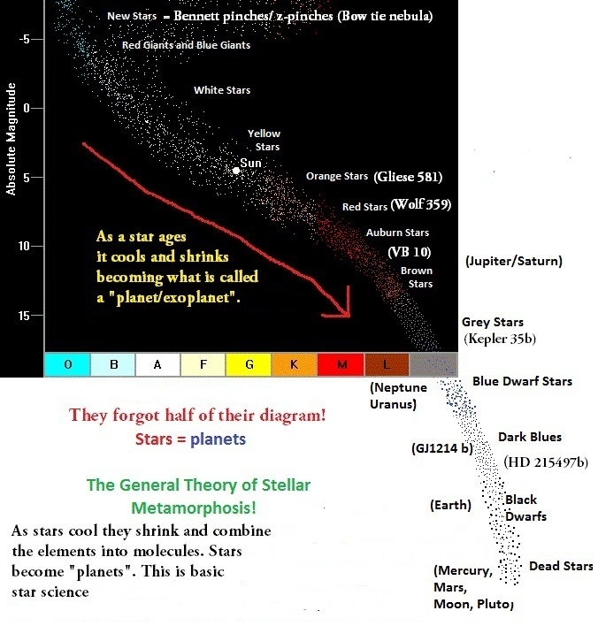

2. Phase Transitions
2.1 Matter Creation
Quasars create matter as they are new born galaxies. ^{[4][5]} Stars do not create matter they are the dissipative structures that sort the material into cohesive objects and begin the formation of life. A picture of this matter creation is provided as the radio galaxy Hercules A, as it is a new galaxy growing new arms. To deny the observational fact that material is coming out of this object is to be in denial of both common sense and scientific discovery.

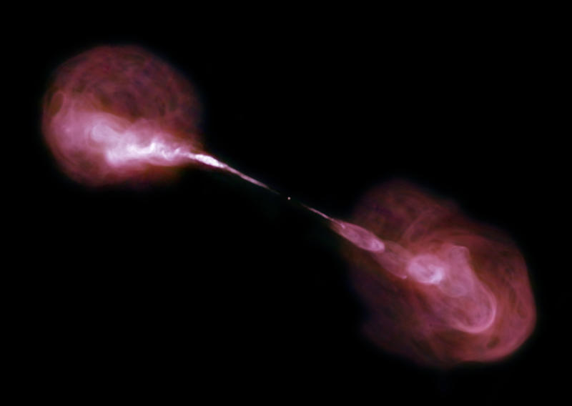
Hercules A

2.2 Gas to Plasma
A portion of a large gas cloud that was created by a birthing galaxy condenses and is squeezed and heated by a Z-pinch mechanism. The pinching and heating of the material is caused by enormous electric current flowing through the gas causing very strong magnetic fields to ionize the gas to plasma, similar to an induction heater used to melt metals. The enormous amount of heat and pressurization in the center of this object causes the outer layers to exhibit extremely cold temperatures so that thermodynamic equilibrium remains steady as the star is forming. As we can see theoretical proto-stars created via gravitation or T-Tauri stars are pure fiction invented by mathematical physicists as no pictures of them currently exist in scientific literature. Below is a picture of the Boomerang Nebula, this is a birthing star, as no math is required to see what a new star looks like.

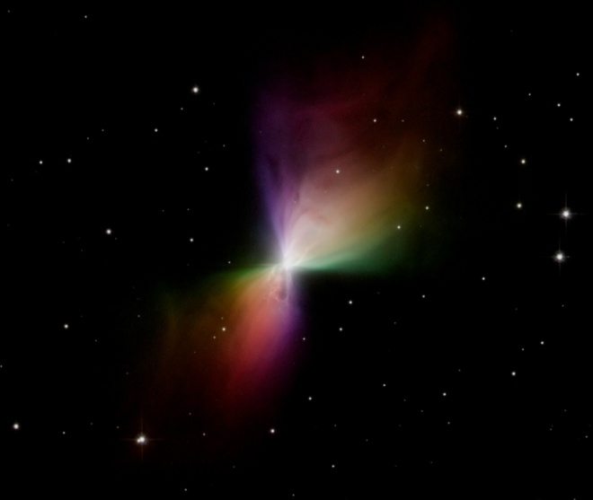
Boomerang Nebula

2.3 Plasma to Gas
A young star full of plasma remains very hot and large, as the majority of the mass is located in the outer shell of the star. Eventually it will condense as the material needed for iron core formation starts depositing on the inner iron substrate. The other elements will start recombination meaning they will combine to make what are called molecules such as water, silicone dioxide, methane, and even amino acids. This plasma will continue to cool as the shell contracts to become gas creating what is called a red dwarf and eventually a “gas giant planet”.

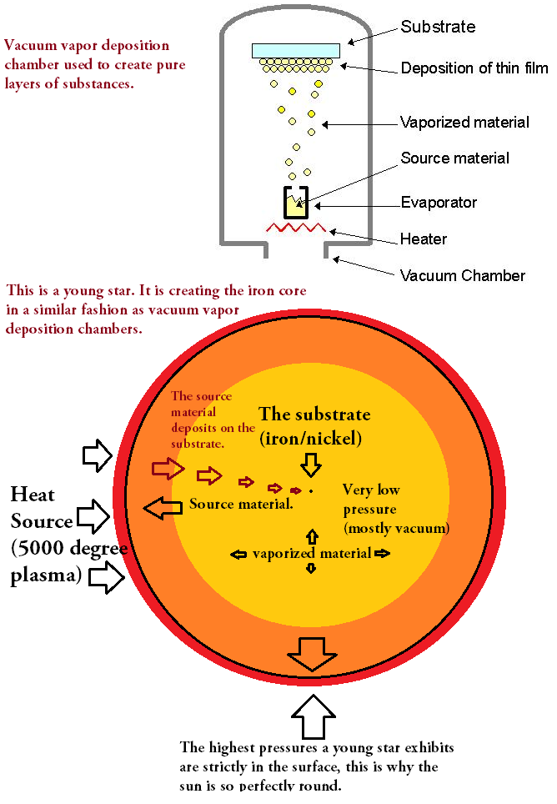

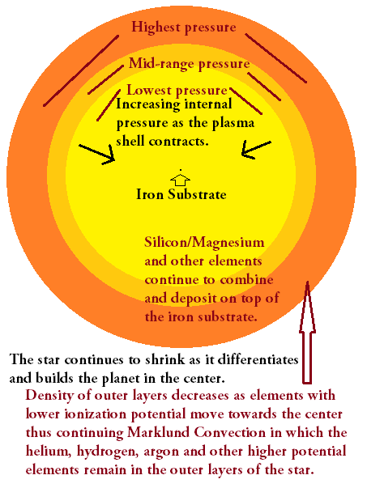
Orange Star

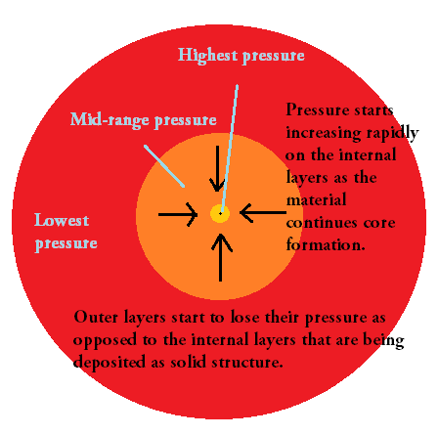
Red Dwarf Star

2.4 Gas to Solids and Liquids
A gas giant continues cooling and deposits the material as solids and liquids thus forming what are called “rocky planets” like Earth. The gas undergoes continual deposition, condensation and freezing on higher temperature and pressure scales. This process creates the very ground that is walked upon, and is also why geological areas are made of layered rock such as the Grand Canyon. Also water vapor in the atmosphere of the cooling star cools considerably and becomes liquid in very large amounts thus forming the oceans.

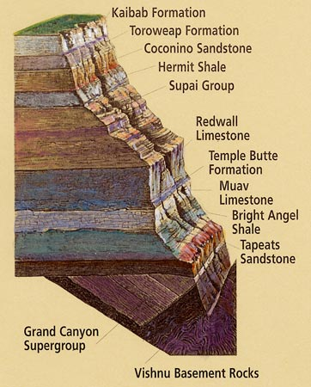

2.5 Solid Material to Asteroids and Rings
The dead star wanders the galaxy smashing into other dead stars as they change orbits creating asteroid belts and rings around other younger stars. This is why the famous proto-planetary disks are bright in the infrared but cool very quickly, as they are the remains of stars smashing into each other leaving red hot shrapnel to float about indefinitely in outer space. It is taught and believed by the establishment that proto-planetary disks create Earth sized objects the opposite is actually true, they signal star destruction.

2.6 Phase Transitions
Simple phase transitions are ignored by the astrophysicists, astronomers and geologists of the 20th and 21st centuries. Thermodynamic phase transitions are the process with which plasma can change its state back to a gas, or a gas can become a solid/liquid or go back to being plasma again. The incredible amount of energy that can be stored and released when a young star cools and recombines the vast majority of its plasma into gas or gas into plasma is astounding as this recombination and ionization on large scales are what cause solar flares. Also in addition, the energy then thus stored as the gas deposits as liquids such as oil/water increase even more considerably. If gas deposition did not occur inside of middle aged stars such as Jupiter or Saturn, then the older stars such as the Earth would have never formed incredible oil deposits or any layered material such as the Grand Canyon or any geological formation for that matter.
The process of planetary differentiation occurs during a stars’ metamorphosis, from large gas cloud, to large cohesive blue star in a z-pinch, then down to cooler plasma that becomes gas, then down to solids and liquids which forms the very atmosphere and ground all humans walk upon. The birthing process of a star is the only stage at which the overall enthalpy of the system increases. After the star is born its evolution takes the reverse path and the enthalpy of the star diminishes considerably.
This decreasing enthalpy is what gravitation is, it is an effect of large scale non-equilibrium thermodynamics. ^{[6]} Gravitation itself is a thermodynamic event in which a stars material is simply losing enthalpy at a specific rate. It is not a force, is not constant, and is not caused by math equations that state that space warps. The faster the lowering of enthalpy the higher the “gravitation”, thus meaning if a star loses enthalpy faster than another, it will exert more “gravitation”. This is why the younger stars Jupiter and Saturn are measured to be more “massive” than the Earth, and why the Sun appears to be more massive than all the others combined. The truth is that they are more than likely much similar in mass, not thousands of times heavier than each other. Using mass as the cause of gravitation is not science. Actual objects changing their state cause gravitation, not fantasies like space-time warping or fictional objects like gravitons.

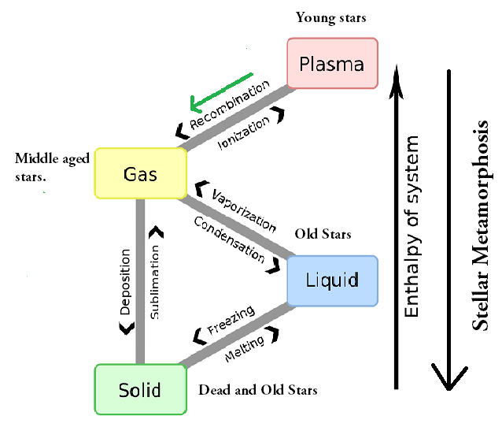

3. Chemical Separation
In ionized plasmas the material will chemically separate according to its ionization potentials. This is understood as Marklund Convection. ^{[7]}

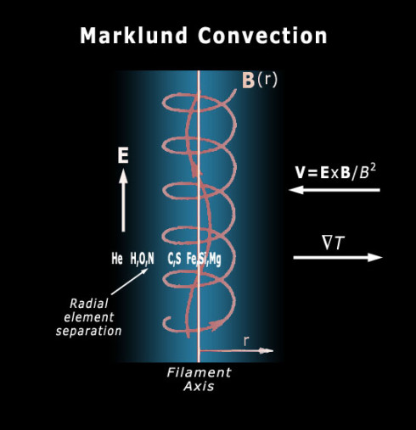

We can see this convection in the weather patterns of the brown dwarf star Jupiter and in all weather on all stars including the Earth and Neptune. It is sorting all types of elements according to their ionization potentials, specific heat capacities, hydraulic and pneumatic properties. This is what the Earth looked like during intermediate stages of metamorphosis. Jupiter will turn blue and shrink in the future as it takes up the appearance of Neptune in a few hundred million years.

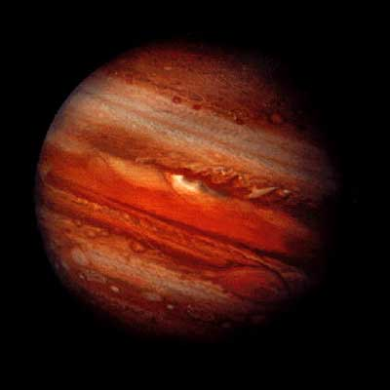

Jupiter has very high ratios of ionized material as is evidenced by large electrical currents in the gigantic atmosphere of this aging star, as the metallic hydrogen explanation fails to account for ionization, which is clearly evidenced via radio waves. This means that the mathematical models for Jupiter being only a neutralized ball of gas have been falsified extensively by the observational evidence for radio wave emission. This ionized material is in the process of water ocean formation and because of this will further facilitate the layers of silicates to cool from waters’ high specific heat capacity. The water is what cools the silicates down to form a crust that encapsulates the still molten core and will trap the heat of this star for many more billions of years.
This process is also what forms the layers of rocks seen on the Earth such as feldspars and quartz and creates entire swaths of land raised slightly above the more dense basaltic formations. The more water that is formed from hydrogen and oxygen neutralizing each other, the smaller the magnetic field of Jupiter will become over time. Over many more millions of years it will eventually take up the appearance of Neptune and Uranus which have vast oceans of water and are in the process of life formation.
The layers of the Grand Canyon were made as a result of direct deposition of gaseous silicon dioxide and hydrogen based molecular gases that have higher ionization potentials, as opposed to high density hydrocarbons (oil, natural gas, coal) and iron based composites that deposited in earlier stages of metamorphosis. Deposition is a process in physics when a gas becomes directly a solid and is an essential process in Stellar Metamorphosis as well as other types of phase transitions. We can see this process in the creation of snowflakes from water vapor being directly deposited in crystalline patterns that fall to the ground and layer themselves on the Earth.

References

^{[1]} Wolynski, Jeffrey (2012). Stellar Metamorphosis: An Alternative for the Star Sciences. http://vixra.org/pdf/1303.0157vC.pdf.
^{[2]} Abruzzo, Anthony (2008). Are Planets the End Products Rather than the By-Products of Stellar Evolution?. The General Science Journal http://gsjournal.net/Science-Journals/Research%20Papers-Astrophysics/Download/1160.
^{[3]} Oparin, Alexander (1924). The Origin of Life. http://www.valencia.edu/~orilife/textos/The%20Origin%20of%20Life.pdf.
^{[4]} Arp, Halton (1989). Quasars, Redshifts and Controversies. Cambridge University Press. ISBN 0-521-36314-4. http://books.google.com/?id=_JYWqe2qMZ0C.
^{[5]} V. A. Ambartsumian, Theoretical Astrophysics. Translated from the Russian ("Teoreticheskaya astrofizika", Moscow, 1952) by J.B. Sykes, New York: Pergamon Press, 1958
^{[6]} Gyarmati, I. (1970). Non-equilibrium Thermodynamics. Field Theory and Variational Principles, Springer, Berlin.
^{[7]} Marklund, Göran (February 1979). "Plasma convection in force-free magnetic fields as a mechanism for chemical separation in cosmical plasma". Nature 277: 370–371.

