“The Structure of Motion and Energy”
From the perspective of Field Structure Theory
Prepared for the Natural Philosophy Alliance (NPA-20) conference
to be held July 2013 at UMD campus, College Park, MD
Charles Donald “Don” Briddell
Independent Field Structure Research
donbriddell@fieldstructure.org
© 18 May 2013
Paper 12

Abstract: Motion of all kinds is understood in structural analytics as deploying and condensing plenum waves. The structural relationship between boson and fermion motion is explained.

.1 Introduction

.1.1 Traditional views of motion and energy

Traditional motion analytics creates an arbitrary space/time matrix against which motion is charted as the relative change in position of an event(s) in time. The objects moving in a conceptual space/time matrix are not causally attached to the matrix and were never designed to suggest this was the case. The connection between object and its motion is thought to be structurally unrelated to the space.

Einstein curved space to account for gravity, but offered no explanation as to what was curving. The mainstream view in physics is that space has only two properties: (1) it is devoid of form and structure and at the same time (2) it is somehow curved? Why a featureless space could curve the orbital path of a LMO (Large Massive Object) is left unanswered. The idea of mass affecting space was there with Einstein, but not the reciprocal idea that space affected mass. Etymologically, this view probably originates from the perceptual modes orperandi of western science that interprets the world from the object’s point of view.

1.2. Field Structheory Theory’s view of motion and energy

In Field Structure Theory (FST), reality is understood from the field’s point of view, because this view connects and harmonizes space, with energy and mass dynamics. There is a plenum that has structure and this structure determines everything about the formation and character of energy and mass.
Mainstream physics makes no meaningful connection between matter and space because space is thought to have no features that matter. In FST all manifestations of form are field-like in nature. Matter is a condensed field, kinetic energy is a condensed field in the act of deploying and potential energy is a fully deployed field. Motion is a property of the underlying universally pervasive field matrix, the plenum. Pervading reality is a plenum. It is an action matrix that imparts motion.

- When the plenum interacts with itself, energy arises.
- When energy interacts in the proper manner, the plenum condenses and knots into a mass.
- When mass decays, energy is released.
- Mass is where there is an abundance of plenum (energy) held to a location by virtue of being entangled by a knot.
- Mass occurs by the fixing of condensed EM waves through the agency of three-dimensional knotting.
- A three-dimensional knot called a fieldstructure is how Nature creates space and time.
- The plenum itself has no spatial/temporal form.
- In FST, something that is three-dimensionally knotted causes one part of the form to expand while another part of it condenses.
- A stable mass is one in which its expansive centrifugal force is balanced by its condensing centripetal force while maintaining a spatial/temporal form.
- Gravity is the effect on the plenum caused by condensing energy to a locality, hence all forms having mass also have gravity.
- When plenum interacts to produce energy, it does so by twisting together a right and left-handed loop of action.
- Electromagnetism (EM) arises when an interacting set of right-handed (RH) and left-handed (LH) plenum waves twist together to form a wave set.
- When one side of the wave set condenses leaving the side not condensed, the condensed side becomes a fermion particle, while the other deployed side remains a wave.
- Charge becomes a characteristic of force when either the RH or LH wave has been condensed leaving the other side of the wave side deployed.
- When both sides are equally deployed or condensed there is no charge. (Photons and neutrons have neutral charge).
- Electrical current is a wave that is either deploying or condensing in its effort to equalize the frequencies of the RH and LH waves that make up an electromagnetic wave set.
- The phenomena of kinetic radiant EM energy occurs when a mass decays.
- Energy is the release of a condensed wave allowing it to deploy.

It is the job of mass to organize action (energy) into structures that will endure in time and maintain a localized spatial extension. Mass can be seen as a device that tells energy how to move within a specific volume of space. Mass and energy are both derived from the plenum; radiant energy being deployed plenum having boson structure, while mass is the closed energy fermion form of the plenum.
The impulse to move is coming from the plenum matrix and not from the object moving in the matrix. For example, if a magnetic field, which is condensed wave surrounds a wire, a current of electrons is induced to flow in the wire. Fields formed in and of the plenum matrix come with an inherent structural imperative that becomes transferred to all structure be it energetic or material. Understanding the structure of mass is only a partial knowledge of reality. The structure of the plenum gives the full picture as to the nature of reality. This infers that objects in themselves don’t create motion, instead they respond to motion. It is the underlying topological geometry of the plenum that is causing motion. The plenum is a scaffold on which reality is energetically formed. The structure of the scaffold determines where a mass will move. Field Structure Theory shows how the topology of the action plenum forces objects in motion to use the architecture of interacting loops the way a locomotive has to follow the rails. What moves is one side of the wave in its effort to deploy frequency evenly with the other side of the wave set. (wave set = R and L handed EM waves). This architecture has been explained in Papers 3 to 11 most of which have been presented at annual meetings of NPA. [1] To have a synchronous universe, requires a plenum medium that integrates time/space and energy/mass into an interactive whole. The plenum keeps the material of the universe coordinated and structured.

Space and time are neither disconnected, nor separated from, matter and energy. This is the idea of there being a background dependant aether. [2]

In the simplest possible terms, motion is the effort of the plenum to achieve balance and homeostasis. The boson class of form is responsible for entropy. It is the universe’s attempt to achieve uniformity and quiescence, while the fermion class of form is responsible for negentropy, whose function it is to create and preserve distinctions by the stabilization of energy to a locality. Entropy governs wave deployment and anthropy (negentropy) deals with the condensing of waves. It should be mentioned in passing that the origin of the impulse that creates motion in the plenum involves consciousness, but in deference to those who do not wish to explore metaphysics, no more mention of consciousness will be made in this paper.

2. The Plenum and the Loop

2.1. The Plenum of Action and the Loop

A plenum is an absolute action matrix, meaning it has no on-off oscillation. It’s experience is neither on nor off. Only when it interacts with itself does the experience of on and off oscillation occur. Energy and mass are states that arise in the plenum when action gets entangled with itself or with other action events. Energy is the deployed state and mass is the condensed state. Each unit of action in the plenum is a “loop”.
Fig. 1: The ultimately simple form is the form Nature uses to build a universe. It is nothing more than the form of unqualified action, Occam’s Razor realized!

Loops can be as small as a Planck’s length and as large as the universe itself. Loops become finite fields of action when entangled. The size of the loop depends on how many loops are entangled. When loop fields entangle three-dimensionally, they become knotted objects called fieldstructures that define space, such as the tetrahedron in Fig. 2.
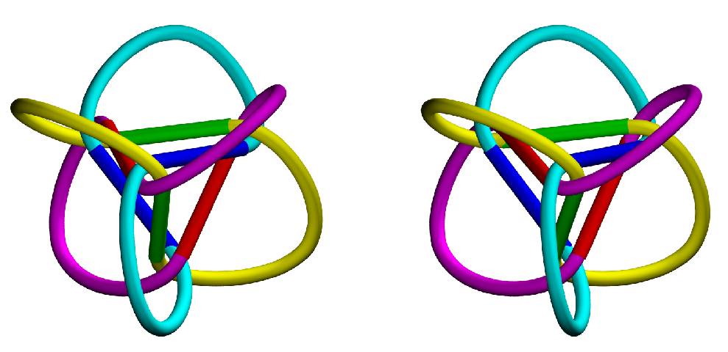
Fig.2: Three loops form a tetrahedron in the nucleus of the structure. If the loops were EM rings, the polyhedron in the center would be a particle and the loops outside the polyhedron would be the charge field of the particle. These are stereo images. Cross your eyes and look between the image until a third image appears. Allow the third image in the middle time to become 3-D in appearance and the space of the form can then be seen. Image by Joseph Clinton

2.2. Loops have structure

All loops come in chiral left (RH) and right-handed (LH) rotational sets. Physically these R and L-handed loops are wave sets (Fig. 3). Only when the plenum loops interact does the chirality of the loops arise. When two or more loops entangle, they do so by sharing a common axis. The sharing of an axis is what integrates a quantum system into a unified whole, be that whole a particle, an atom, a molecule, a cell, or for that matter a human being. Loops entangle by wrapping around each other and in so doing, develop a wave frequency on the loop (Fig.3). This allows two, or any number of loops for that matter, to share the same space and become a single quantum system without destroying the integrit
y of the original loop. They share the same space by sharing the same axis.
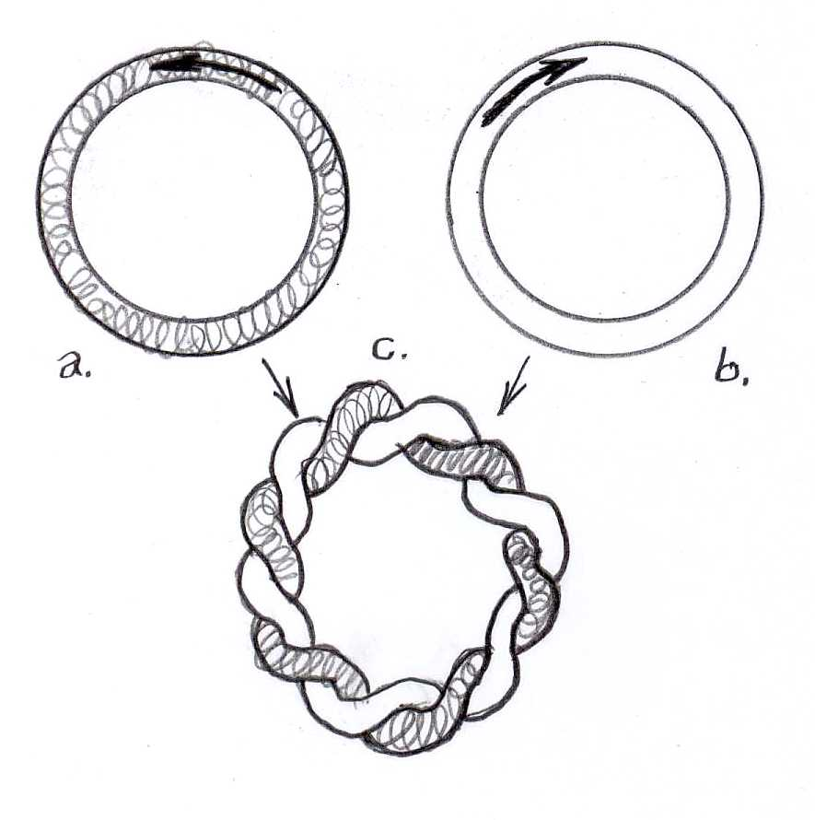
Fig. 3: Two chiral loops interact to share the same spatial domain.

Fig. 4: (Below left) Two plenum loops are twisted together forming a wave and generating frequency. Frequency = energy. Two twisted together plenum loops produce an EM wave set.
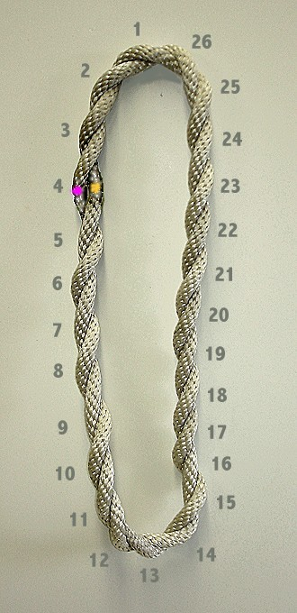
Fig. 5: (Above right) When two twisted together plenum loops have one of the loops condense while the other remains deployed, all the energy (nodes of frequency) except one which is maintained by the deployed loop, condense to a locality. A locality in physics is particle.

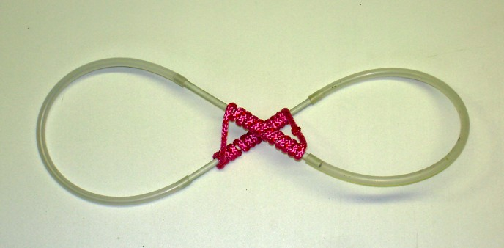Fig. 6: However, there is another way to condense a wave and that is to the center of the deployed wave. When energy is added to a locality in 3-D space, nature employs this form of condensation. Note that in condensing the (red) wave, the loop has to twist and torque imparting energy to the loop. The energy is determined by the number of twists in the (red) condensed wave.

What holds the condensed wave to its central locality?
To hold the wave, three such wave sets have to interact in a knotted topological space called a “Structor”.

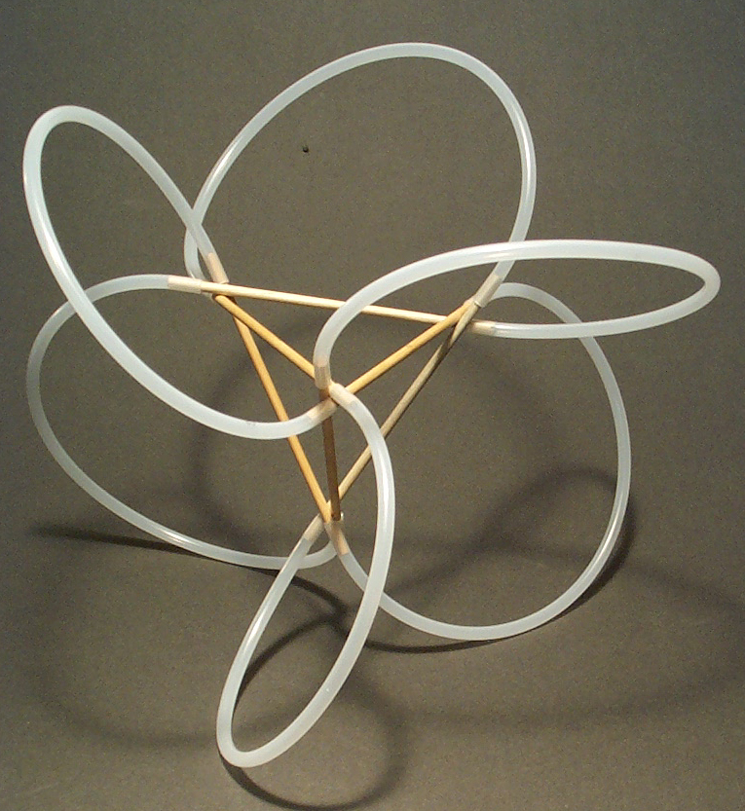
Fig. 7: When three EM loop sets interact in the same domain, a Structor is formed. Note that only the LH side of the wave set is shown. This model is showing only the charge field of a form having locality. Applied to a particle such as an electron, this model describes the orbitals of the three waves that make up a fermion particle. These three waves the three quarks. The RH wave side is not shown in this model. The condensed RH side of the wave is added in Fig. 8.

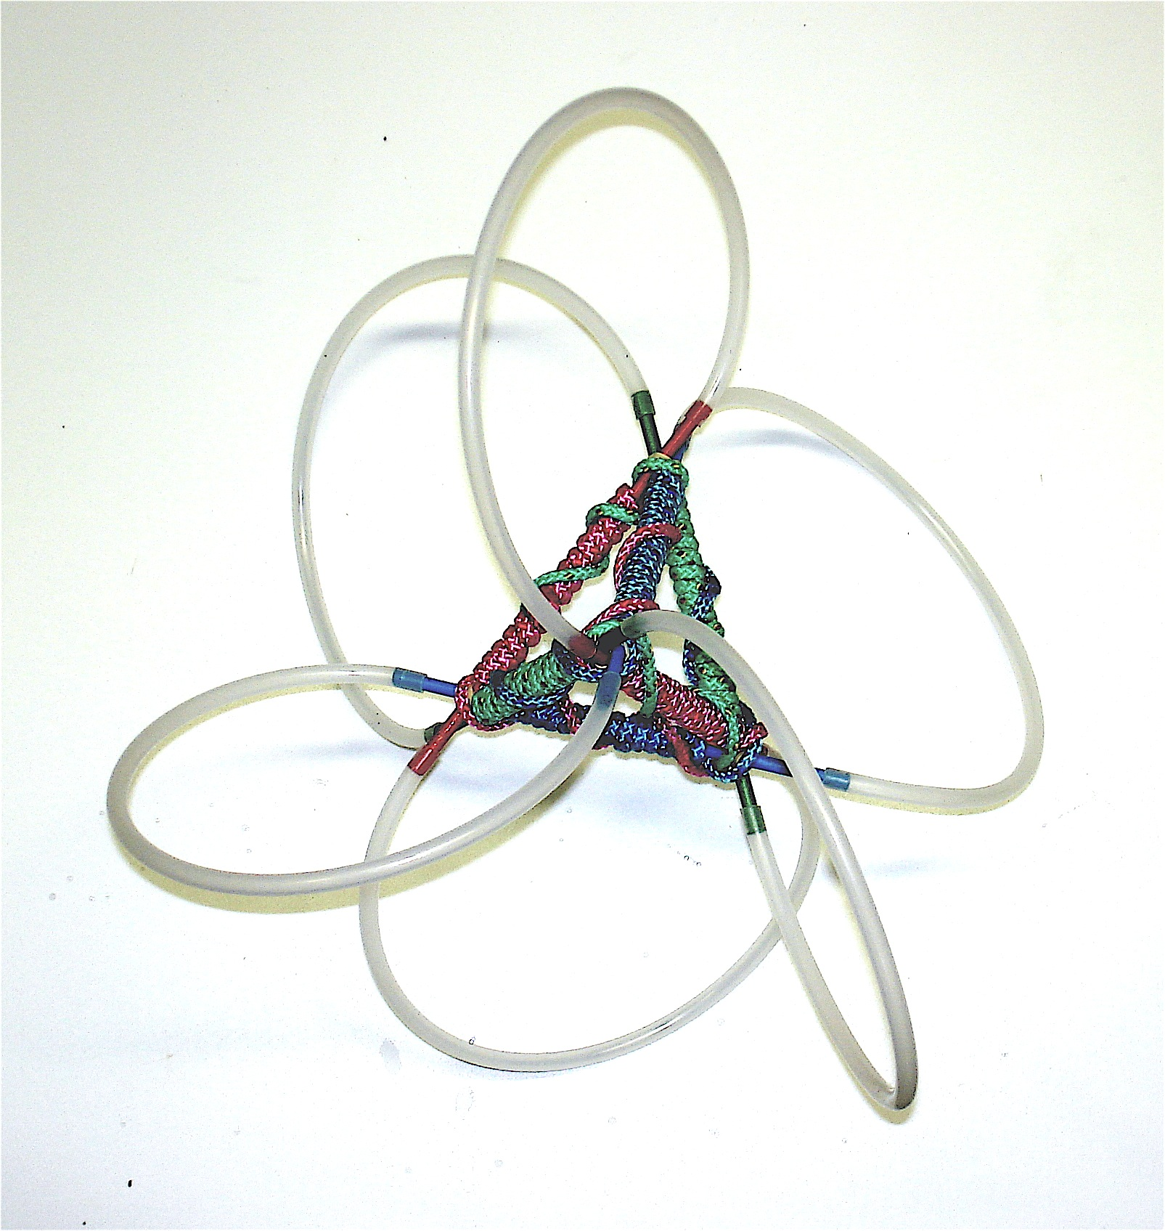
Fig. 8: In this model the RH and LH loops of the Structor are shown. When three (or more) EM waves interact three-dimensionally, they knot together. Because of being condensed, the form now has a charge. The charge relationships are responsible for condensing the wave. In this case, the condensed wave is RH. This is the structure of all fermions denoted by the fact the deployed energy of the original EM waves are now confined to the center of each wave by the interacting magnetic fields. There is a magnetic pinching effect at the vortices (vertices of the tetrahedron) that prevents the RH wave having a positive charge from deploying. The energy is trapped in the nucleus. The Structor accounts for why the energy of the fermion particle (or atom) is confined to its nucleus while a negative LH charge field surrounds the nucleus.
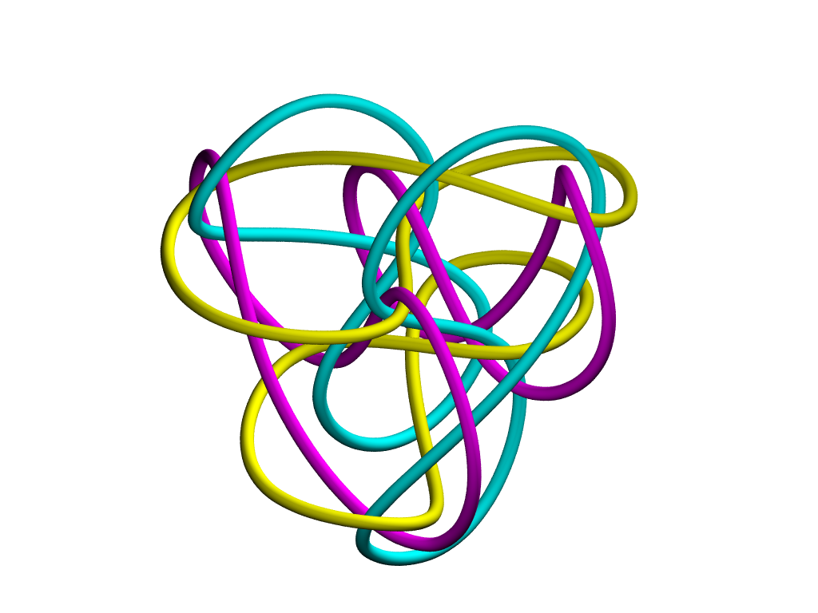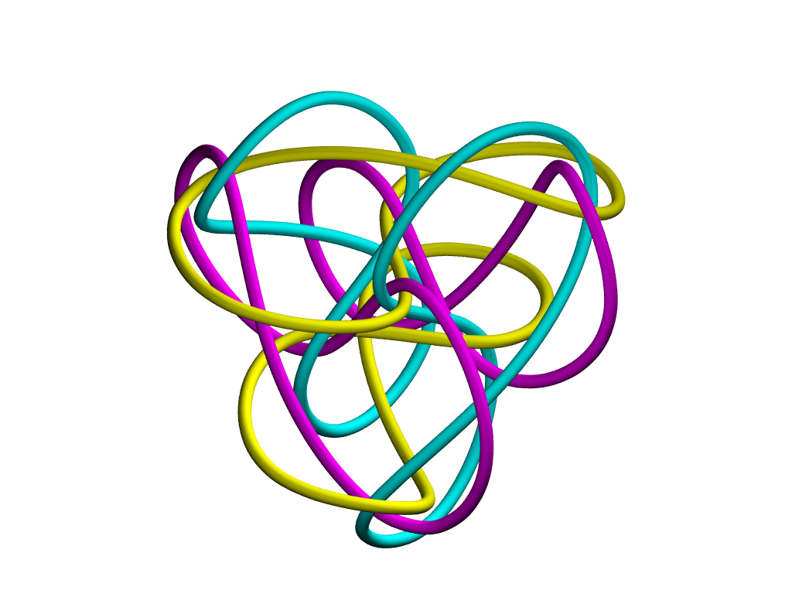
Fig. 8: This image of a SuperStructor is a stero image. Look cross eyed between and focus on the image in the middle until it becomes three-dimensional. You will see in three-dimensions an internal triangle circuited to an larger external triangle. SuperStructors model the atomic platform of structure where there is a particle orbital shell surrounding a inner nucleus. This model shows the larger LH external tetrahedron field connected to the condensed internal RH nuclear tetrahedron. Image courtesy of Joseph Clinton.

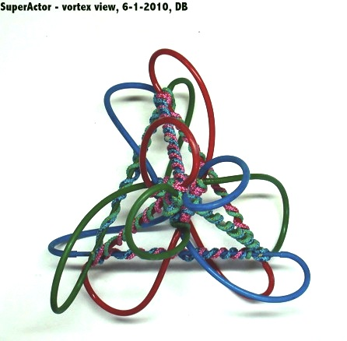
Fig. 9: This SuperStructor shows how both R-hand and L-hand EM waves interact in the atomic platform of structure. The larger external tetrahedron has the condensed frequency of the wave held to its tetrahedron field while at the same time being connected to the smaller condensed nuclear tetrahedron, which in this photo is located behind the vortice in the middle of the form. The location of the nucleus tetrahedron to the cloud tetrahedron is better viewed in Fig. 8. This means the larger tetrahedron can accumulate energy frequency (twistings) while deployed without having to send the energy to the nucleus, which is what an electron cloud can do in an atom. The cloud can be thought of as an extended locality particle but a particle that occupies multiple positions, in this case the four vortices of the tetrahedron. Hence in FST the electron can be found at multiple certainties. In the SuperStructor (SST), handedness of the larger tetrahedron will be the opposite handedness of the smaller nuclear tetrahedron. The electron cloud, where the electron has a multiple certainties of locations, will be LH and where the orbits of the loops interlock in the nucleus, there will be a RH form, the proton. LH = negative charge, RH = positive charge. Fig. 9 is a model of hydrogen at its lowest energy state.

Together, and only when together, the three EM wave sets are called quarks.

The structural relationship between the electron and proton have been shown above. The neutron develops
when both the three right-handed positron waves and three left-handed electron waves condense, the neutron forms. The model for the neutron is under construction.

2.3. Reality is loop interaction, not intersection.

The loops do not merge and become one, rather, they preserve their individuality and at the same time, participate with other loops in the same quantum system by twisting together and forming a rope-like bundles. There are no intersections in this physics. Reality is interaction, not intersection. In this way Nature never looses its structural memory of its parts, or its association with other loops with which a loop is associated energetically. The essential form, the loop, is always persevered. It is a conclusion of FST that the loop cannot be lost. Conservation of Energy equals conservation of loops.

In order to share the same axis, the loops twist together (Fig.3). The twisting can be two loops or any number of loops. Twisting bends the loops into toriodal helices with the center of rotation being the place of interaction between the loops. The net effect of interaction causes the loop to develop a wave and the wave will have frequency. Frequency is how the energy of a wave is measured (E = fh).

3. A word about the use of models

3.1. Modeling with static materials versus kinetic energy

Throughout this paper I will be showing models that are material in nature. It has been argued that energy isn’t material, so of what good are material models? In FST, material models are thought of as the static start and end states of kinetic energy structures. Our material world is all we know empirically and it is all start and end-states. We know there is energy connecting up all start and end-states. We only know about by how energy affects the start and end-states and nothing about what energy is between them.

Light is deploying radiant electromagnetic (EM) energy that has impacted a material object such as our eyes. Particles, having mass, are condensed and localized EM energy. Both mass and energy are forms of plenum energy. Materials obey the same rules as energy and differ in that EM light energy can share the same space whereas two or more localized condensed light (mass) structures cannot occupy the same space, but they can share the same axis and be entangled in the same energy system. Fig. 3 shows how two material loops of rope can occupy the same spatial extension without interfering with each other and still share the same axis. The axis is the point of contact between the loops. The axis in this case is a prefect circle having no undulation.

3.2 Static and Kinetic Energy

The plenum is related to mass the way a string is related to a knot. The static energy structures of end-states reveal inherent properties of kinetic energy structure. If a structure has a stable time-enduring form, then its time enduring form can be modeled. Both mass and energy have such end-state forms and hence can be modeled. Fig. 4 (a) and (c) are start and end-states. In (a) the knot can get no tighter. In (c) the knot can get no looser. (b) is the transitional kinetic state between (a) start state and (c) end-state.
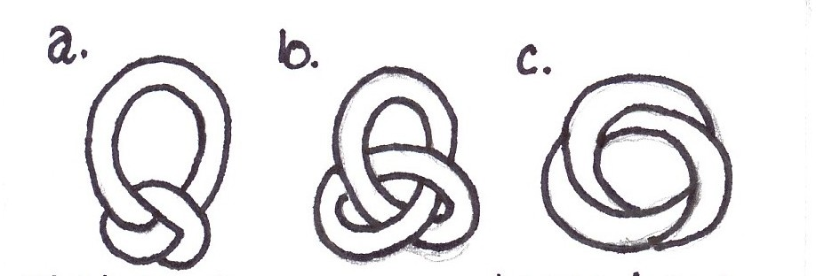

Fig. 4: Start, Transitory and End states of a wave. (a) is analogous to a mass state, (b) is a kinetic energy state and (c) is analogues to a fully entropic energy state.

The transitional transitional state is in all cases wave-like in nature. We can’t build transitional states models with material models, only the start and end-states, which are the before and after models, but not the transition models between start and end-states. This leaves the question, and it is a momentous question indeed: since start and end-states of particles and atoms can be structurally modeled at the human scale with fieldstructures, is it possible to build a fully functioning macro atom, an atom a centimeter in diameter? If the universe is a fractal hierarchy, then there is the possibility that energy and mass are scaleable according.

3.3. The Role of Bosons and Fermions

In the Standard Model (SM) of physics there are two forms of energy, (1) boson events, which are dubiously called energy particles [3] and (2) fermions, which are particles having mass. [4] Bosons carry energy to and from fermions. They are called “particles”, but while in the act if carrying force, they are waves. They only get the particle-like behavior when the wave entangles with a fermion mass, collapse their energy into the mass and the energy then becomes localized producing a energy shift in the formion. Clear distinctions between bosons and fermions are not without problems in the Standard Model (SM) of physics. There are boson carries of force that have mass, which is not supposed to be an attribute of a boson particle. Such boson force carriers with mass are the Z and W bosons found in the nucleus of atoms. Because bosons and fermions can transform into each other, the hard distinctions that have been made between bosos and fermions are misleading. One such mistake has been the failure to see matter and anti-matter as condensates of the left and right-handed plenum waves. FST models all states of energy and matter and anti-matter with only chiral EM wave interaction. Particles as simply condensed EM waves that are knotted together preventing the energy from radiating.

3.4 Neutrons modeled as EM wave condensation

For instance, when the positron side of the EM wave condenses to become a proton, the energy of the waves increases hugely from 0.511 MeV to 938 MeV. Inversely, if the electron side of the wave condenses while the positron side remains deployed, the electron side of the wave becomes an anti-proton. If both the electron (e-) and the positron (e+) side of the wave condense, a neutron forms having 939.565 MeV. Neutron mass = mass of proton (a condensed e+) plus a condensed e-. The condensed e- changes frequency as did the condensed e+, but in the e- case, the difference is 1.283 MeV (938.272 + 929.565) whereas the positron’s condensed difference is 938.272 MeV. This is because as deployed waves, both e- and e+ have the same frequency. When e+ condenses it takes all but one unit of deployed e- frequency with it to form the dense proton leaving the deployed e- with only one unit of energy (0.511). When the deployed e- condenses as well, it too changes frequency from 0.511 to 1.283 MeV. The condensed e+ and e- now properly equal the neutron mass.
Fig. 5: Double loops deployed with frequency 26 and condensed with frequency 16. Sorry, I should have matched the frequencies in the model for clarity.

3.5. Start-states and End-states

To understand motion, what is needed is to be able to model what happens structural between start-states and end-states. This has been a problem because when energy transfers between end-states it is in the form of a wave. Particles are not transferring even though physics uses particle names and imagery to refer to the energetic event. Energy can’t be seen, but particles can. Thus physics can’t see what happens between the start-states and the end-states. By calling an EM wave a photon, physics is using fermion mass nomenclature for a boson energetic event. The thread that connects start-states to end-states is provided by a structural background dependent plenum which behaves as a matrix of loops having all possible diameters and lengths. Reality is build in fractal loop systems of relatedness. Reality has one form, the action loop of the plenum. The plenum develops energy and mass by creating fractal interlockings of its loop structure.

4. The Time and Space Consideration

Time and Space have to be included in a discussion of motion along with energy and mass. Traditionally, the bedrock variables to account for changes in form and structure are changes in energy and mass. FST has discovered for energy and mass to have a fixed relationship (E = mc²), it is necessary for there to be a fixed relationships between time/space as well. [5]

The notion that a change in mass changes the nature of space has been hinted at in the way mass is thought to bend space in General Relativity. [6] Time too has been theorized to change, as in Einstein’s time dilatation hypothesis, i.e., time slows with speed and stops when a mass obtains the speed of light. These are perceptual differences keyed to the observer and the observed. In FST time and space are structural fixtures synchronized to act together with themselves and with mass and energy.

In FST, time is scale dependent. Looking at the whole of physical experience, it is apparent that as the scale of events become smaller relative to the viewer, the time it takes to complete an action such as an orbit is observed to be faster. As the scale gets larger, time seems to slow down. It takes an electron about 150 attoseconds for an electron to circle the nucleus of an atom and the earth takes 365 days to orbit the sun. In each case as time changed, the spatial extension in which the events happened changed as well.

The point is that the size of an event and speed of events march together. Furthermore, while time appears to go from “too fast to measure” (Planck’s time) to “too slow to measure” (universe’s time), energy and mass are changing in step with the changes in time duration and space volume as defined by the respective action fields. The fine structure constant is the mechanism that keeps each scale fractally compatible with all other iterations of scale.

To establish a link between time/space and energy/mass, the fundamentals need to be established from first principles. This insures the constants in nature apply universally irrespective of the energy/mass or the space/time relations. Fundamental attributes (constants) are preserved throughout all interaction and at all scales of form and structure. The mere existence of constants in Nature is strong evidence that there is a structural fractal continuity running throughout all forms at all scales. Each fractal iteration preserves the fundamental relationships as the scale of the events change.

4. Waves
4.1. The problem of modeling wave energy which can’t be “seen” until it impacts a mass.

How is the notion of motion to be understood in the example of an electromagnetic wave when there is no visible tangible evidence of its motion between start and end-states of wave transmission, i.e., when the wave leaves a mass causing the mass to be disturbed and arrives at another mass again causing a disturbance? An EM wave is invisible until it impacts a material having mass. Space looks dark and empty when in fact it is saturated with EM energy of all kinds coursing in the medium of the plenum. The ambient heat in the universe would seem to confirm a frequency flow in the plenum. In FST, if there is temperature, it means there is yet room for the universe to expand. When the heat of the universe becomes zero, expansion stops. We should be able to calculate the size to which our universe could expand. Answering that should be worth a doctoral degree or two.

4.2. Material vs Energetic Form and Structure

When a loop braids with its self, or two or more loops braid with each other, they create chirality (Fig. 6).
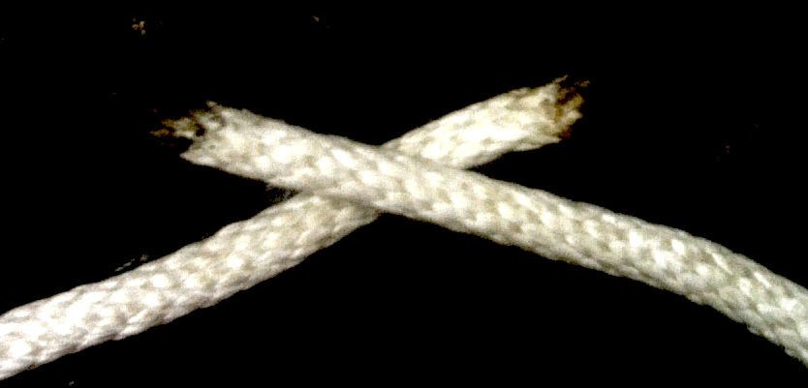
Fig. 6: Twisting together a loop (or loops) requires the loops to rotate clockwise (LH) on one side and counter-wise RH) on the other. If two loops are being twisted together, one will be LH and the other RH. Chirality is an inherent product of entanglement.

If TWO loops are twisted together, when one loop is condensed, it will take all the energy, i.e., the twist, with it leaving only a single twist of the opposite handedness in the wave that did not condense (Fig. 5). In other words one loop will take all the twist with it as it condenses, leaving only a single twist in the remaining loop. This is interesting because when two loops are twisted together it cannot be determined which loop is RH and which is LH. The only way handedness can be known is to condense one side of the wave. The condensed wave will then be all of one handedness, while the remaining deployed wave will be a single twist of whatever handedness the condensed wave is not. The implications of this are in keeping with quantum indeterminacy. Since there is no way of telling if the condensed wave will be RH or LH at beginning of the wave collapse (another name for wave condensing process) then whether the particle that results from wave collapse will be a real or anti-particles seems to arbitrary.

This explains the paradox seen in the Aspect Experiment. [7] Whether or not there is a determining mechanism for which side of a chiral wave set condenses is a big question in FST. The role of consciousness may have a part in the decision making since the effort required to pull the trigger and set the process of wave collapse in motion is incredibly delicate to the point of seeming to be arbitary.

KTS (Known To Science), EM waves are chiral with a RH and a LH rotation. Because both handednesses are present in an EM wave, it has no charge. A condensed boson wave (photon) has a spin one number, because both RH and LH waves are present thus making the form symmetrical and whole. Each time the loop winds around itself in the case of a single loop, or in the case of two or more loops wound around each other, a wave structure develops with frequency nodes. A node is a 360 degree rotation of the loop and constitutes one frequency unit/ of the wave (Fig. 5).

The formation of a wave disturbs the plenum. The disturbance comes in the form of there being more action loops concentrated into an area than nature would want if entropy was allowed to fully operate. Whenever a wave is made, condensing to some degree is happening. Even when a fully deployed wave, has the frequency of the RH and LH matched, there is a degree of condensing, this is the latent energy of the plenum field, the zero point energy as it is called. This also implies that the frequency of the plenum as a whole increases as the waves become large, universe in size. The cosmological implications of that are enormous.

Entangled deployed loops, loops that are twisted around each other in the same quantum system, have no kinetic force, but they do have a latent energy in the form of a potential. To make a wave kinetic and give it force, one side of the wave, or other the other side, must condense while the other side remains deployed. To my knowledge, physics measures the frequency of a wave by measuring the number of nodes in the wave that passes a point in a space within a given time period. In essence, physics measures a portion of the loop, not the number of nodes in the entire loopwave. It would be a revelation to know the total number of nodes in an entire wave of anything. Our view of the world would change radically. This would give us a totalized view of an event and not a localized view constrained by relativity.

Kinetic energy, motion of any kind, is caused by having one side of a chiral wave deploy or condense. Condensing leads to particle formation when it occurs three-dimensionally and in such a way the action is knotted together. Inversely, deploying of a condensed way leads to radiant energy. When the waveloops are entangled symmetrically and have equal frequency, the wave set is in a potential state, energized by not actualized. It is fully entropic. When one loop or the other condenses, leaving the other deployed, the wave set is in a kinetic state and the condensate will have a charge and be surrounded by a charge field of the opposite handedness. Electric current can be fully explained by this mechanism of deployed/condensed wave. It is the reason one side of the circuit is hot and other cold. The hot side has the condensed wave and the cold side has the deployed wave. The current “flows” when the condensed wave is allowed to deploy by closing the circuit. The condensed wave will attempt to redistribute itself evenly throughout the wave’s field, i.e., the circuit’s network. That is why one side of the wave, the positive wire, has the force and the other side, the negative wire, has no force, but must be present for the wave to follow from its condensed state as it deploys.

4.3 Charge

Charge comes from the handedness of the EM wave. Curiously, when two loops twist with each other, they establish an intrinsic chirality whereby one loop becomes right-handed and the other left-handed. When two loop waveloops are equally deployed, the number of nodes are equally divided between the R and L-handed loops, there are an even number of nodes. One loop is twisted with itself always has an odd number (Fig. 7).
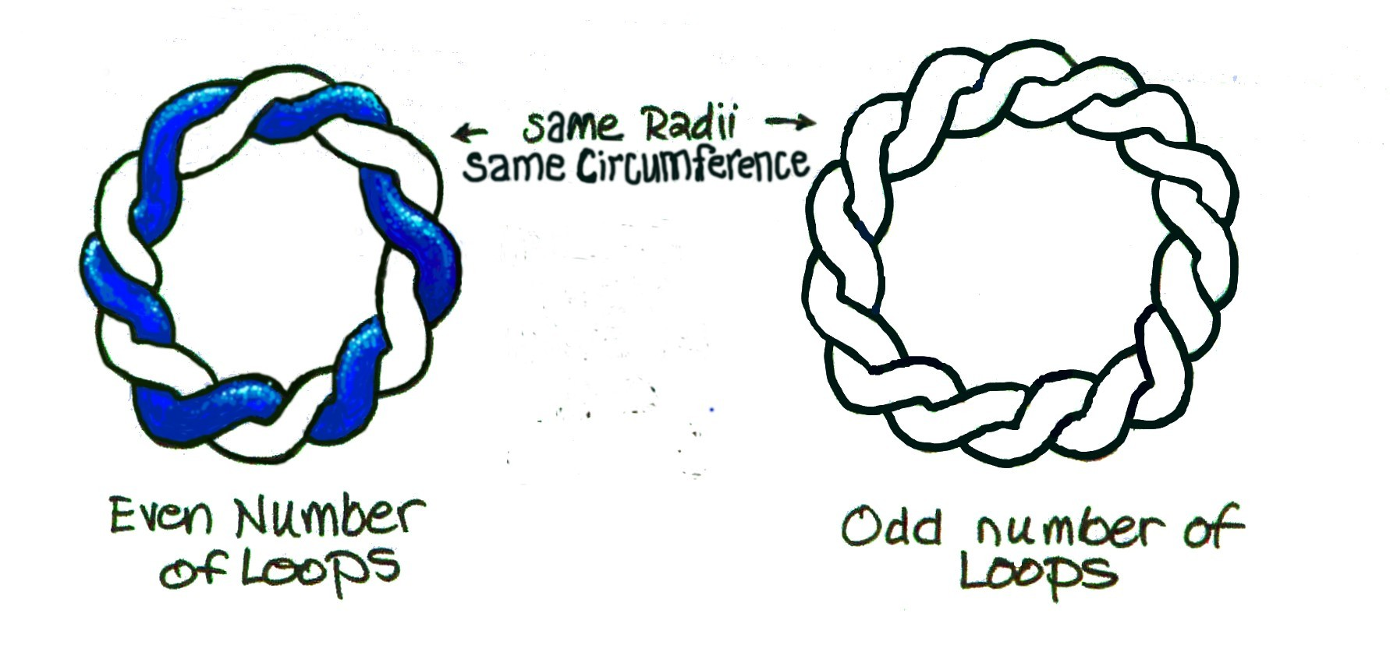
Fig. 7: Two loops = even number of nodes. A single loop = an odd number of nodes

Condensing means the non-condensing side of the wave set develops a deficiency of action, while the other part of the wave set, the side that is condensing, develops an abundance of action. Entropy is the desire by Nature to have both waves of a wave set to be of equal frequency. They both want to be either full deployed or full condensed. When one part of the wave set becomes energy plentiful because it condensed and the other part to which it is always interacting, becomes energy deficient because it remained deployed, then the system is charged and forceful. Motion is the attempt of the plenum to regain homeostasis, balance, uniformity, and a perfect state of entropy where no part of the wave field has more energy (frequency) than any other part.

4.4 The Atom

The atom is a perfect example of how energy in a field can condense one side of an electromagnetic wave set and leave the other deployed. In the real world, the right-handed side condenses to the nucleus and leaves the left-handed electron side of the wave set deployed in the atomic field surrounding the nucleus. The anti-world reverses the situation, condensing the left-handed wave to the nucleus and the right-handed wave remains deployed. Collapsing the wave means the frequency of the wave is crammed into a smaller area. That is why 99.96 % of the energy of the atom is sequestering in the nucleus.

5. The Plenum

5.1. Gravity
The Plenum is an action matrix. Concentration of plenum action produces a field. EM fields, as well as strong and weak nuclear fields, are all degrees of condensation of the EM wave interaction. Gravity arises when the plenum waveloops condenses. Gravity is removed when the plenum waveloops associate with a mass are redeployed, i.e., the mass decays.

5.2. Electromagnetic Fields

Stable fields associated with stable particles are established when the energy of the plenum is concentrated in such a way that the energy cannot redeploy. The holding mechanism is the topological properties of the fieldstructure knot. When knotting happens to the EM waves, entropy is prevented from exerting deployment. The condensing of energy in the particle or atomic fields is blocked from being able to deploy by the three-dimensionally knotting of the waves. The blocking mechanism is accomplished by having the chiral wave set act against itself through magnetic pinching and knot constriction. Energy as nodes of frequency are allowed in but not out. The ability of energy to find stability in a condensed form is called extropy. Matter is antropic, the antonyn of entopic. Matter, a fermion field particle, in FST terms, would then be a condensed energy field that is stable. A boson field would be a condensed wave that is in the act of redeploying, processing toward homeostasis, and a state of complete entropy. The rest, or internal motion of a fermion mass is the condensed energy that cannot expand. When matter decays it decays ultimately into radiant energy. Gravity is removed when a mass decays by the spherical expansion of radiant EM energy. The job of radiant EM energy is to tell the universe a mass no longer exists and gravity is no longer needed.

When a particle having mass, a fermion, is formed in FST, it is viewed as depleting the plenum in a given volume of space. Motion is the attempt of the plenum to regain homeostasis by moving the concentrated action from its condensed form and redistributing it evenly throughout that portion of the plenum affected by the formation of matter. That would make gravity a finite force. If gravity is finite, it is one more reason the Big Happening Never Banged.[8]

5.3. Gravity and Anti–gravity, the other motion maker

The stress put upon the plenum when mass is formed by concentrating plenum creates the effect of gravity. Imagine, if you will, selecting a space (a plenum unit) and coiling addition units of plenum into that space. Given the plenum is a loop having a specific minimum dimension (Planck’s length), the only way to put more loops in the same space, assuming all plenum loops are identical, is to loop and twist them around each other. As has been shown, twisting creates frequency. When that frequency is knotted three-dimensionally into a fermion, it cannot readily disentangle. Disentangling a fermion requires a very high-energy input.

5.4. The Role of EM energy in relation the Plenum

Gravity is the attempt of the plenum to redistribute back into the plenum the action that has been concentrated to form matter. Should the loop energy deploy, as for instance in a matter/anti-matter decay, the EM energy that had been bound in the matter and anti-matter is now free to become radiant energy once again, half RH and half LH. The plenum inside the expanding EM sphere is relieved of gravitational stress put upon it by the mass, while the plenum outside the radiant spherical wave front still registers the affect of gravity. In this view, it is the job of light to tell the plenum (universe) that a mass is no longer present. It tells the plenum as it expands into the universe, that the mass that created gravitational stress on the plenum is no more. By replacing the frequency missing from the plenum when the mass was created the frequency of the expanding EM wave decreases until the frequency of the plenum is the same as the frequency of the EM wave. When the frequency of the EM wave is the same as the frequency of the plenum, all the gravitational influence had by the mass is removed. The universe knows the mass no longer exists. That means gravity is a finite force and not an infinite force as is now believed and in the process explains the “tired light” supposition.

To account for motion, FST hypothesizes there is a pre-existing structure that has all the possible pathways for determining what motions are allowed and what are not allowed, a scaffold as it were used by energy and mass. That scaffold is the action plenum. The pathway of motion is determined by the topo-geometry of the plenum matrix associated with a particular energy or mass event. Radiant energy deploys through the plenum. Mass on the other hand is an energetic holding pattern of condensed plenum that forms a spatial domain having locality. Postulating the plenum as pre-existing structure insures that forms derived from the plenum have the same structural constraints. Material objects having locality, as well as non-local radiant energy, are dependant on background structure of the plenum. Neither a particle wave, nor an energy wave, can exist apart from the plenum. This conclusion is reached when in modeling it is observed that every form has a form from which it is derived. This is the “something comes from everything” conclusion as opposed to the Big Bang’s conclusion that “something comes from nothing” (a singularity).

By understanding the topo-geometry of the Plenum, motion, in all its forms local or radiant, as well as spatial and temporal, can be explained. The key to understanding the universe, and all therein, is in the understanding of the structure of the plenum. This is a radically different approach form mainstream physics, which in the main does not acknowledge a plenum let alone that it has a structure. FST puts the plenum at the heart of the matter structurally. Matter is the outcome of the deeper more subtle processes of the plenum. The plenum is no longer some passive detached so called “spooky” presence. It is everything, omnipresent, omnipotent and omniscient in FST.

Wikipedia presently defines motion as: Motion (physics), any movement or change in position or time. http://en.wikipedia.org/wiki/Motio. This simple definition begs a boat-load of questions! This definition implies that motion is simply positional change, only meaningful in a relative sense. There is no insinuation that motion has any pre-existing meaning or barring on the objects that move, prior to their moving, be the orbital movement that of a particle, a planets or a star. Field Structure Theory (FST) presupposes that there is a pre-existing matrix (the Plenum) that pre-determines all motion by its topo-geometry. How motion manifest in a particular way describing a particular motion, is predetermined by the structure of the plenum.

Field Structure Theory (FST) and its underlying topo-geometry of Structural Skew Topology (SST) premises motion to be understood as waves moving across and through a fundamental matrix that is the substrate of energy. This matrix has form and structure called a plenum. Plenum is like aether, but differs in that energy and mass are dependant upon and inseparable from, the plenum. In other words, Plenum is background dependant thinking and aether, as commonly understood, is thought to be background independent of energy and mass. The difference is across the board affecting everything about our physical world.

References
[1] NPA = Natural Philosophy Alliance, <www.worldnpa.org>
[2] Pearls strung on a thread are background independent since they can move independent from the tread, whereas knots on a thread cannot moved independent from the thread making knots background dependent.
[3] http://en.wikipedia.org/wiki/W_and_Z_bosons
[4] http://en.wikipedia.org/wiki/Fermion
[5] This has been detailed in Paper 9 and 11.
[6] In FST, space is not curved by gravity. That mistake comes from a mistake in the gravity force equation of Einstein, which uses Euclidian inspired geometries using vector intersection.
[7] http://en.wikipedia.org/wiki/Aspect_experiment
[8] “The Big Happening Never Banged” is a statement attributed to Roger Tobie.

Negentropy has been offered as the antonym of entropy. It is an unfortunate word in that it sounds as if it is referring to something negative. Perhaps Antropy.

