Explanation of twin paradox according to the Euclidean Reality Model
Witold Nawrot
Lokalna 13, 04-903 Warszawa, Poland
e-mail: info@euclideanreality.com

The Four dimensional Euclidean Reality model clearly explains why during the uniform, rectilinear motion, the time dilation effect is symmetrical for both twins, and why and when the time dilation is eventually measured in a system of one of the travelling twin.

1. Introduction:
The effect of time dilation in case of fast moving objects is well proven and accepted by science. However, some doubts exist concerning the relative time dilation observed mutually by observers in both moving systems and the final effect of the time dilation occurring only in one of the systems. The explanation of this fact can be find in mainstream literature [1], however it is a description of differences between two systems participating in the experiment, rather than the final explanation of mechanism of the time dilation phenomenon. Therefore it is still accepted that the time dilation is a simple result of velocity – in the other words it is assumed that if any object moves very fast then its clock is slowing down.
In the new model of Euclidean Reality it is possible to describe this problem in a different and more comprehensible way than it was done up to now - for instance in [1]. According to the model, as long as both objects are moving with constant velocity in relation to each other, the time dilation is only a seeming effect, resulting from the manner of performing observations by the two objects. The true source of time dilation is no longer the velocity, as it has been assumed according to SRT, but the change of the velocity which changes the seeming effect into the real one. And only this change of velocity, not the pure velocity, is now the true origin of the time dilation, although the total time-dilation effect is still proportional to the relative velocity.
2. The observed time dilation
According to the new model of Euclidean reality, the reality is an absolute Four dimensional Euclidean Reality (FER). In this space exist bodies. These bodies move along certain trajectories, which are at the same time the time axes of coordinate systems of these bodies. It means that the length of path travelled by a body in FER is equal to the time indicated by the body’s clock. In the FER there are no space dimensions assigned in advance. An observer interprets directions perpendicular to the currently observed body as the space dimensions. It is logical, because we do not observe the reality itself. We can observe only bodies in this reality and on basis of observation of the surrounding bodies we learn about the dimensions of space. A more detailed description of the model, ideas of time, space, motion etc. can be found at [2-6]. Finally, according to the FER model just the change of the direction interpreted as the space dimension is responsible for the time dilation, instead of deformation of dimensions as it has been assumed up to now according to SRT. It is shown in the fig. 1 where two observers watching each other are interpreting different directions in the FER as their space-dimensions and thus they are registering a time dilation in their neighbor’s system.
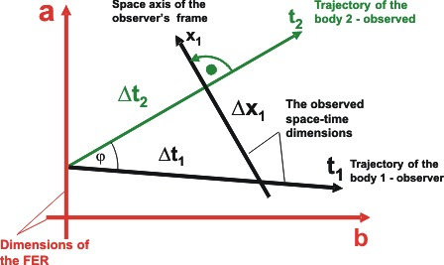
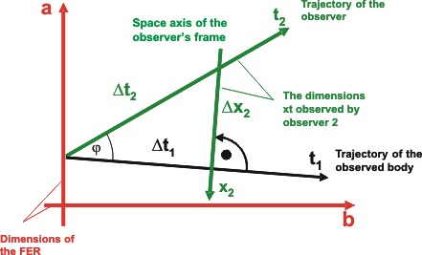
Fig. 1. Both observers, 1 and 2, are moving along their trajectories which at the same time are their time axes –t₁ and t₂ respectively. The trajectories are inclined at a certain angle to each other. On the upper figure, body 1 observes body 2, then body 1 interprets as its space dimension x₁ – the direction perpendicular to the time axis of body 2 – t₂ . And vice versa – in the lower figure, body 2 observes body 1 and then body 2 interprets as its space dimension a different direction than the observer 1 does, namely x₂.
From the choice of the space dimension as perpendicular to the trajectory of observed body, knowing that the length of the trajectory is a measure of time of the body, we learn that the relative velocity is equal to the sine of the angle between the trajectories of bodies (in the FER model is applied the coordinate system in which c=1)
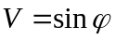 (1)
and the time dilations observed mutually by both observers in their neighbor’s system are equal to:
From point of view of observer 1 (the upper fig.1):
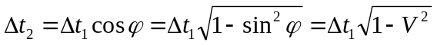 (2)
Then the observer 1 can see the time dilation in the observer 2’s coordinate system.
From point of view of observer 2 (the lower fig.2):
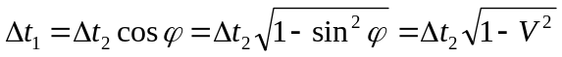 (3)
Then the observer 2 can see the time dilation in the observer 1’s coordinate system.
We can see that as soon as observers are moving along their trajectories – like in the fig. 1, the problem of time dilation is fully symmetrical and it is not possible to say in which of the systems time is really slowing down. According to the above reasoning, the time dilation during the uniform motion is only a seeming effect, resulting from the choice of direction interpreted by an observer as its space dimension, and it has nothing to do with the real time dilation.
3. The change of velocity
According to the FER model, the effect playing the main role in the true time dilation is the change of velocity. In order to describe this problem we will consider the following example:
Let’s consider the detector of particles. It is positioned in point x₀y₀z₀ of our coordinate system (see fig 2a). In the moment of time t₀, at one and the same time, the detector is hit by a few particles moving with different velocities. It means that the particles in the FER are moving along trajectories inclined at different angles to each other. Since the directions in the FER interpreted by us as the space dimensions have to be perpendicular to the trajectory of observed/detected particle, then for each of the particles the space directions in the FER will be different than for another detected particle. It means that the probe in the FER will be positioned in different points for detection of different particles. All the points will be located in the same distance from the point t₀ so they will be positioned on a sphere with the center in the point t₀ on the trajectory of the observer and with radius equal to the distance from the origin of the coordinate system to the probe.
We can say in more general terms that the point in Lorentzian space-time with coordinates x₀y₀z₀t₀ is in the FER the sphere in a four dimensional space with a center in point t₀ on the time axis and radius r₀ equal to:
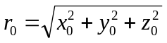 (4)
It is presented in the fig 2.
If all points of the sphere are in fact the representation of one point in the Lorentzian space time then all points of the sphere are in the same time and moving from one point of the sphere to the another takes no time – in other words, any change of position along the sphere is instant.

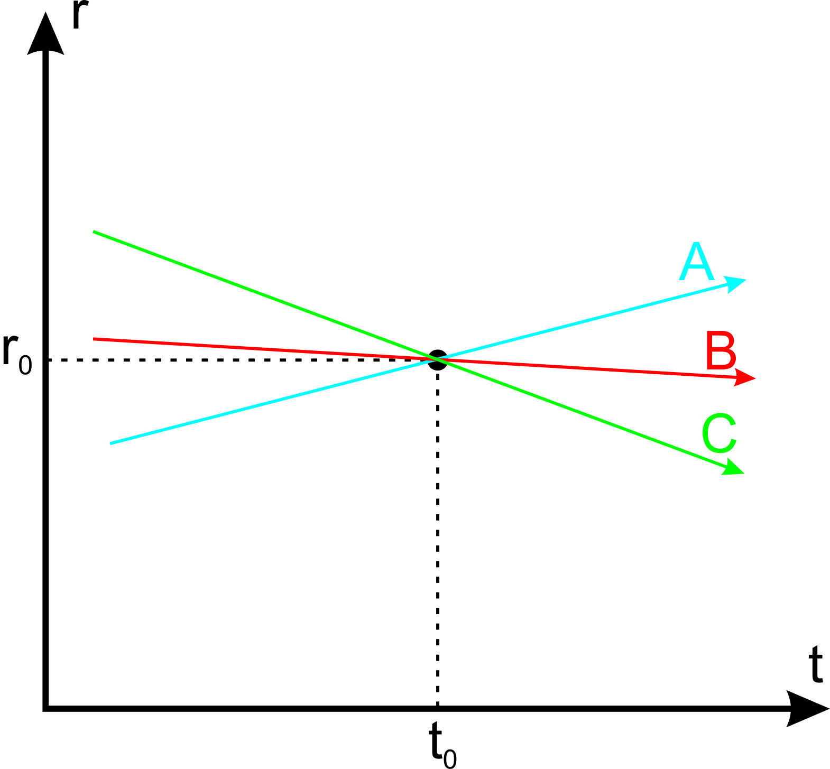 | 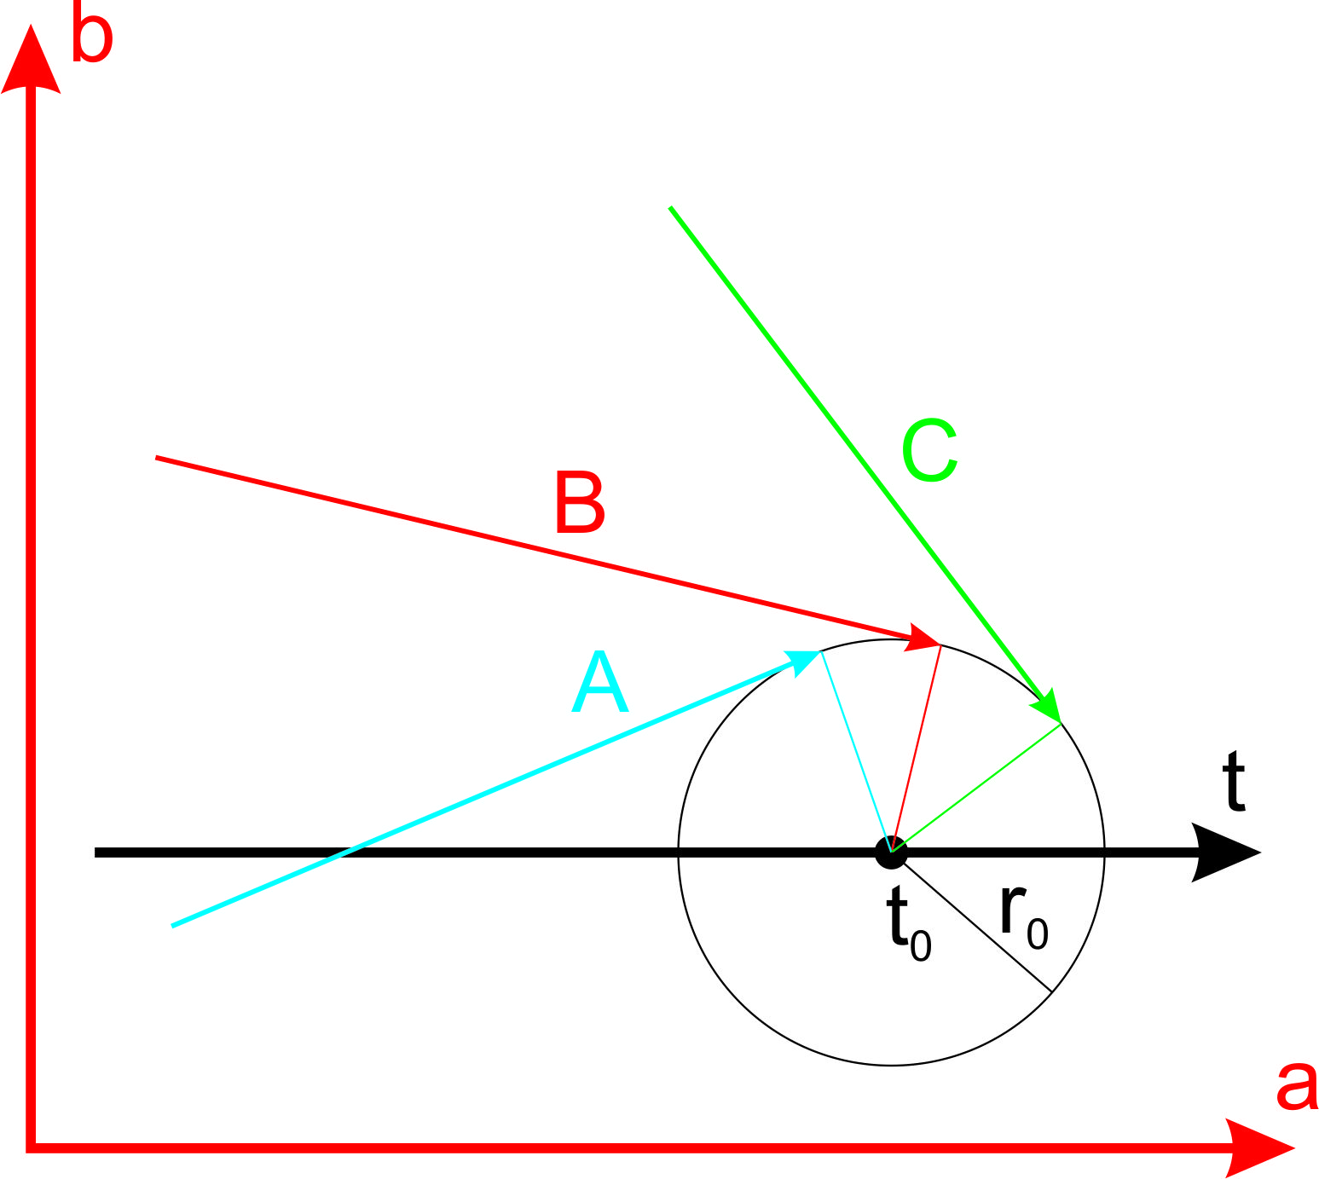
a.) | b.)
Fig. 2. An example showing three particles moving with different velocities hitting the same probe in the same moment of time. In fig. 2a we see worldliness of the particles in Lorentzian space time. In the FER – fig.2b – the distance for each particle is measured along a different direction perpendicular to the trajectory of currently detected particles. All possible positions of the probe are located on the sphere with radius r₀ and center t₀ (fig. 2b). Thereforethe point r₀t₀ in Lorentzian space time is represented in the FER by a sphere with center in the point t₀ and radius r₀.
4. The real time dilation
Let us now consider two observers, moving along the trajectories t₁ and t₂ which at the same time are the time axes of their coordinate systems. The angle of inclination of the trajectories describes the relative velocity according to the formula (1). As it has been explained earlier, each of the observers will observe the time dilation in its neighbor’s system. The dilation dependent on the choice of reference system is described by formulas (2) for observer 1 and (3) for observer 2. As it was shown before in fig. 1, the effect of the time dilation is not the true time dilation but it is the result of the choice of direction, interpreted by the observer as the space axis of its reference frame. In fig. 3a and 3c is repeated the situation from fig. 1, from the point of view of the observers considered in this example.
If now one of the observers turns back and travels in opposite direction than the second observer (for simplicity with the same value of velocity as before), then in the moment of turning back it travels a certain distance along a surface of the sphere described in the previous chapter. According to the reasoning presented there, during the travel along the sphere, the time flow is equal to zero (assuming the instant turning back) – fig. 3b and fig. 3d. Therefore, the total time for the observer changing its velocity is shorter than for the second observer.
In the case presented in figs. 3a and 3b, observer 2 is changing its velocity. The total time of observer 2 is equal to:
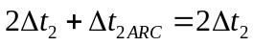 (5)
and the dependence between the time of the two observers can be described by the formula resulting from formula (2):
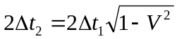 (6)
In the case presented in the figs. 3 c and d, observer 1 is changing its velocity. The total time of observer 1 is equal to:
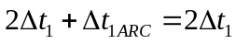 (7)
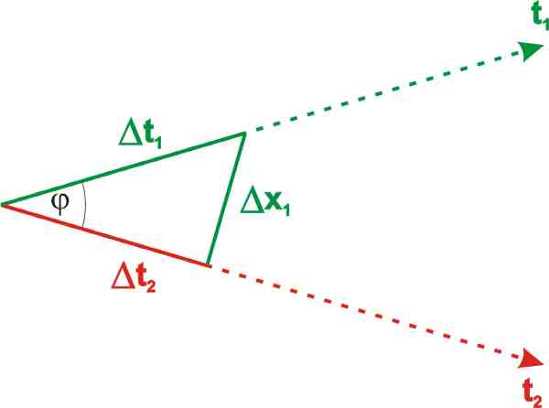 | 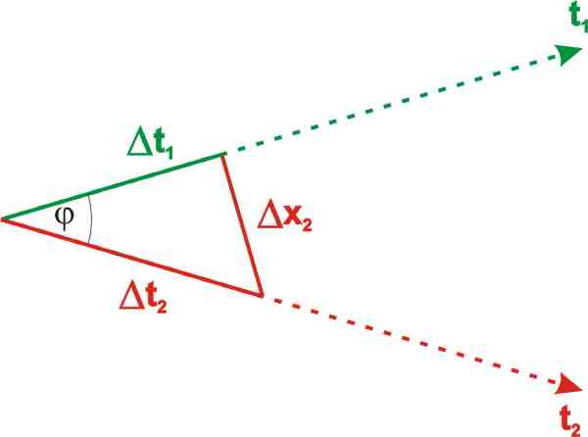
a.) | c.)
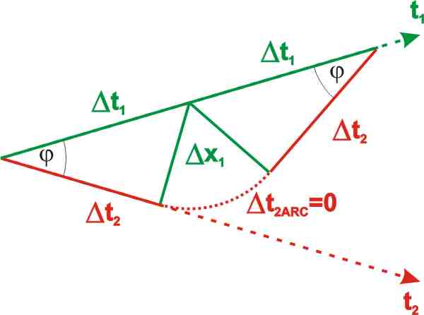 | 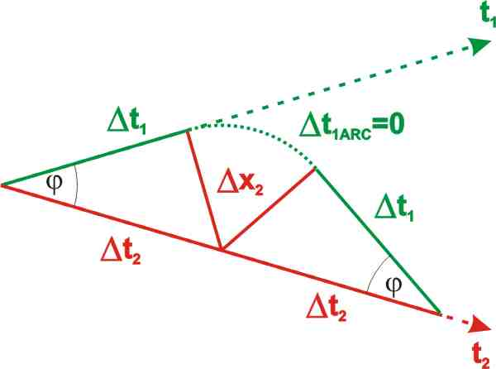
b.) | d.)
Fig. 3. Two observers are moving along trajectories inclined to each other at angle φ. Observer 1 can see that the time in observer 2’s reference system is flowing slower – fig. a – and vice versa, observer 2 can see that the time in observer 1’s reference system is flowing slower. Hence, the problem presented in figs. a and c is symmetrical for both observers. If one of the observers changes its velocity – figs. b and d - then some part of its trajectory leads through the sphere, on which the time flow is equal to zero, and this is the reason why the flow of time in this system is slower.
and the dependence between the time of the two observers can be described by the formula resulting from formula (3):
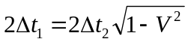 (8)
5. Conclusions
Finally we’ve obtained the dependence between the times, flowing in the observers’ systems, which are a simple function of a relative velocity of the observers. Looking only at the final formula we can get an impression that the time dilation is a simple result of velocity, and that if an object moves, its time is flowing slower. However, according to the above reasoning, such conclusion is false. The true mechanism responsible for the time dilation phenomenon relies on the change of velocity, due to which an object changing the velocity travels some part of its trajectory along a curve on which the time flow is equal to zero (in a case of instant change of the velocity).
Therefore, according to the FER model, the time dilation effect during the relative motion with constant velocity is only a seeming effect and not the true time dilation as it is assumed in SRT.
References
[1] E.S. Lowry “The Clock Paradox”, American Journal of Physics, 31: 59 (1963)
[2] W. Nawrot “Proposal for a Simpler Description of SRT”, Galilean Electrodynamics 18: 43 (2007) http://euclideanreality.com/pdf/Proposal_for_a_Simpler_Description_of_SRT.pdf
[3] W.Nawrot "The structure of time and the wave structure of the matter", Galilean Electrodynamics 18: 49 (2007) http://euclideanreality.com/pdf/The_Structure_of_Time.pdf
[4] W.Nawrot “Euclidean model of the space-time. Is the reality exactly as we can observe it?” http://euclideanreality.com
[5] W.Nawrot "Four Dimensional Euclidean Reality - The basic properties of the model" Proc. International Scientific Congress "Fundamental Problems of Natural Science and Engineering" Saint-Petersburg, Russia 2008
[6] W. Nawrot "Euclidean model of the spacetime - is the reality exactly as we can observe it?" Mathematics, Physics and Philosophy in the Interpretations of Relativity Theory Budapest, 4 - 6 September 2009. http://euclideanreality.com/pdf/Euclidean_model_of_the_spacetime%20_is_the_reality_exactly_as_we_can_observe_it.pdf

